# INF 271 Deliverable 2.Functional Specification

Meet the Team

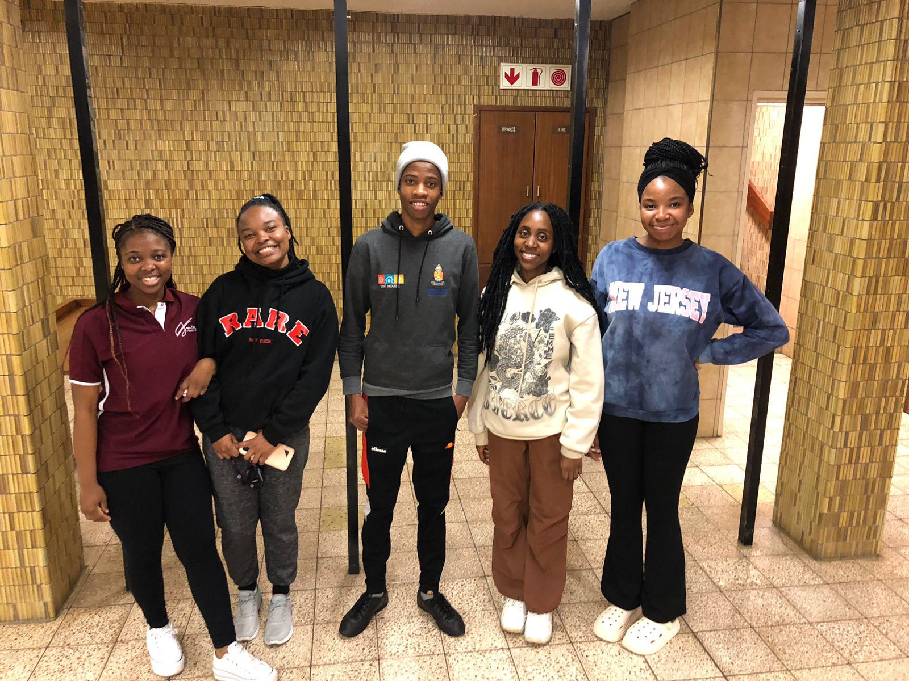  
Members Details from left to right:

|  |  |  |  |
| --- | --- | --- | --- |
| Name | Surname | Student Number | Email Address |
| Phumzile | Phakathi | 215757555 | u21575755@tuks.co.za |
| Busisiwe | Khosa | 2047324 | u2047324@tuks.co.za |
| Rethabile | Kgotlane | 21601144 | u21601144@tuks.co.za |
| Basetsana | Sekhoto | 21608611 | u21608611@tuks.co.za |
| Maria | Sadiki | 22651609 | u22651609@tuks.co.za |

|  |  |  |
| --- | --- | --- |
|  | **Table of Contents** | Page |
| 1 | Overview | 3 |
| 2 | Use Case | 4-33 |
| 3 | Process models  For new system | 34-61 |
| 4 | UML Modelling | 62-90 |
| 5 | Data Modelling | 91-92 |
| 6 | Interfaces and other inputs | 93-94 |
| 7 | Reports and other Outputs | 95-96 |
| 8 | Validation | 97-101 |
| 9 | General | 102-103 |

1.Introduction

Welcome to the second component of our INF 271, Group Project. Over the next few pages, our team will focus on developing the functional specifications for African Adventures Information System. This document will be a nine-part procedure. We will begin with a set of Use Case diagrams to identify the possible times a user will make use of the system. This is followed by a series of process models that help us to breakdown the business processes. After which we include a UML Diagram to visualize our systems entities and their attributes. This will be followed by Data Modelling and analyze how we will be modeling our inputs/interfaces. Then following this up with an analysis on the outputs of our system and a Validation there of. Concluding our project by providing evidence of the progress we made as a team and meetings we had. This document will end with each team member signing off the document adhering to a report, that will confirm their contribution.

2.Use Cases

2.1 Use Case Diagrams

Introduction

This section focuses on the user requirements list. It is an activity diagram that shows how the PBA, PSA, ERA, and ESA interact with the system. The use case diagram has 3 subsystems which are the Online booking subsystem, Admin subsystem, and Balloon subsystem. In total, the use case diagram has 25 use cases. This use case diagram acts as a visual representation of the African Adventures system and how it interacts with external agents, and it offers a high-level view of the African Adventures System of its functionalities and behaviors.

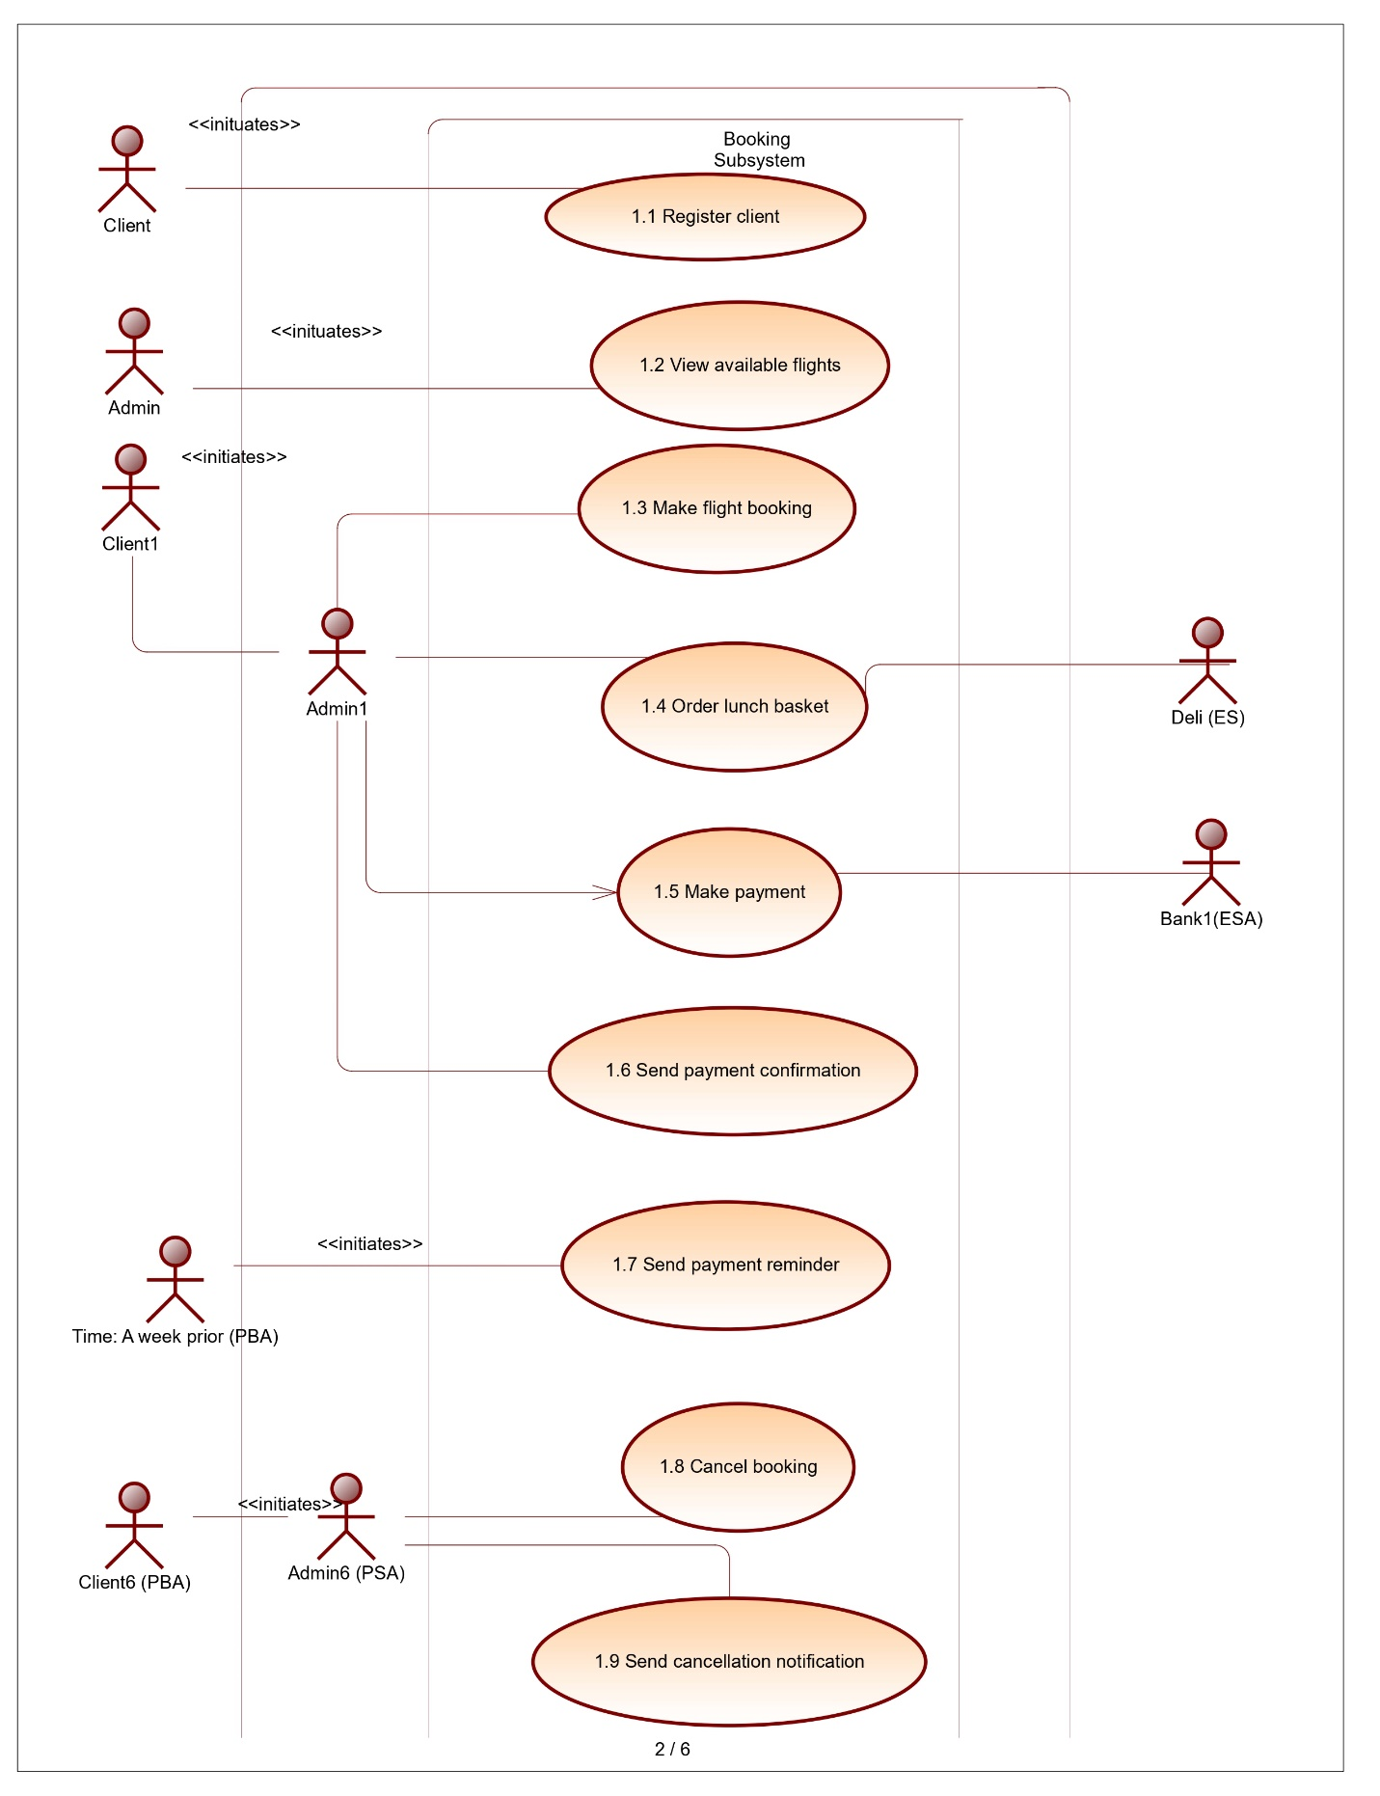

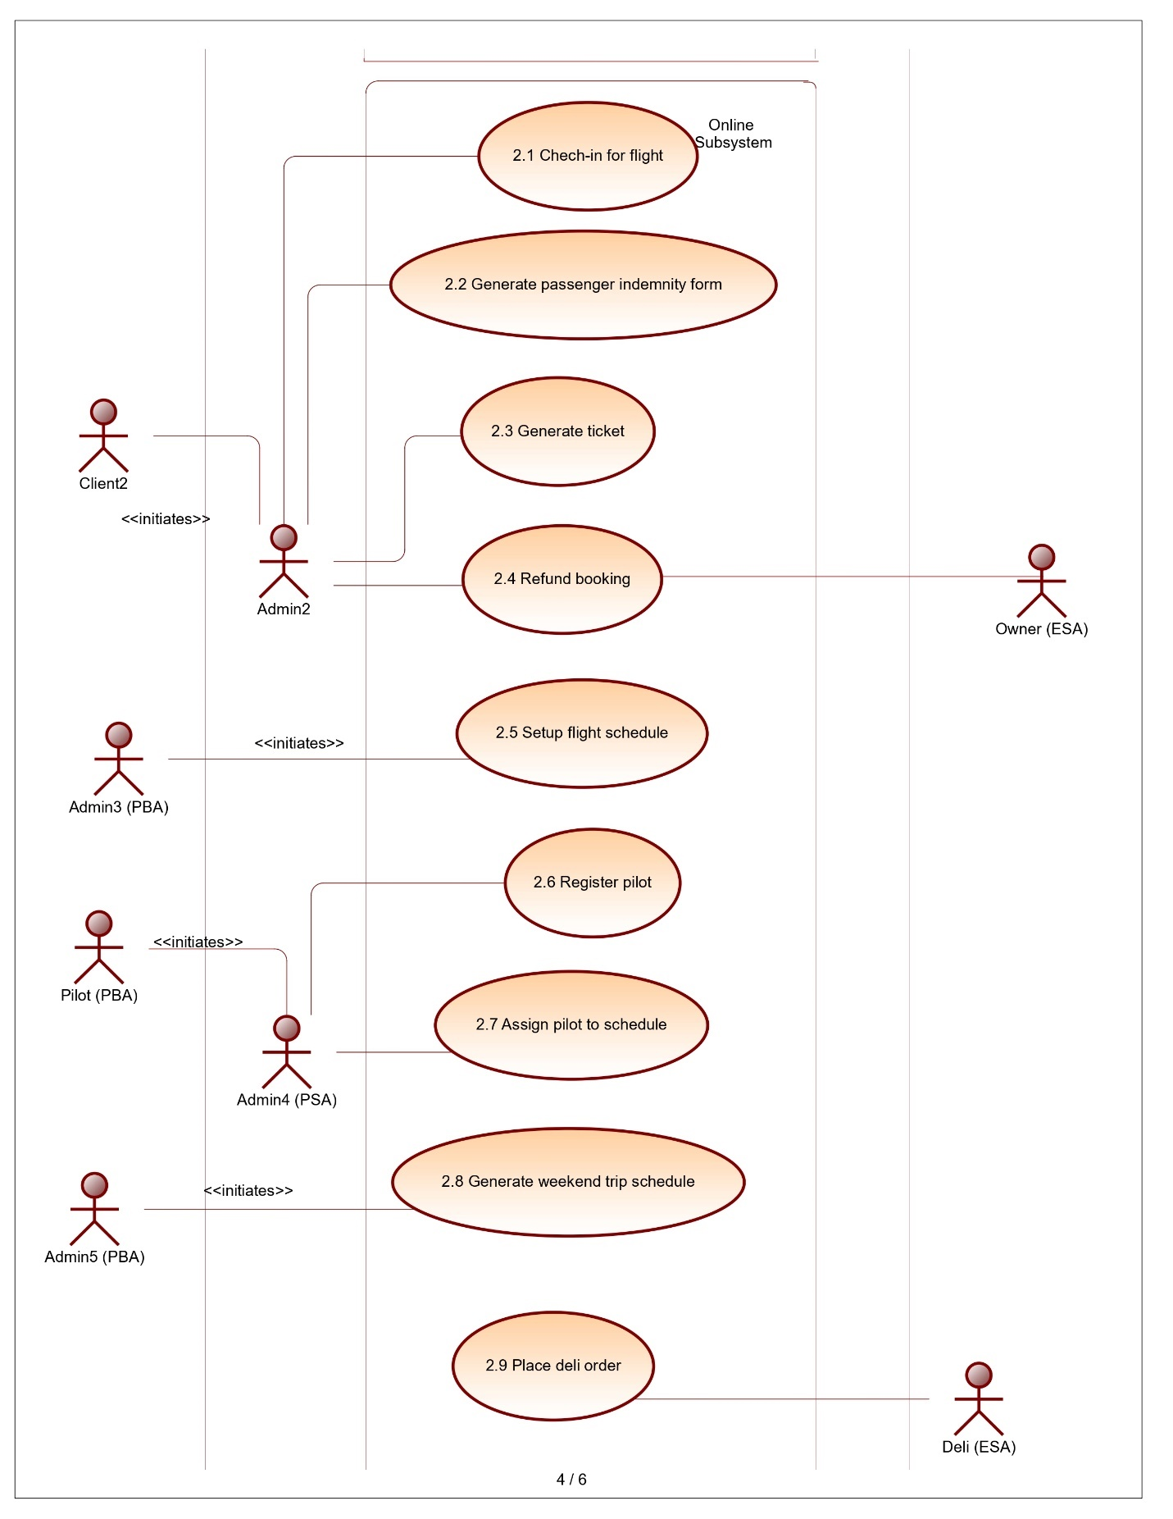

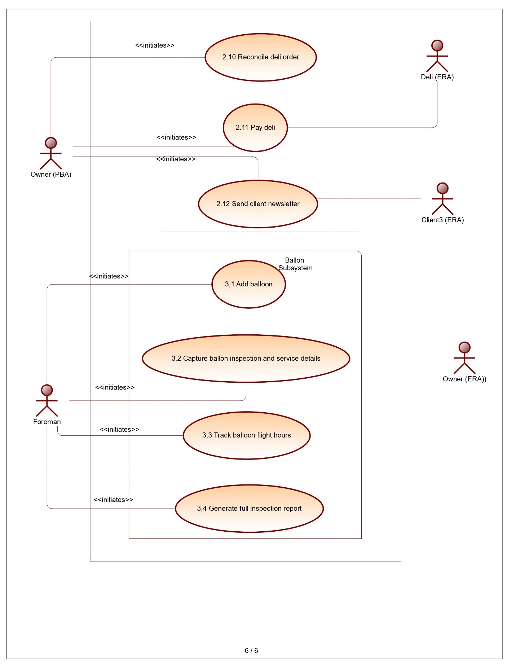

Conclusion

With its great breakdown of use cases and subsystems, this diagram sets the stage for the successful execution of the African Adventures system, ensuring that it meets the needs and expectations of its users and contributes to memorable and exciting balloon adventures in Africa.

2.2 Use Case Narratives

Introduction

Part 2.2 investigates the steps involved in carrying out all 25 Use Cases for Our proposed System. We have identified the participating actors for each Narrative, and we have also gone as far as looking onto alternative steps that could arise.

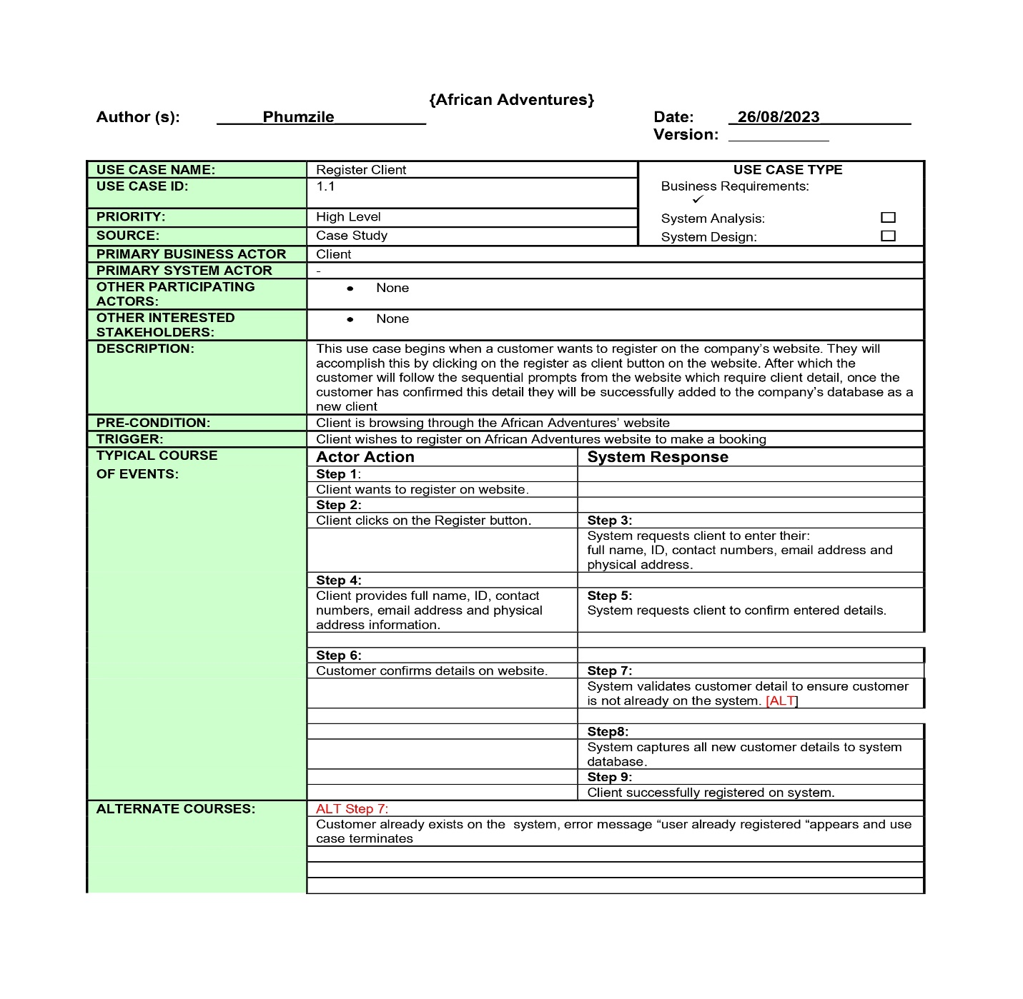

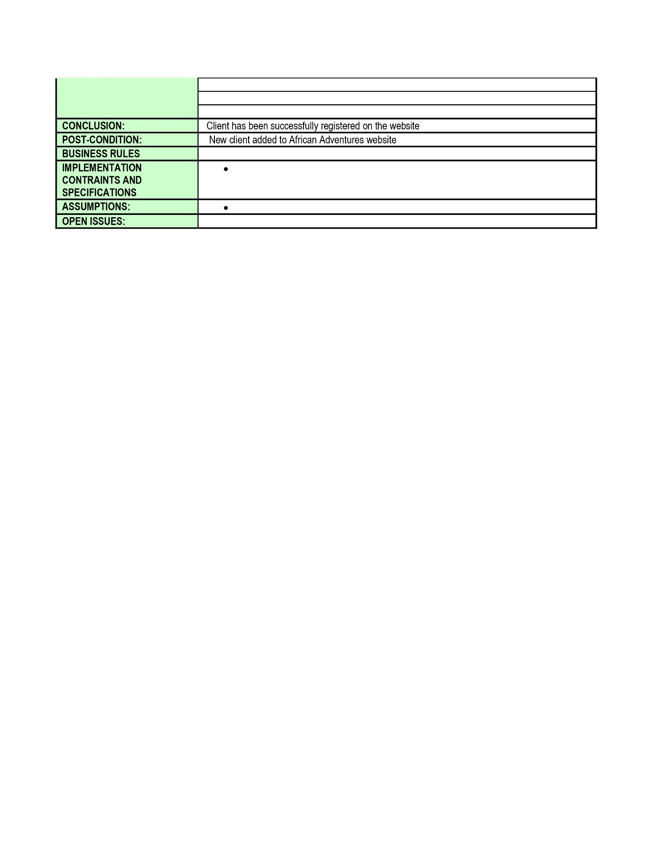

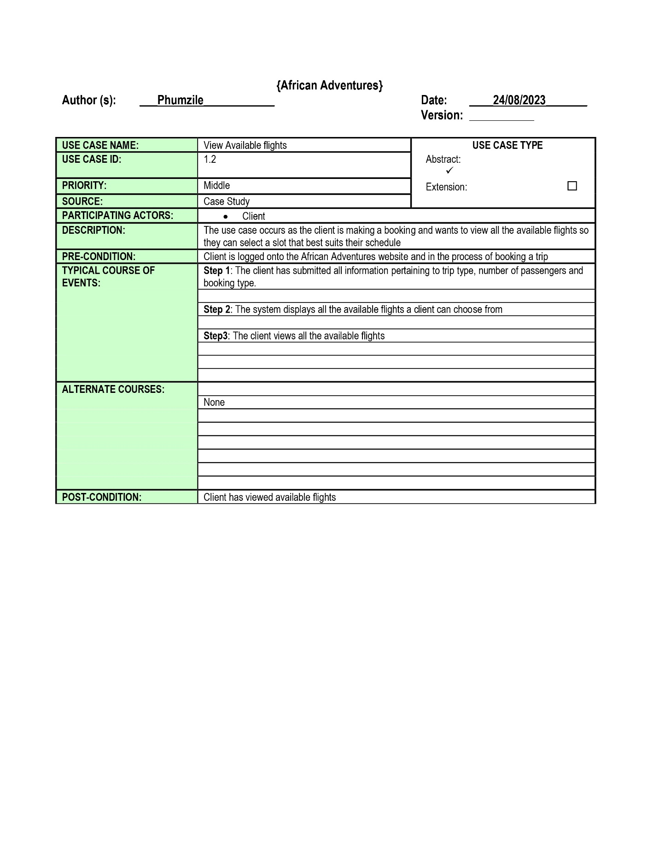

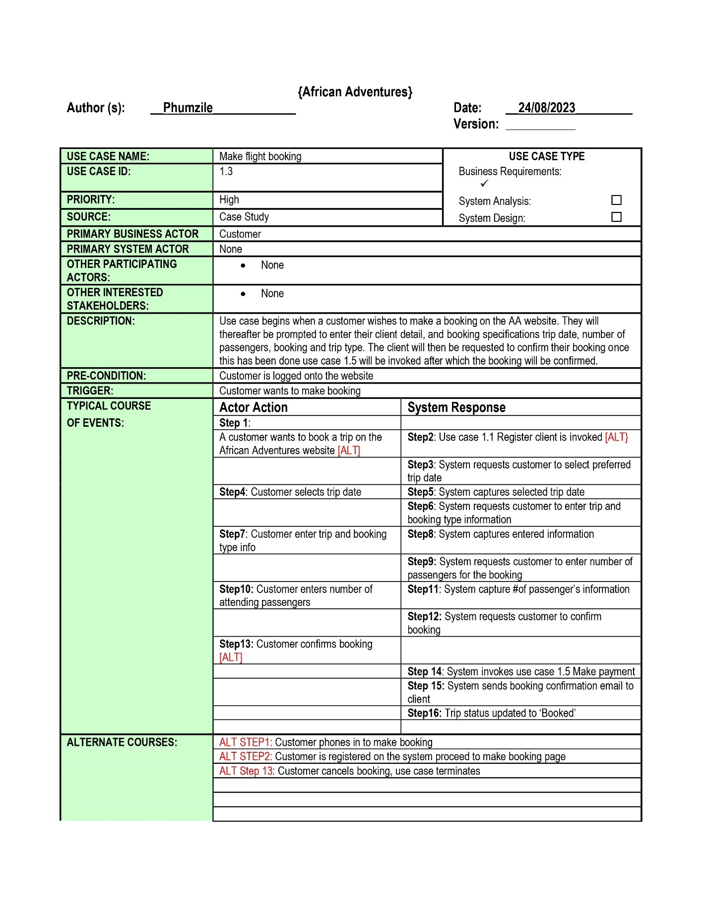

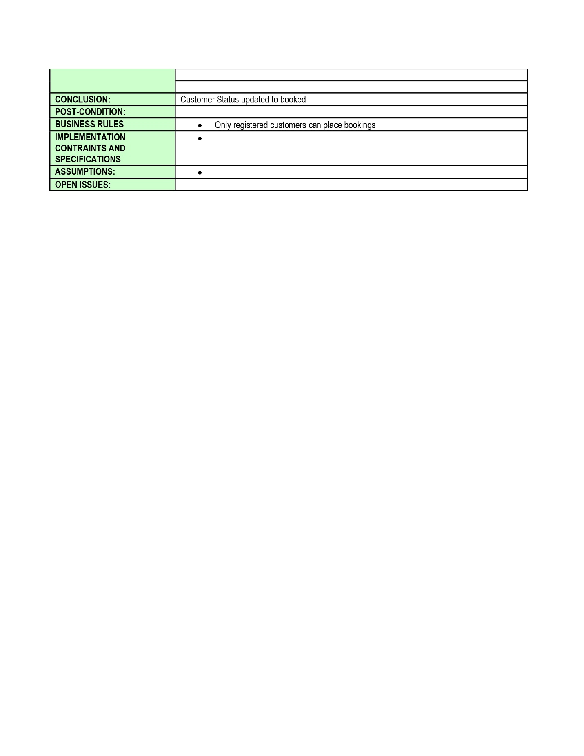

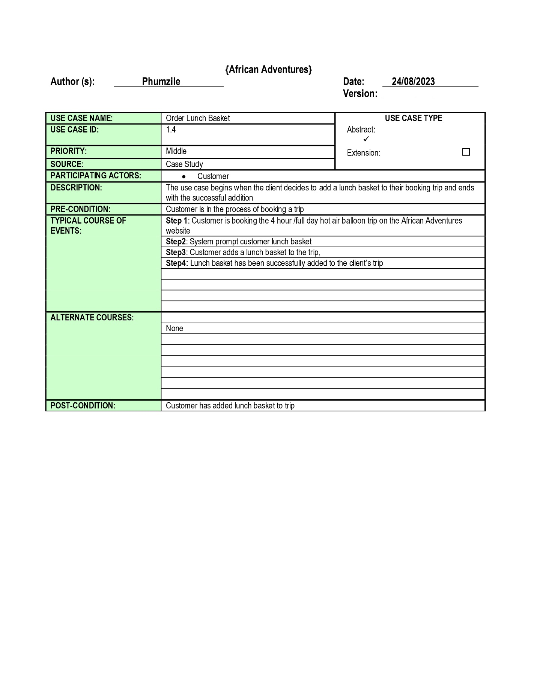

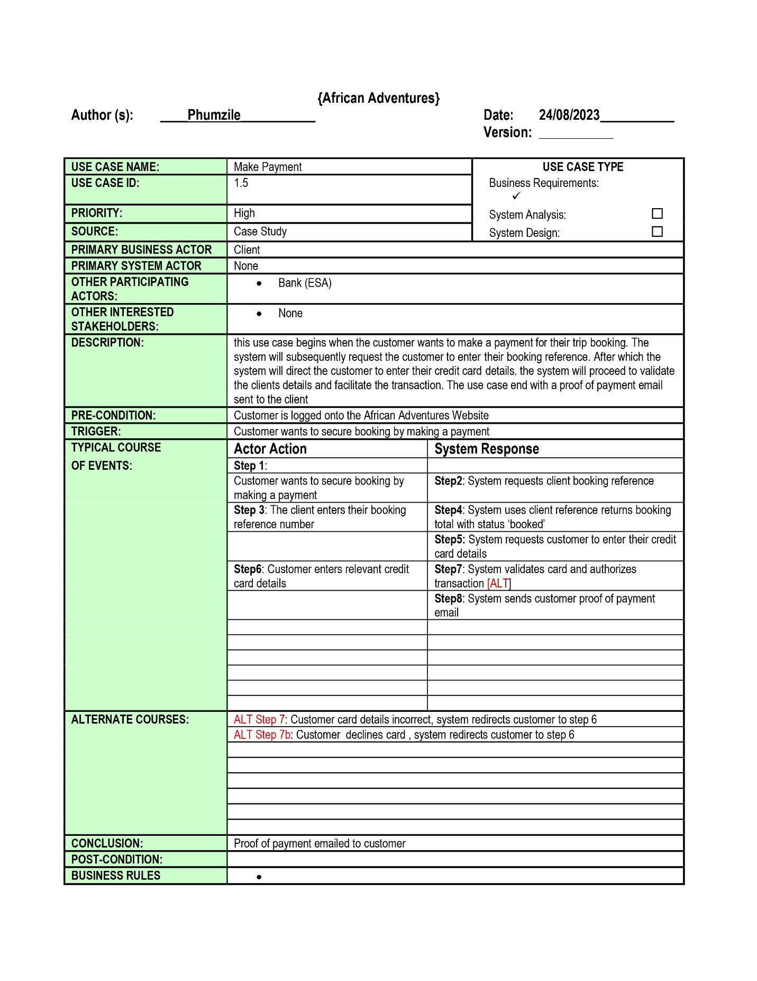

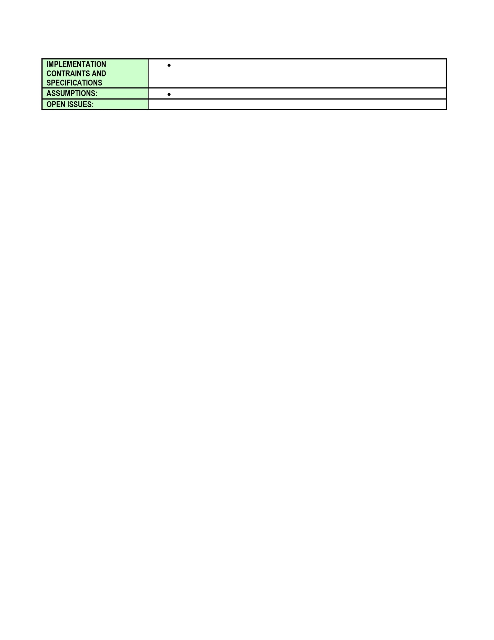

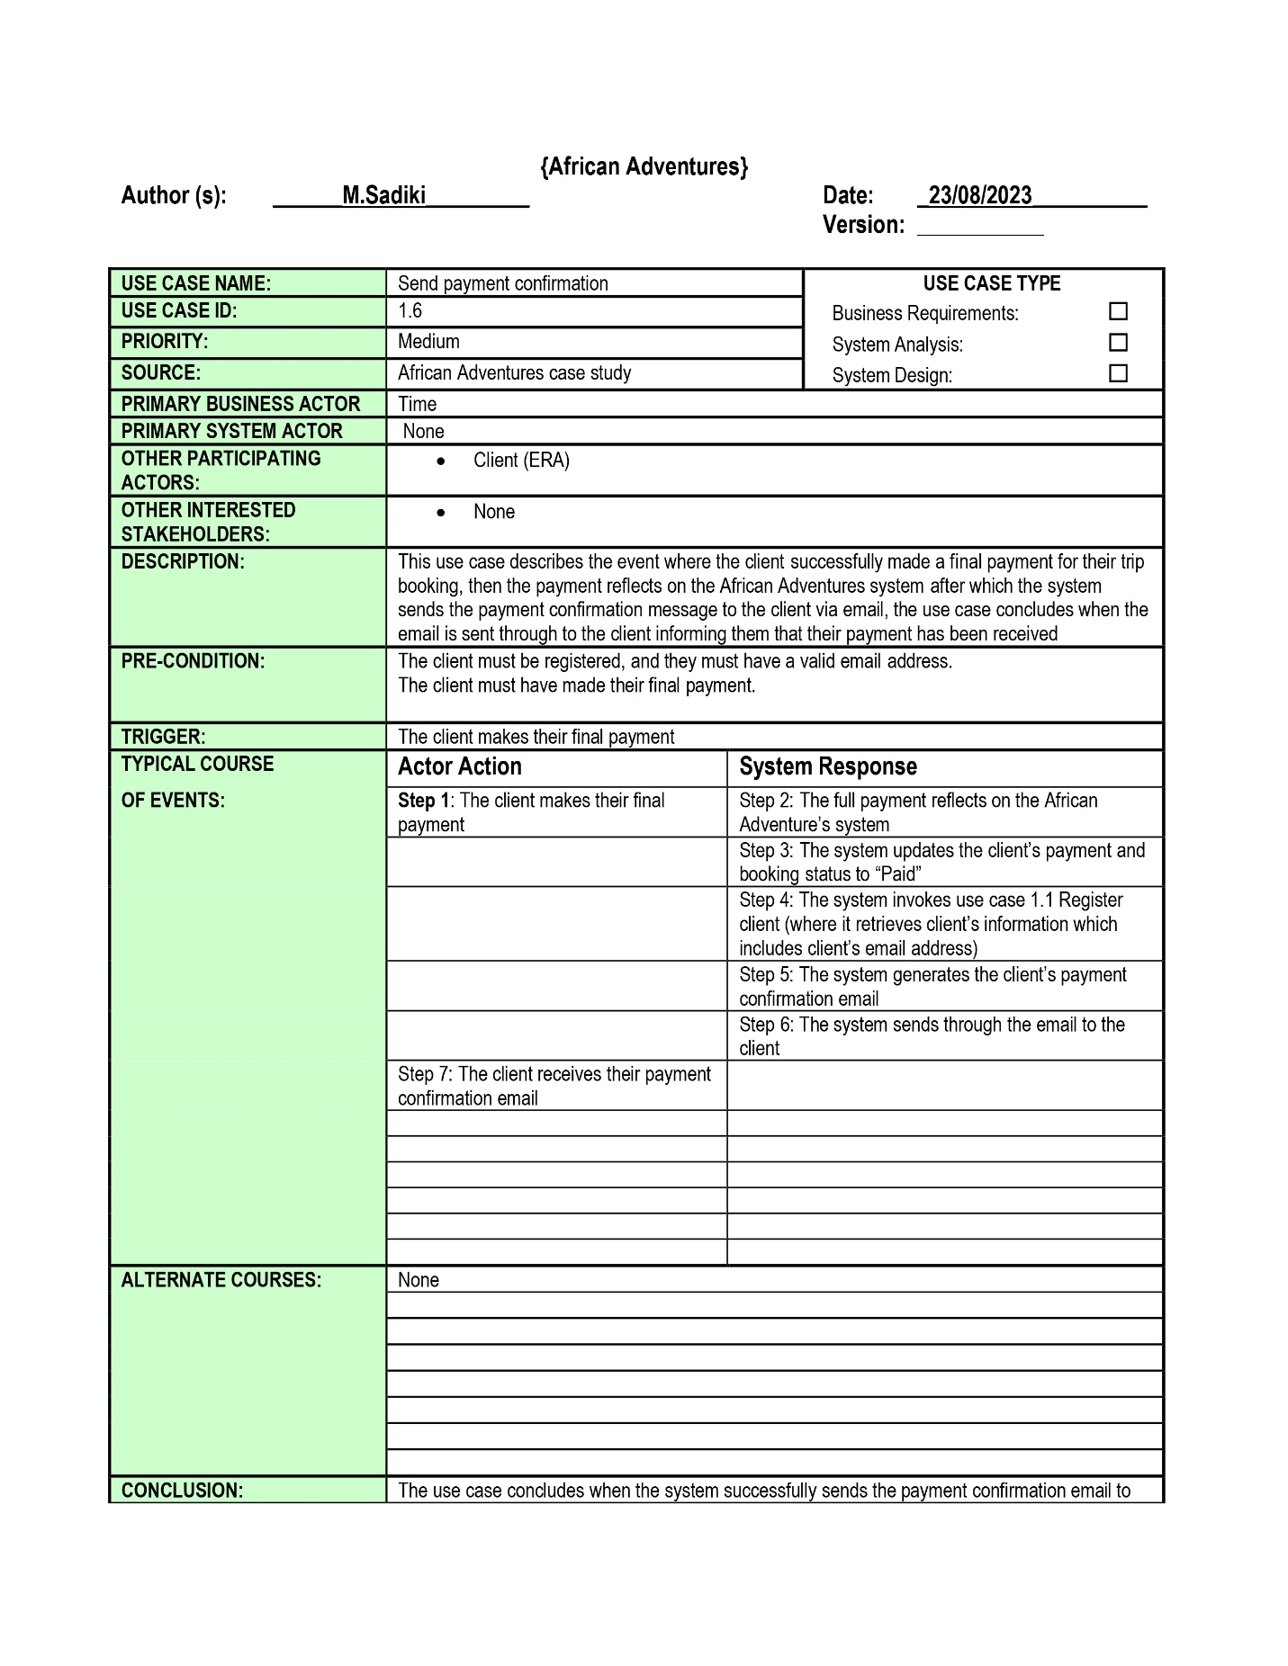

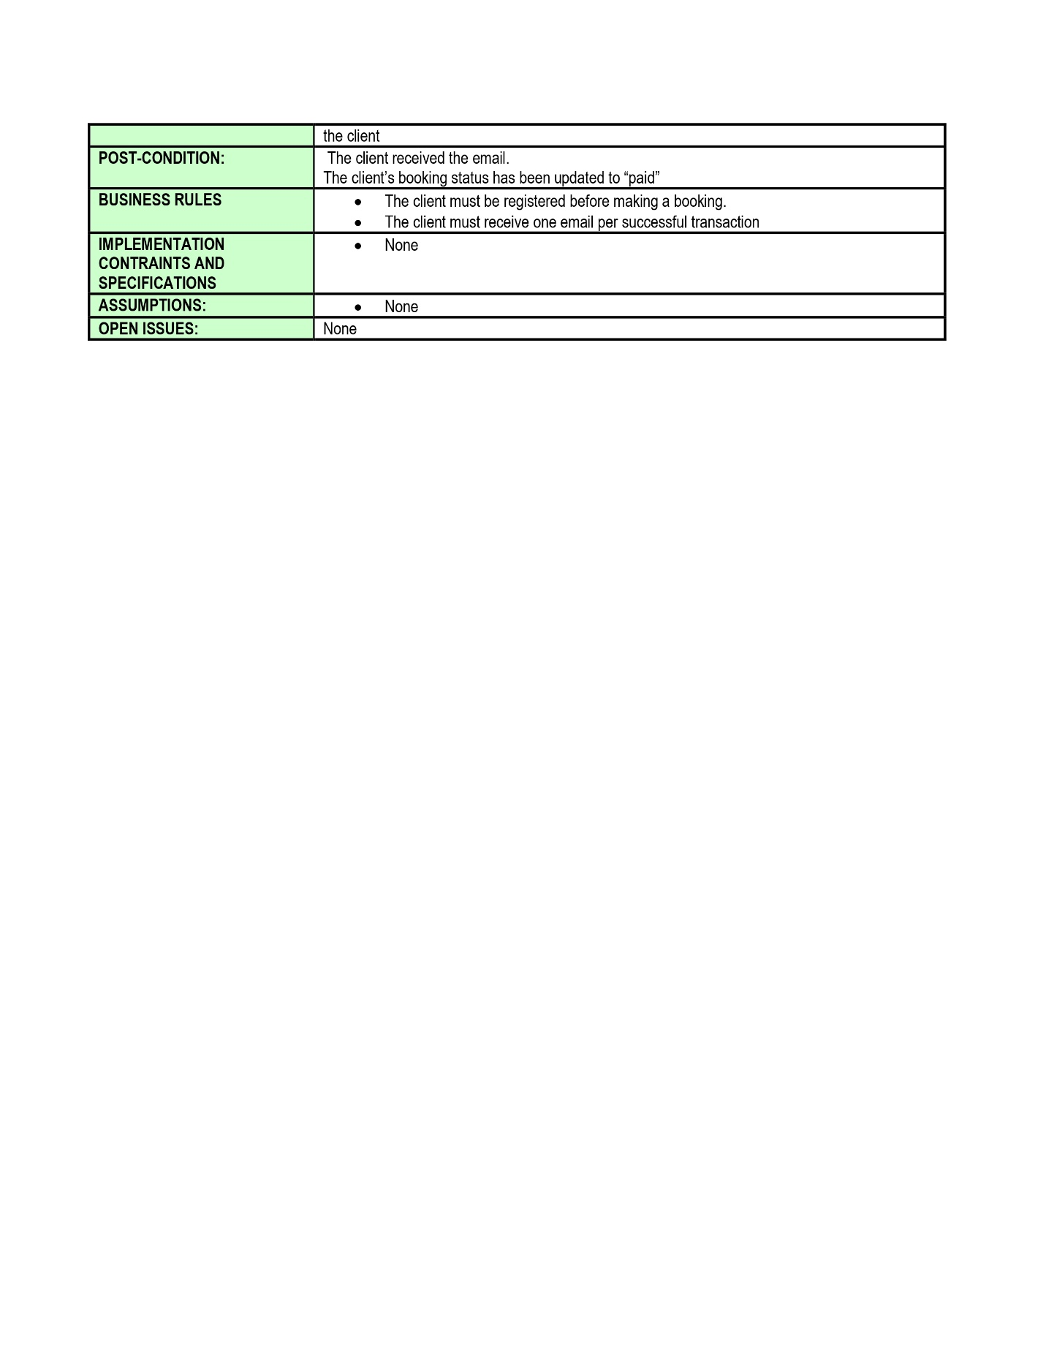

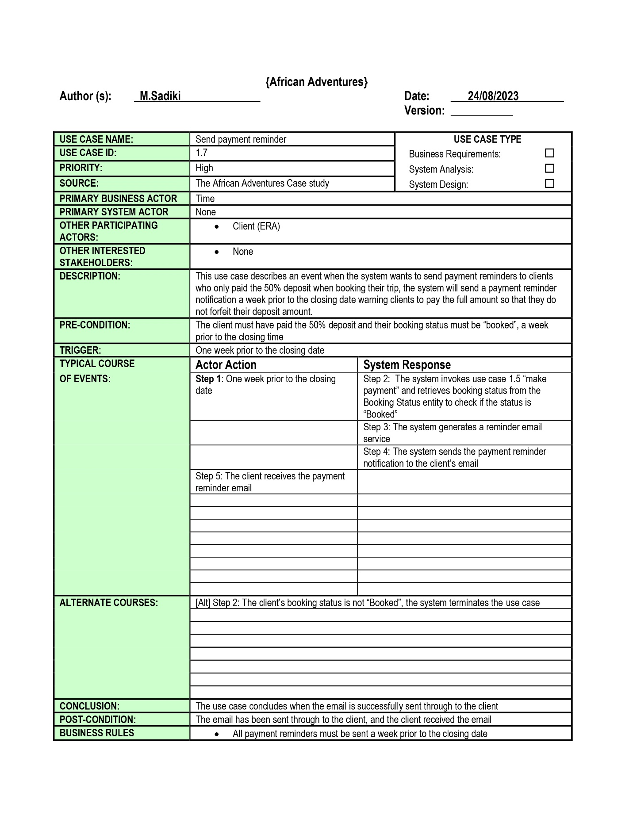

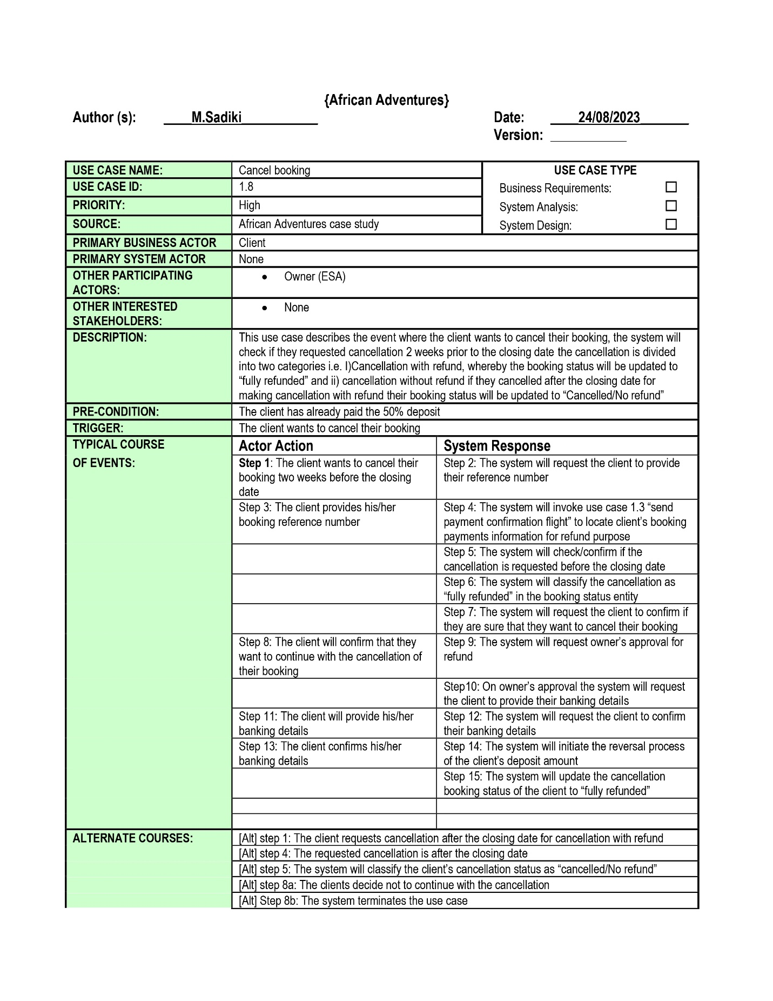

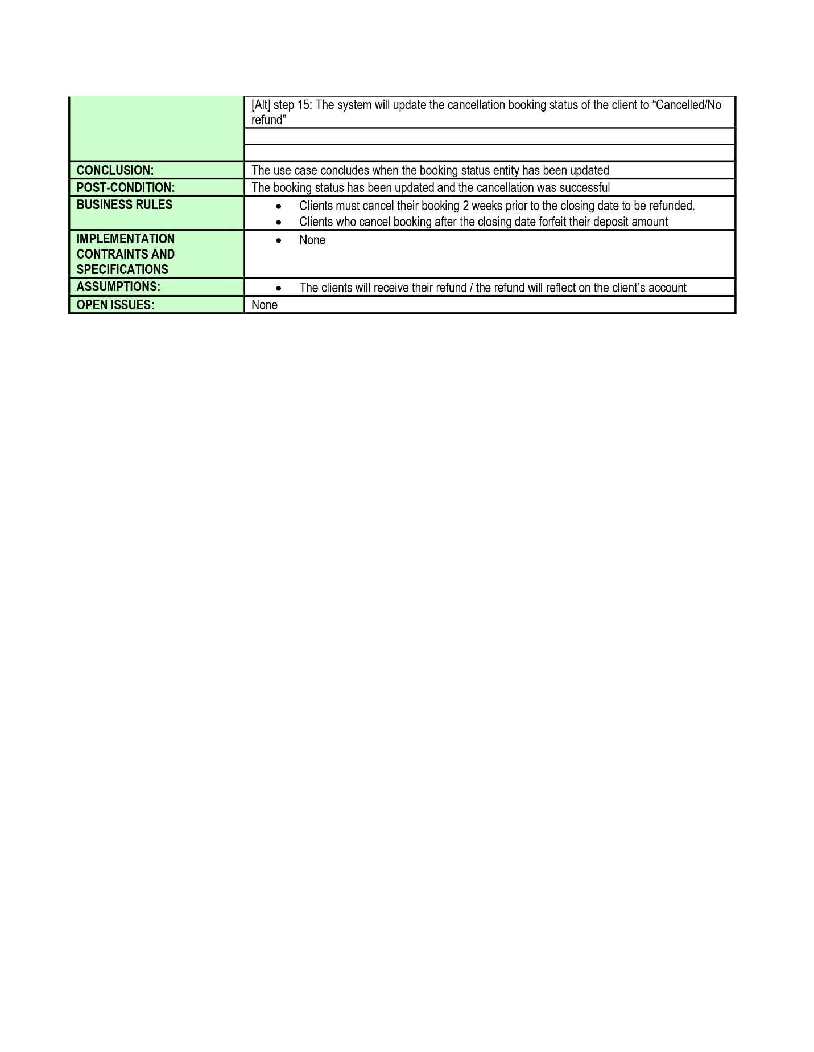

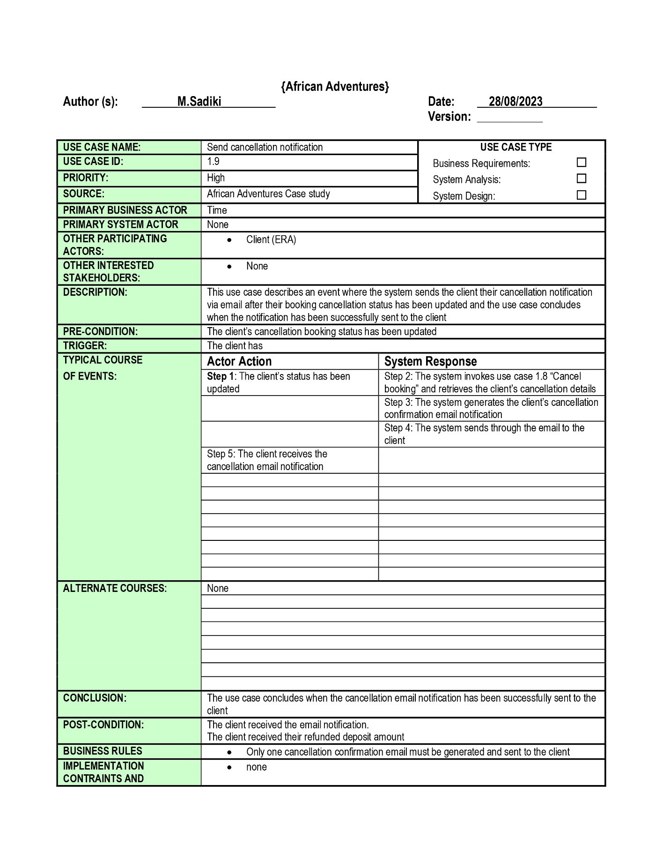

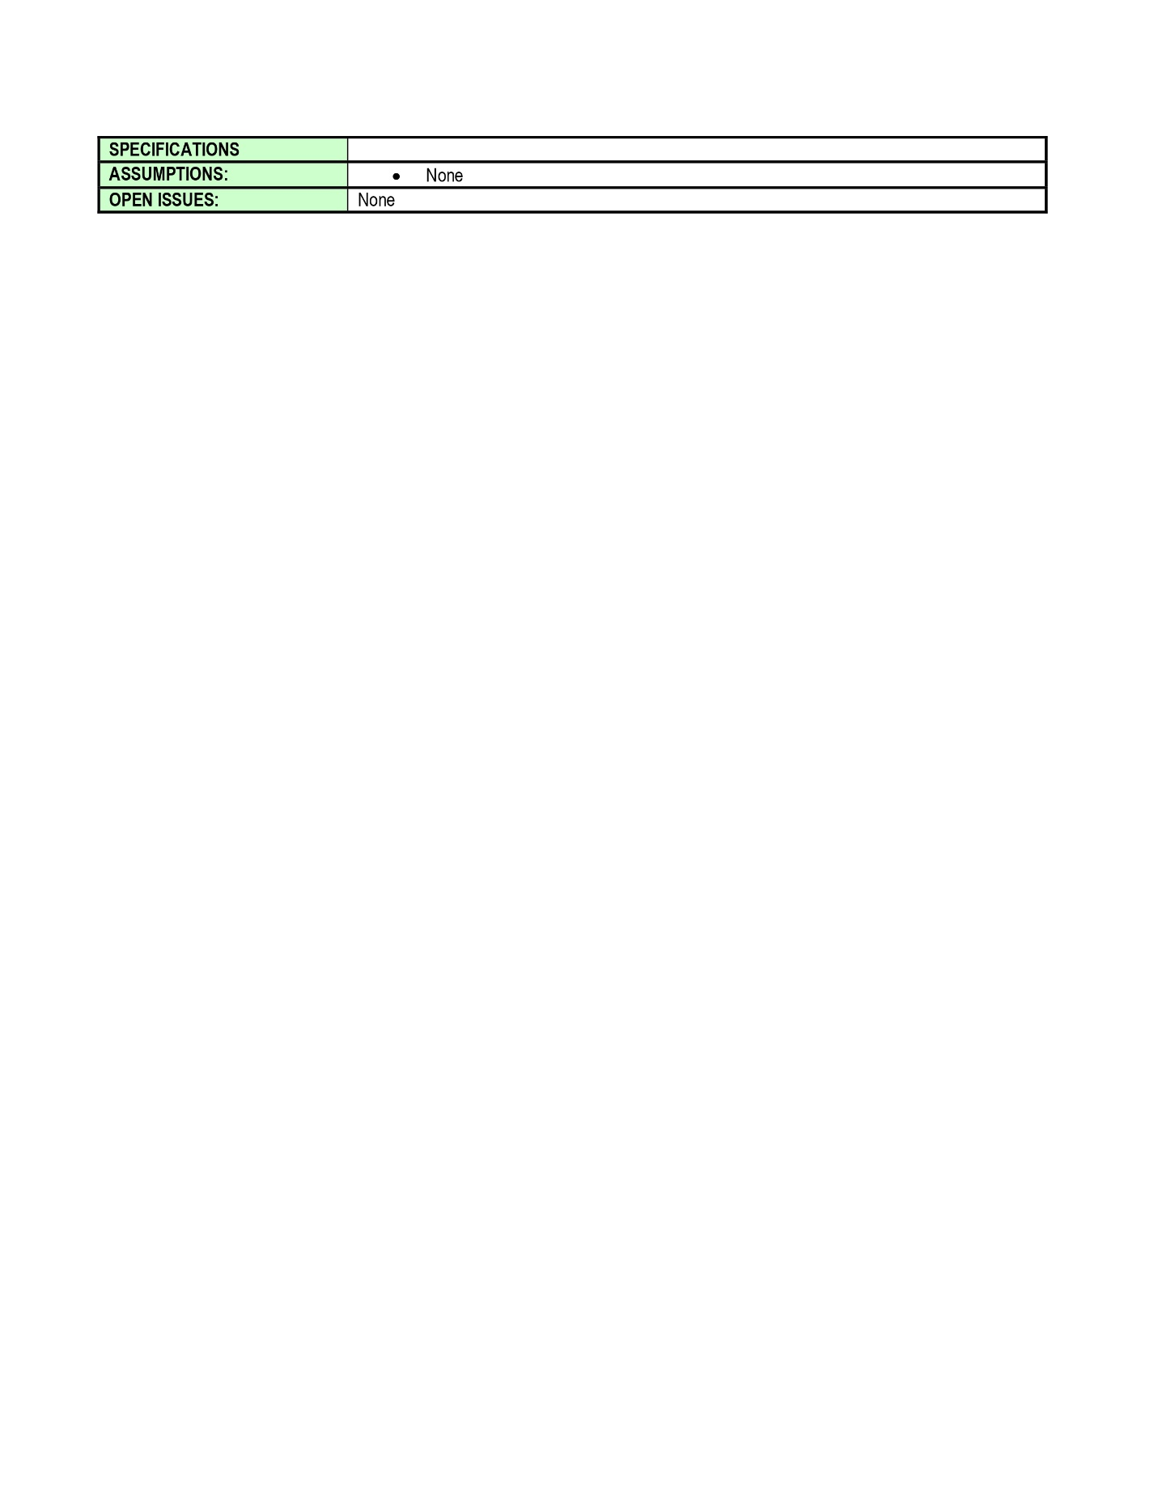

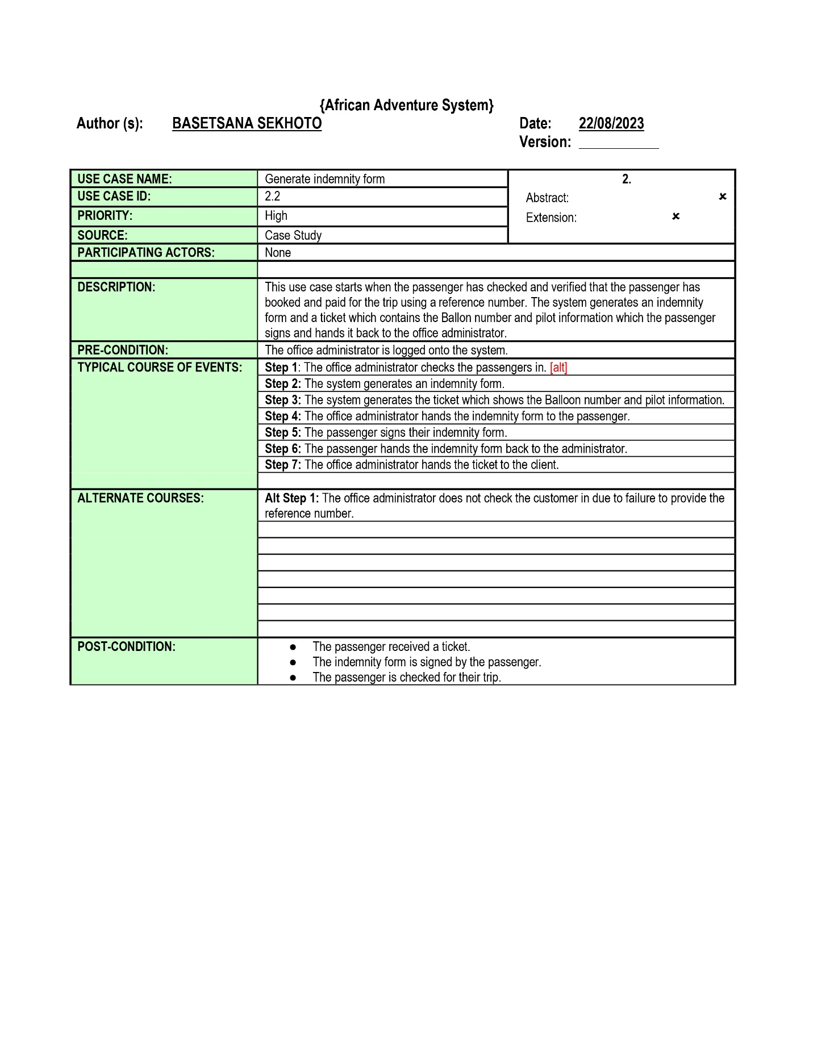

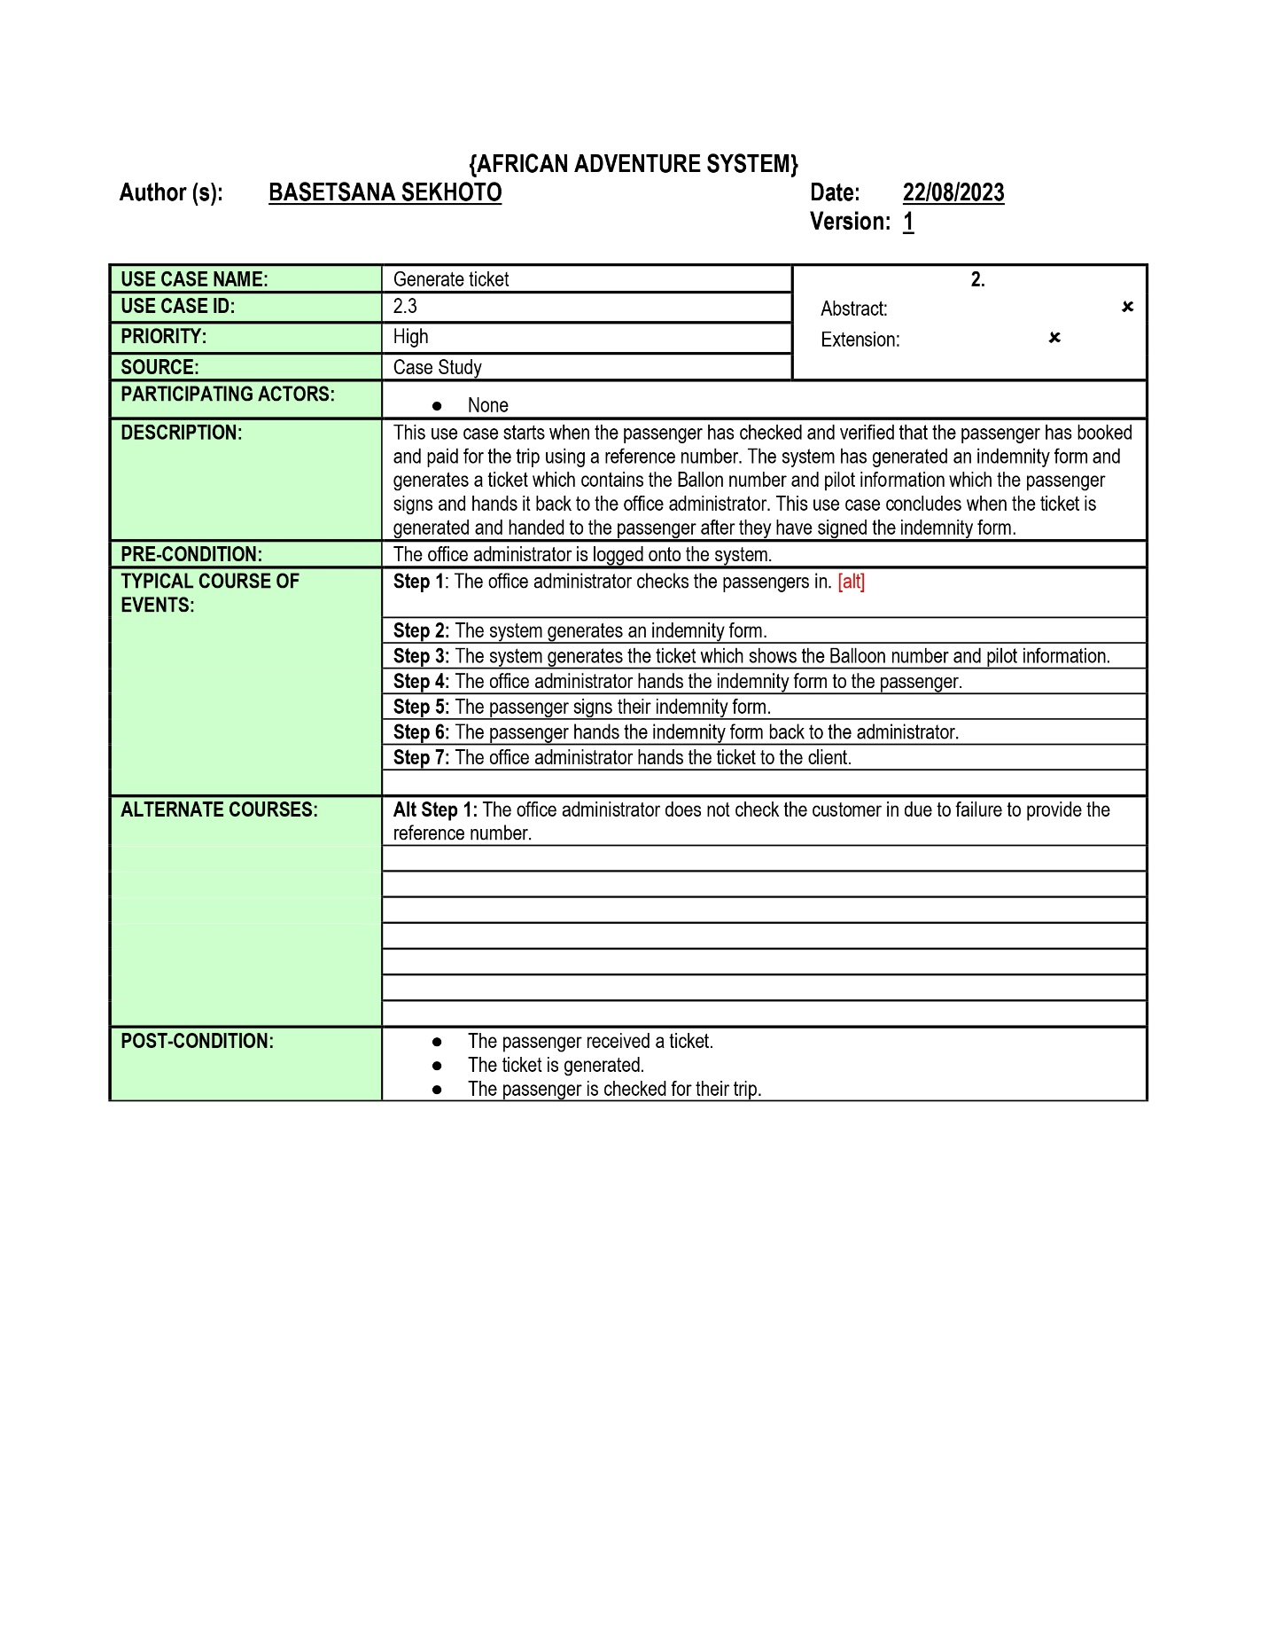

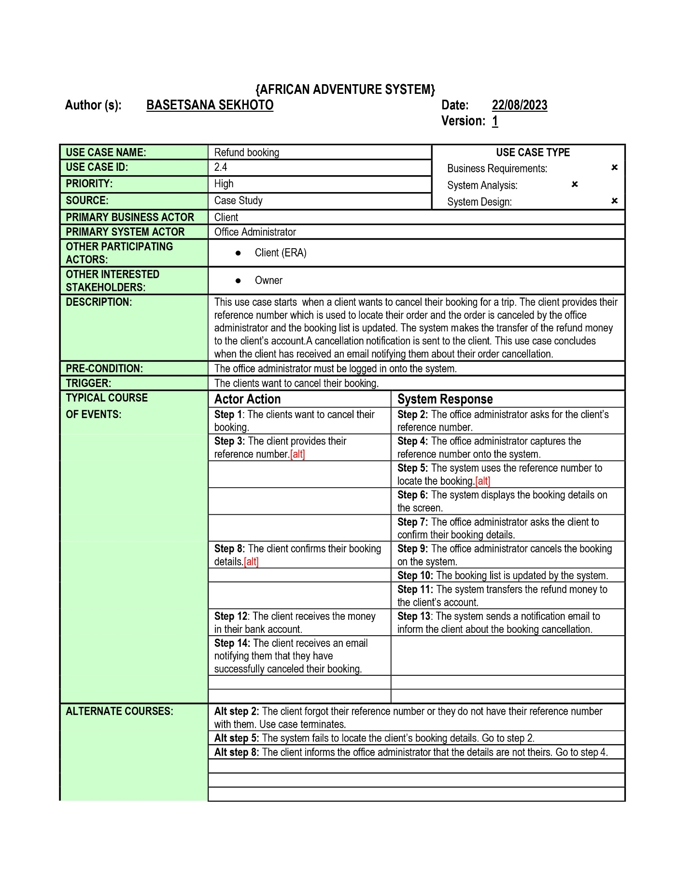

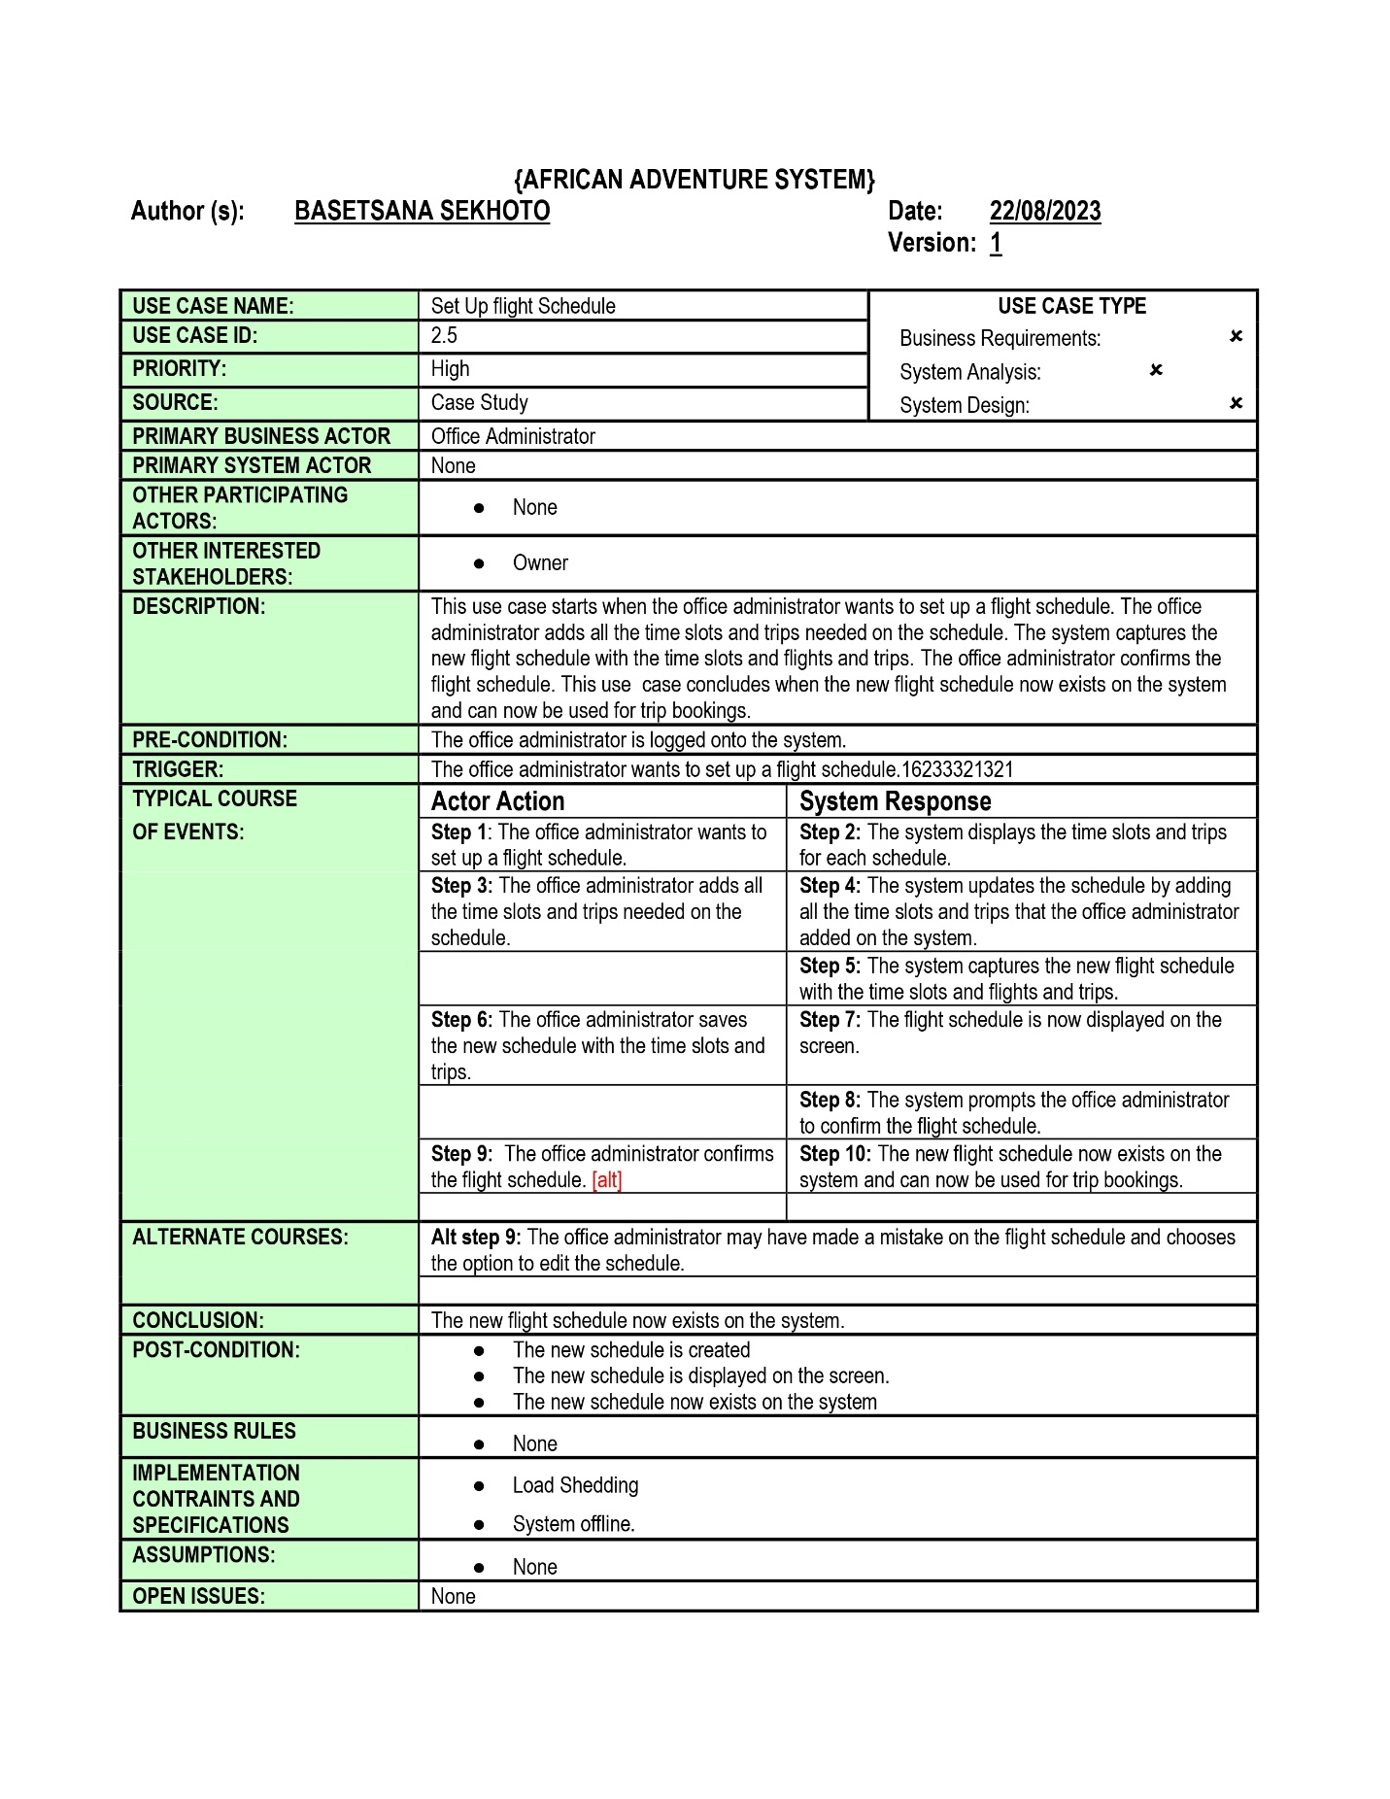

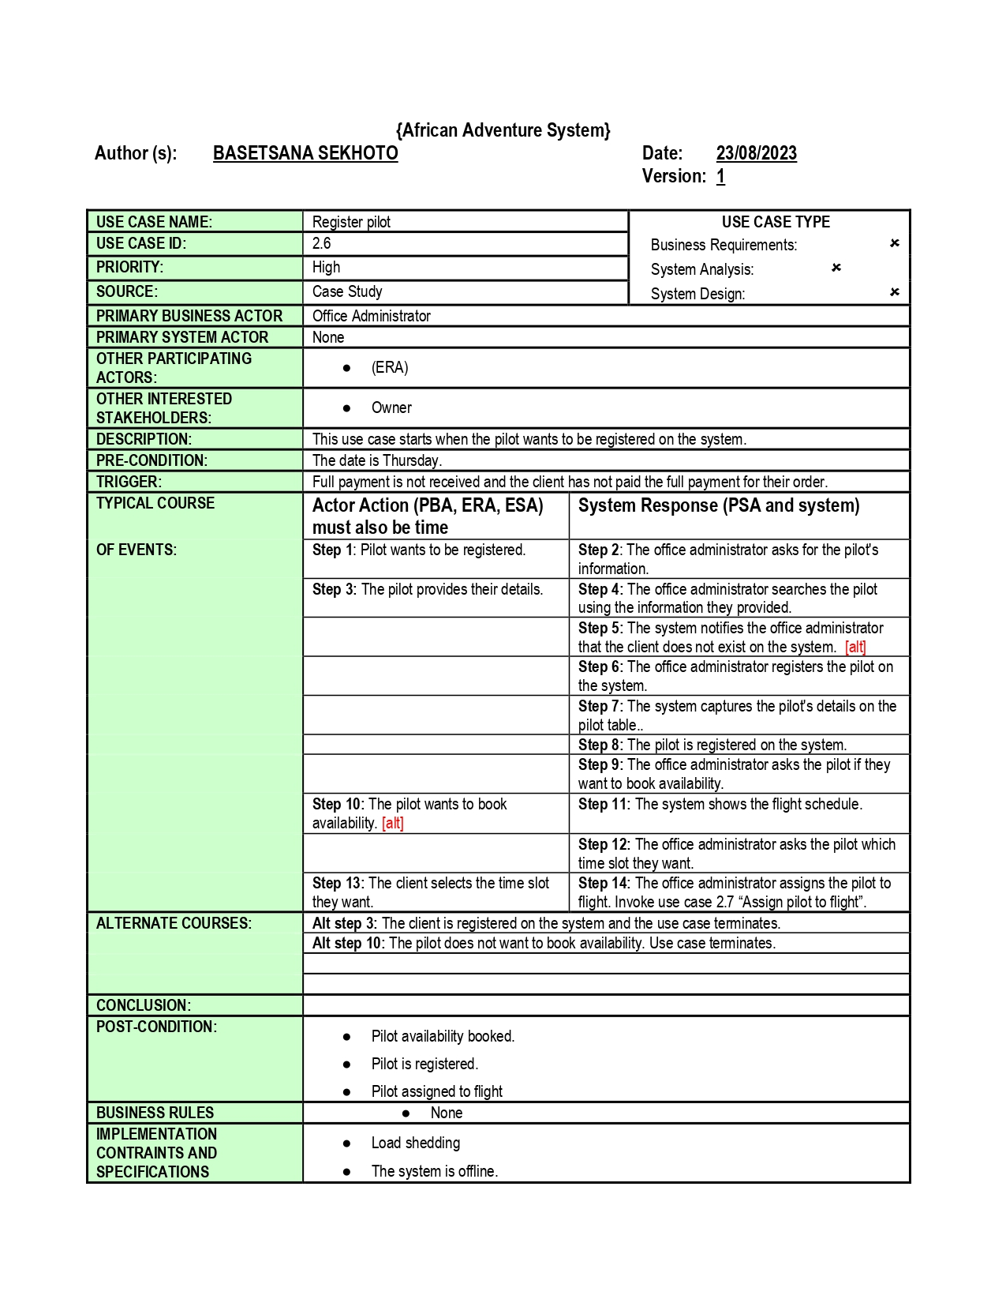

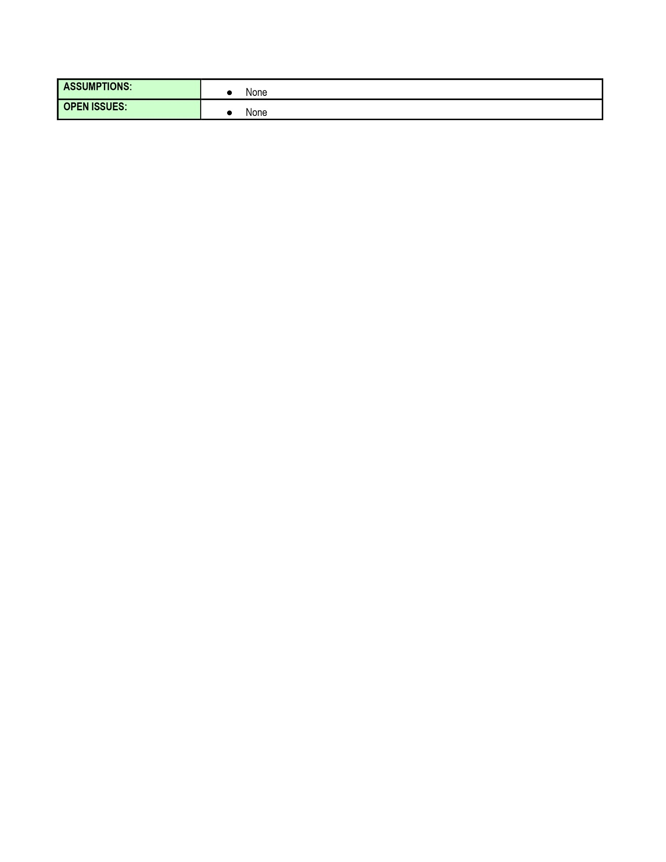

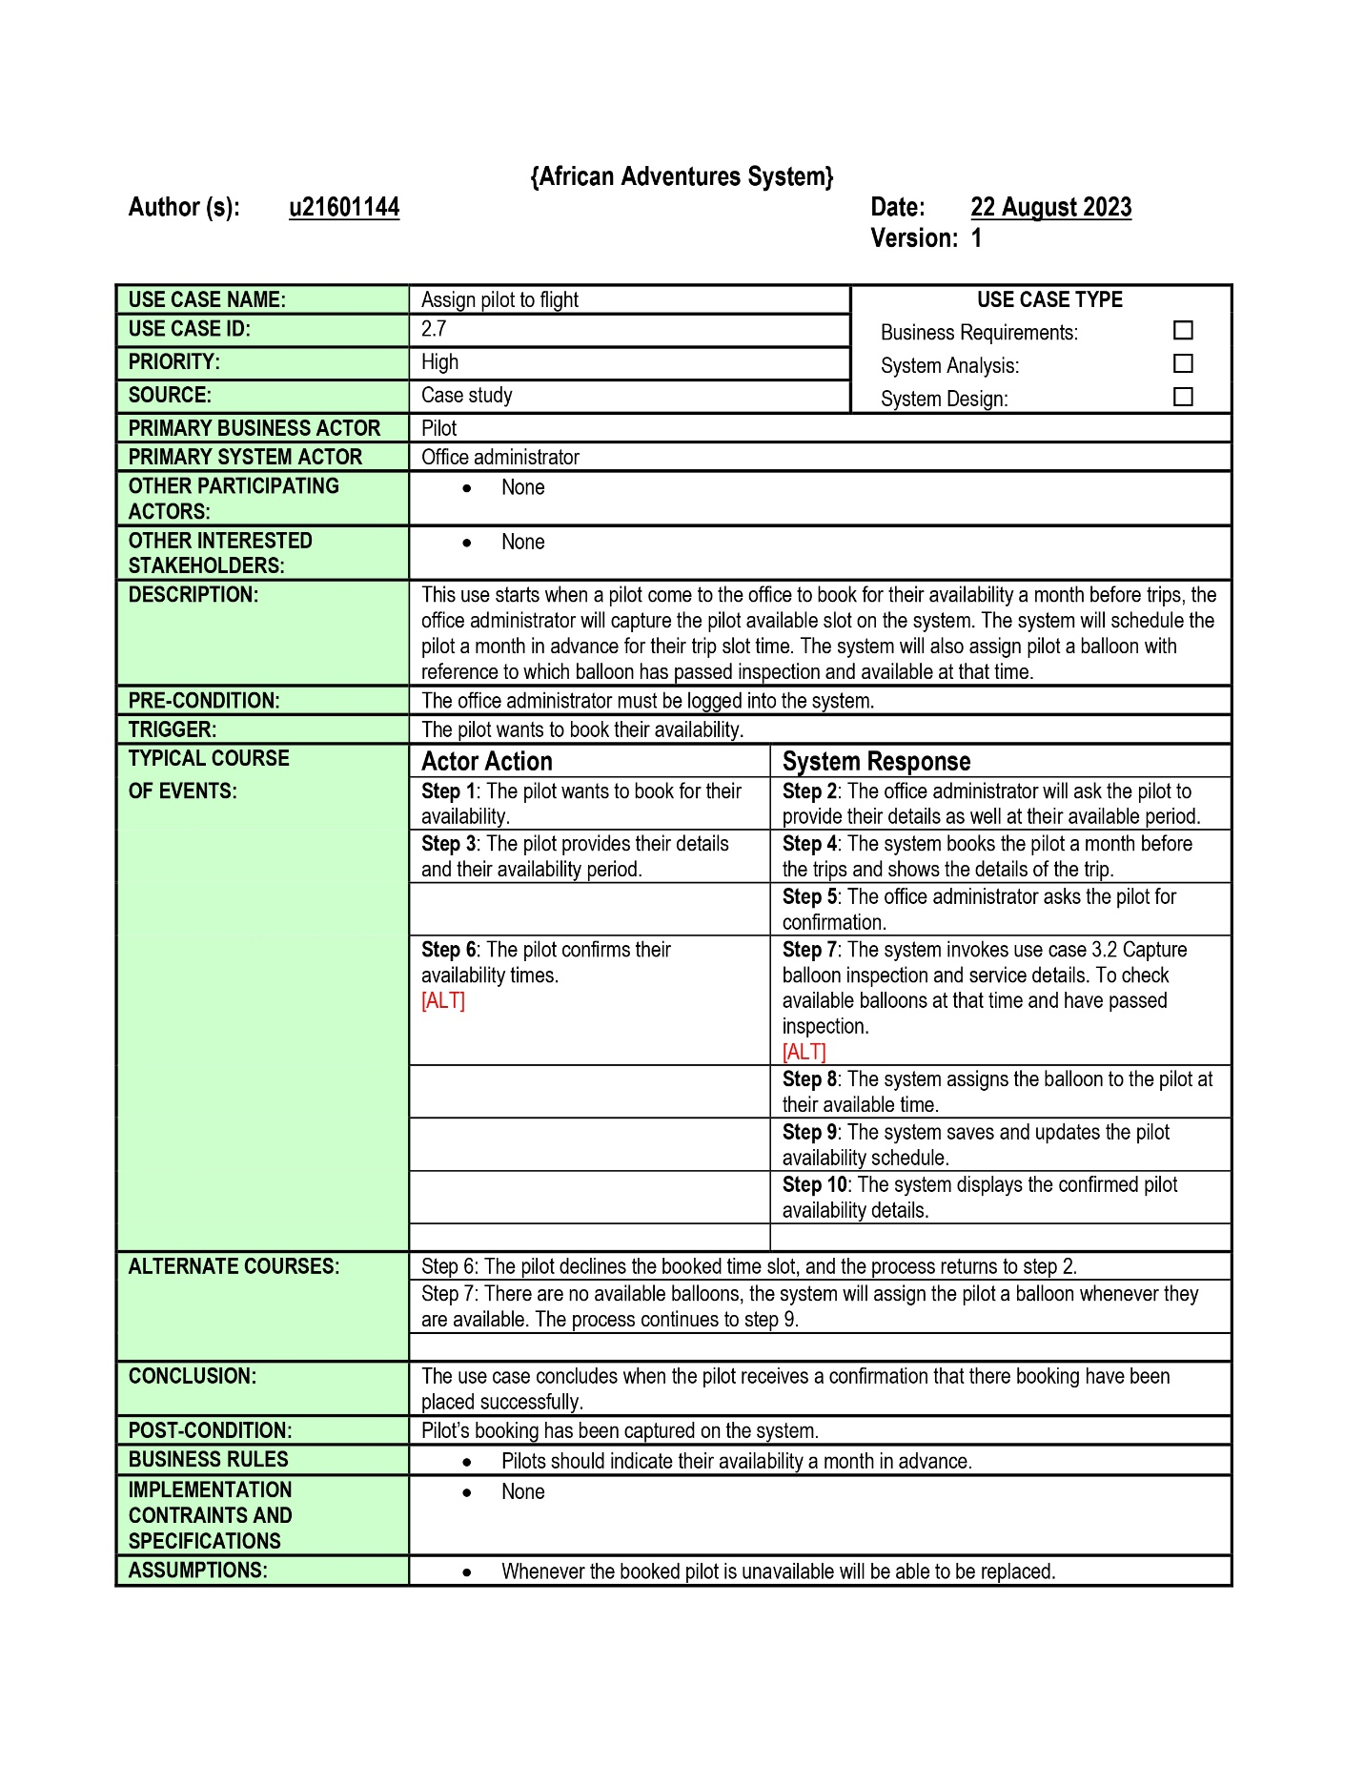



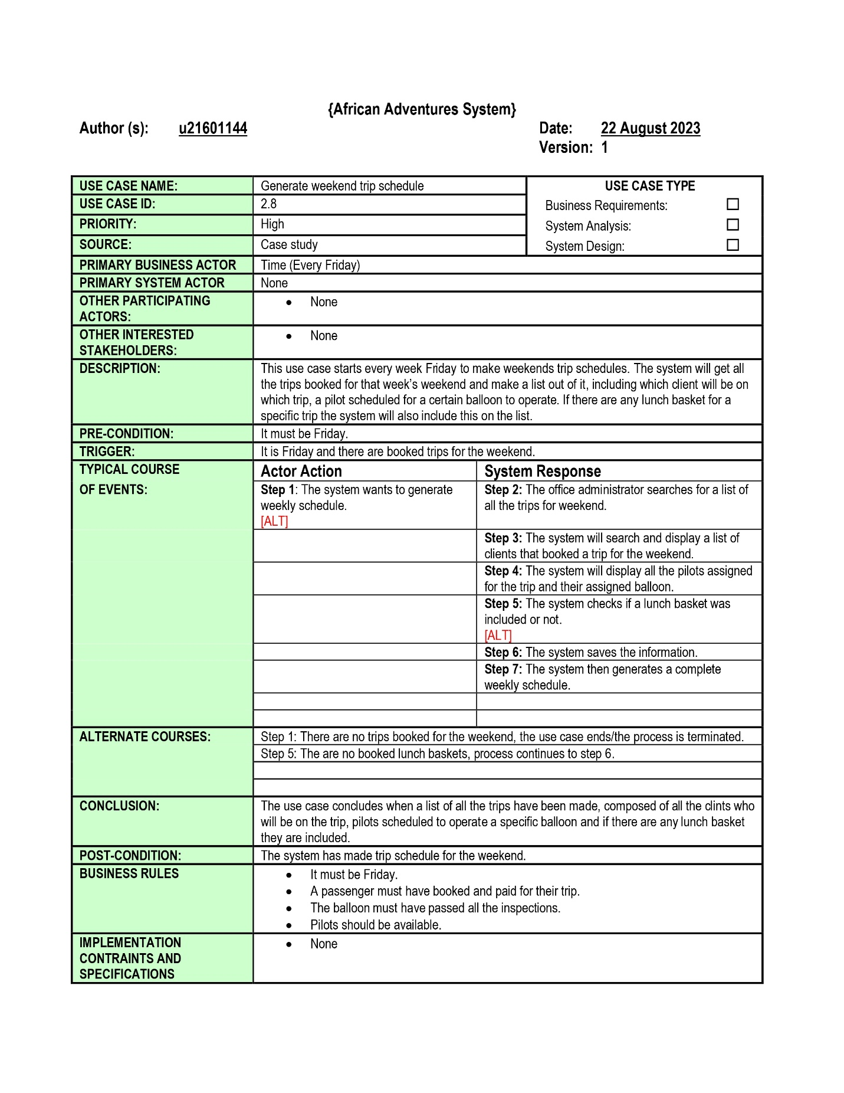

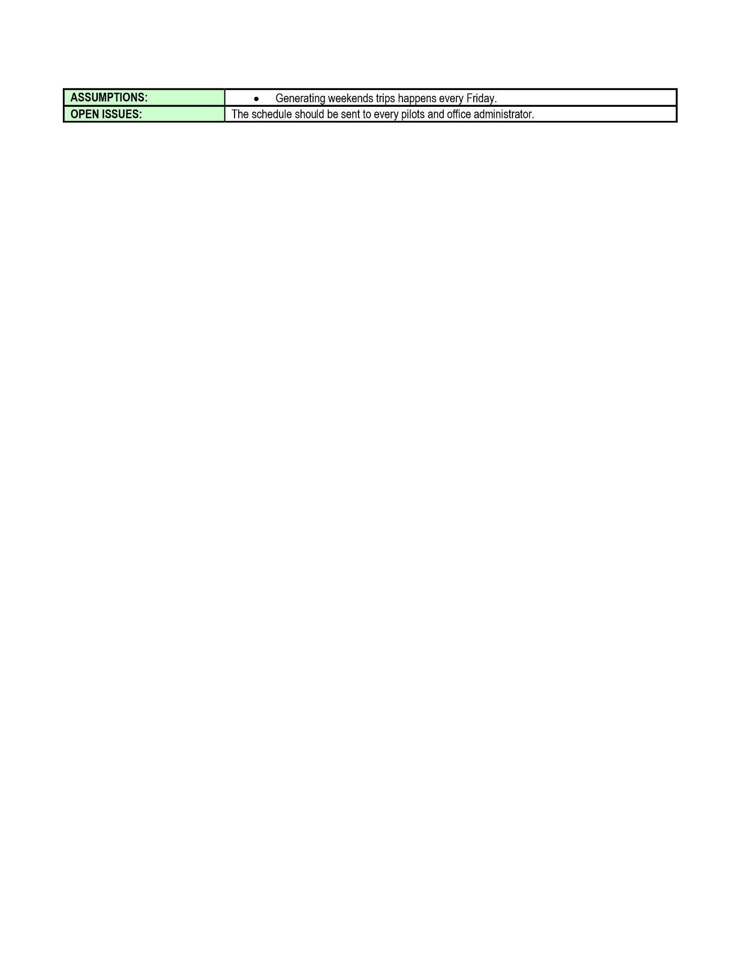

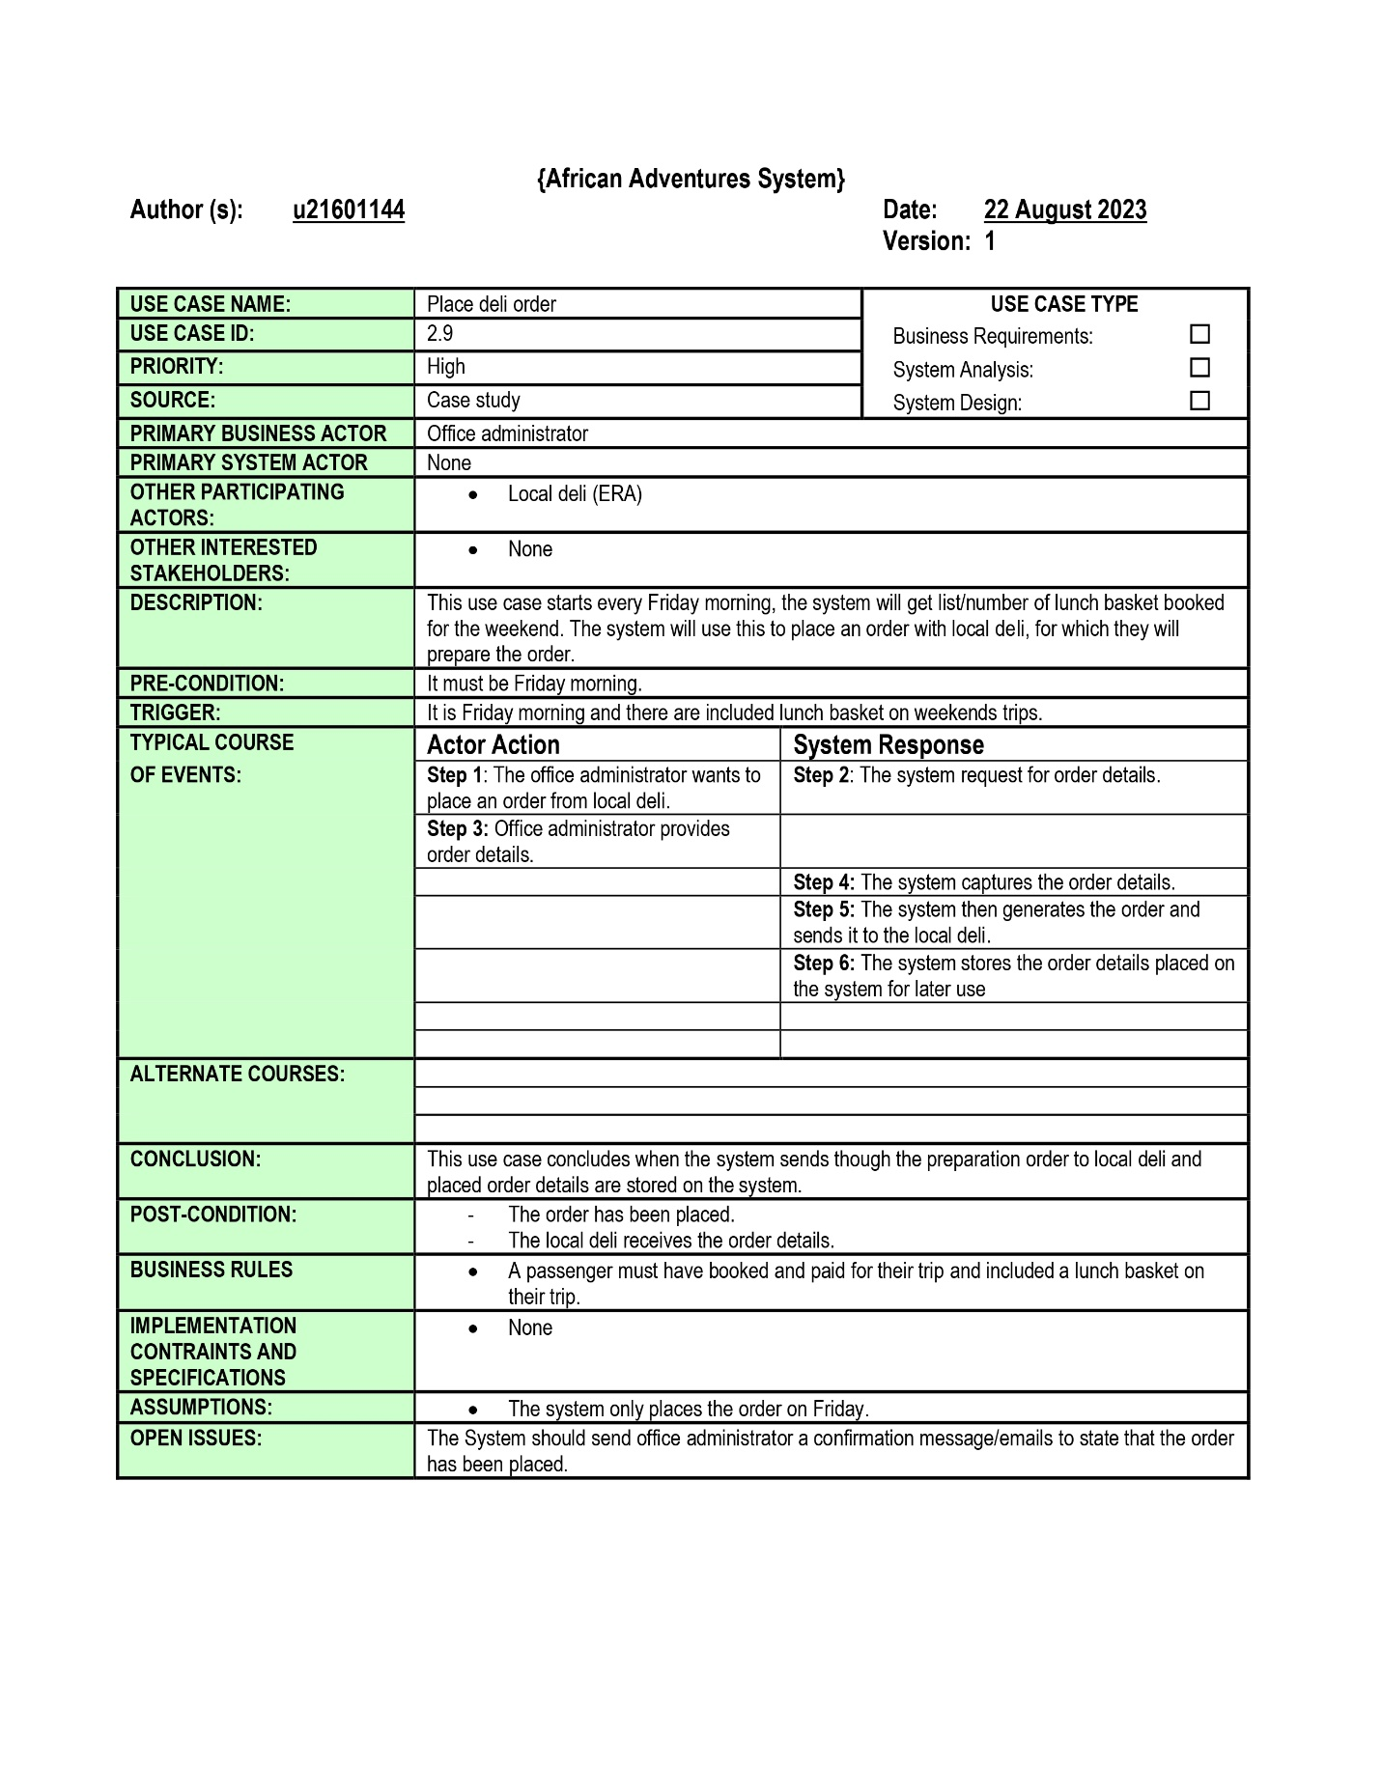

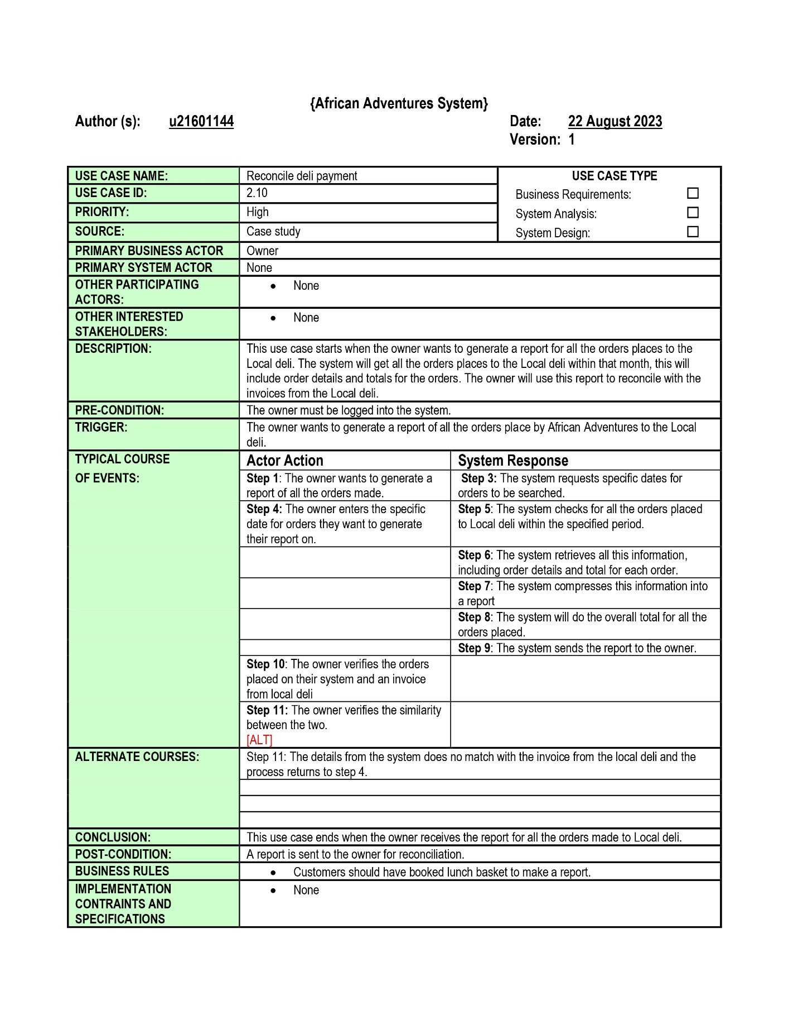

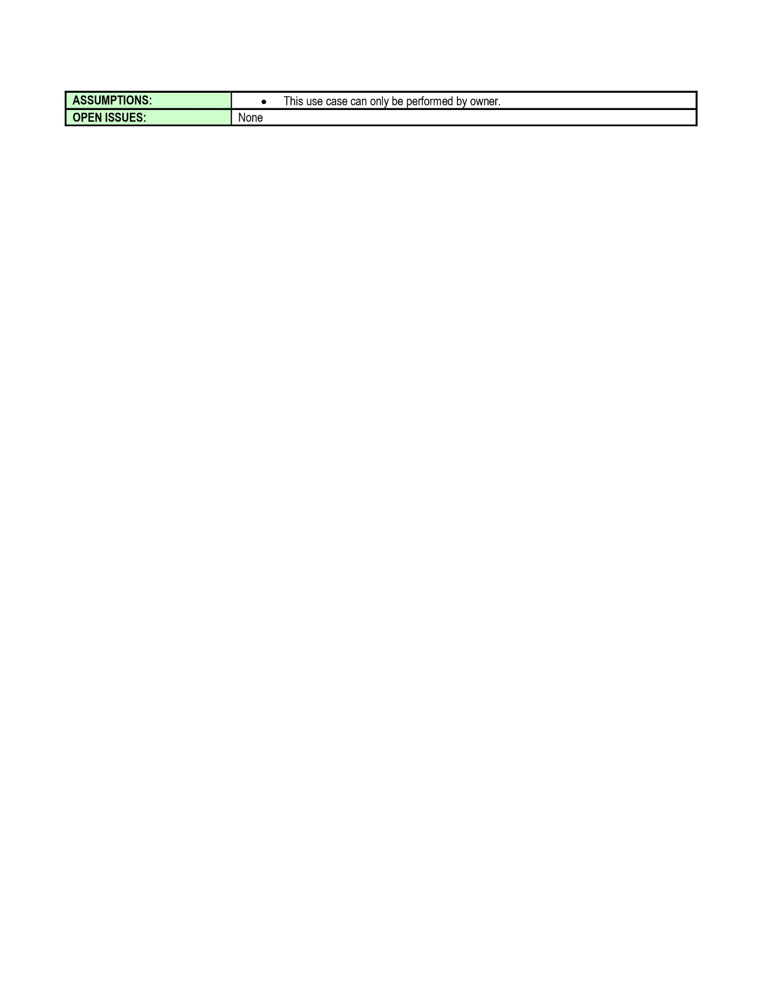

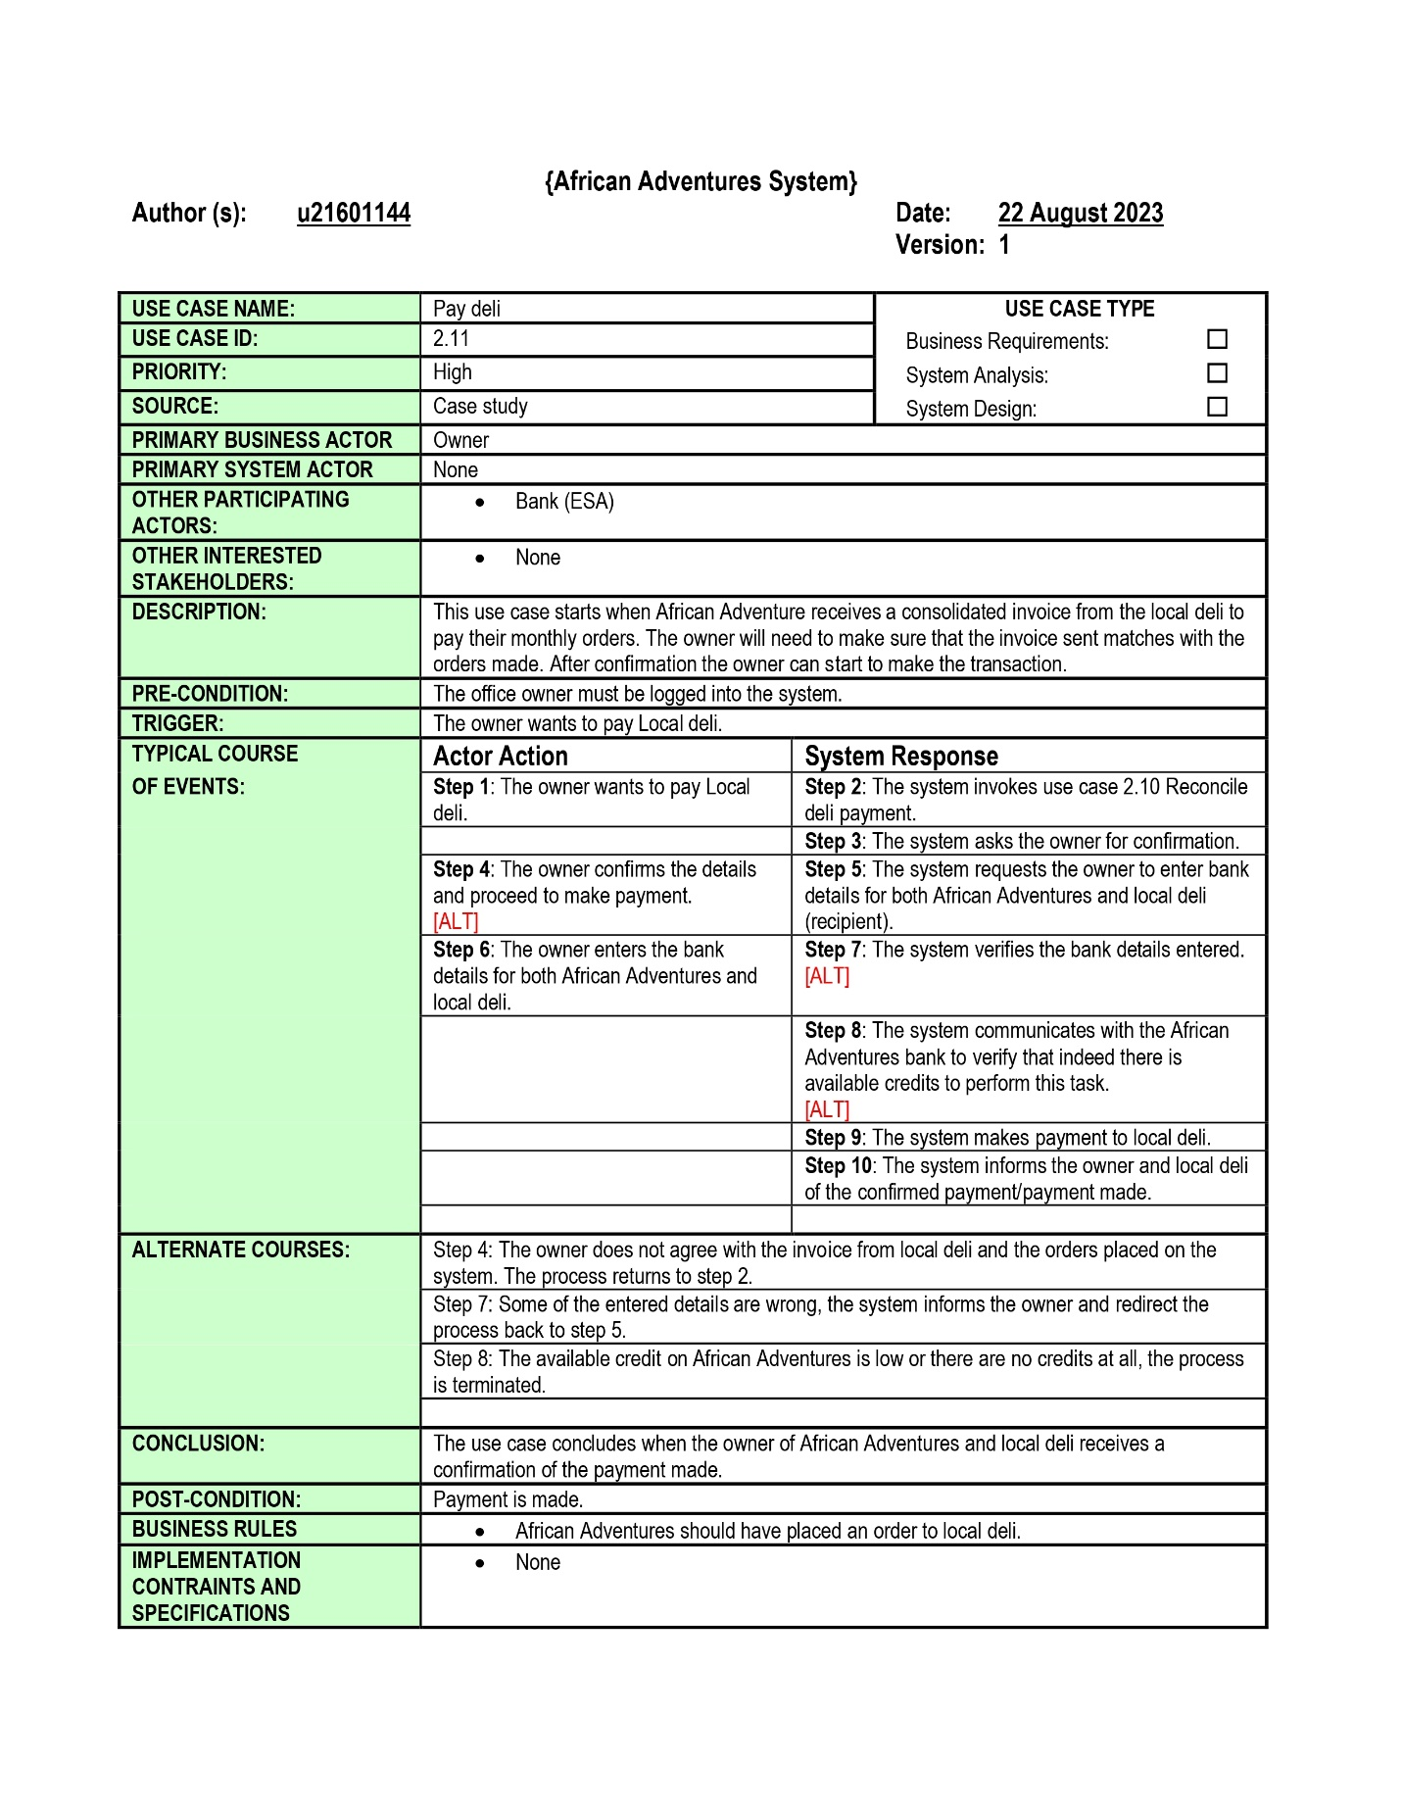

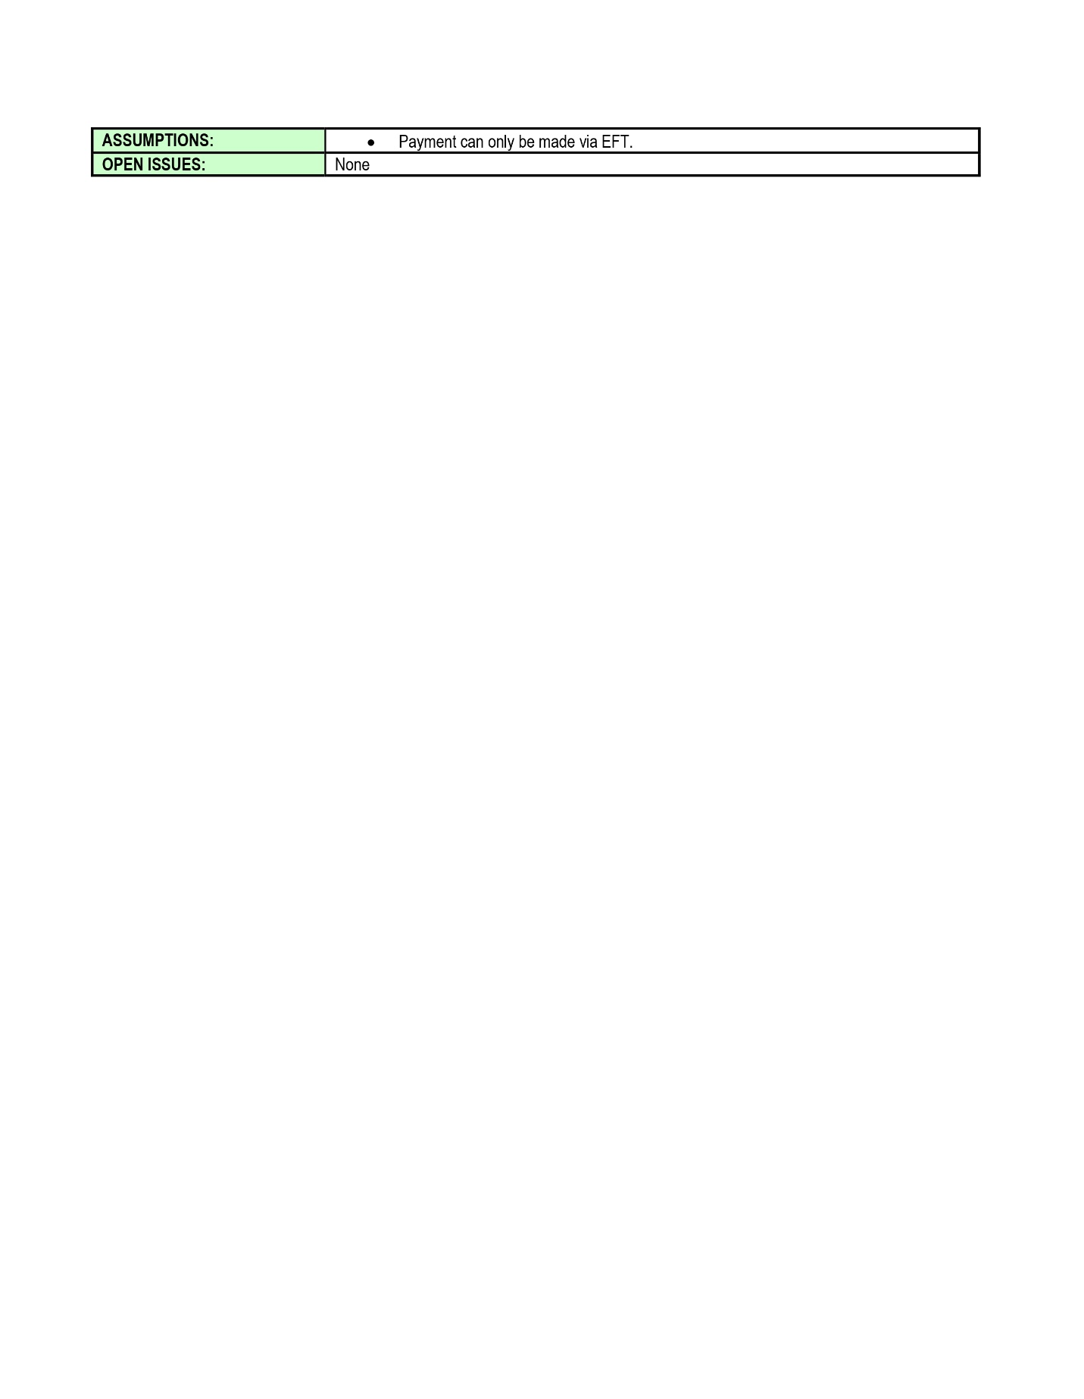

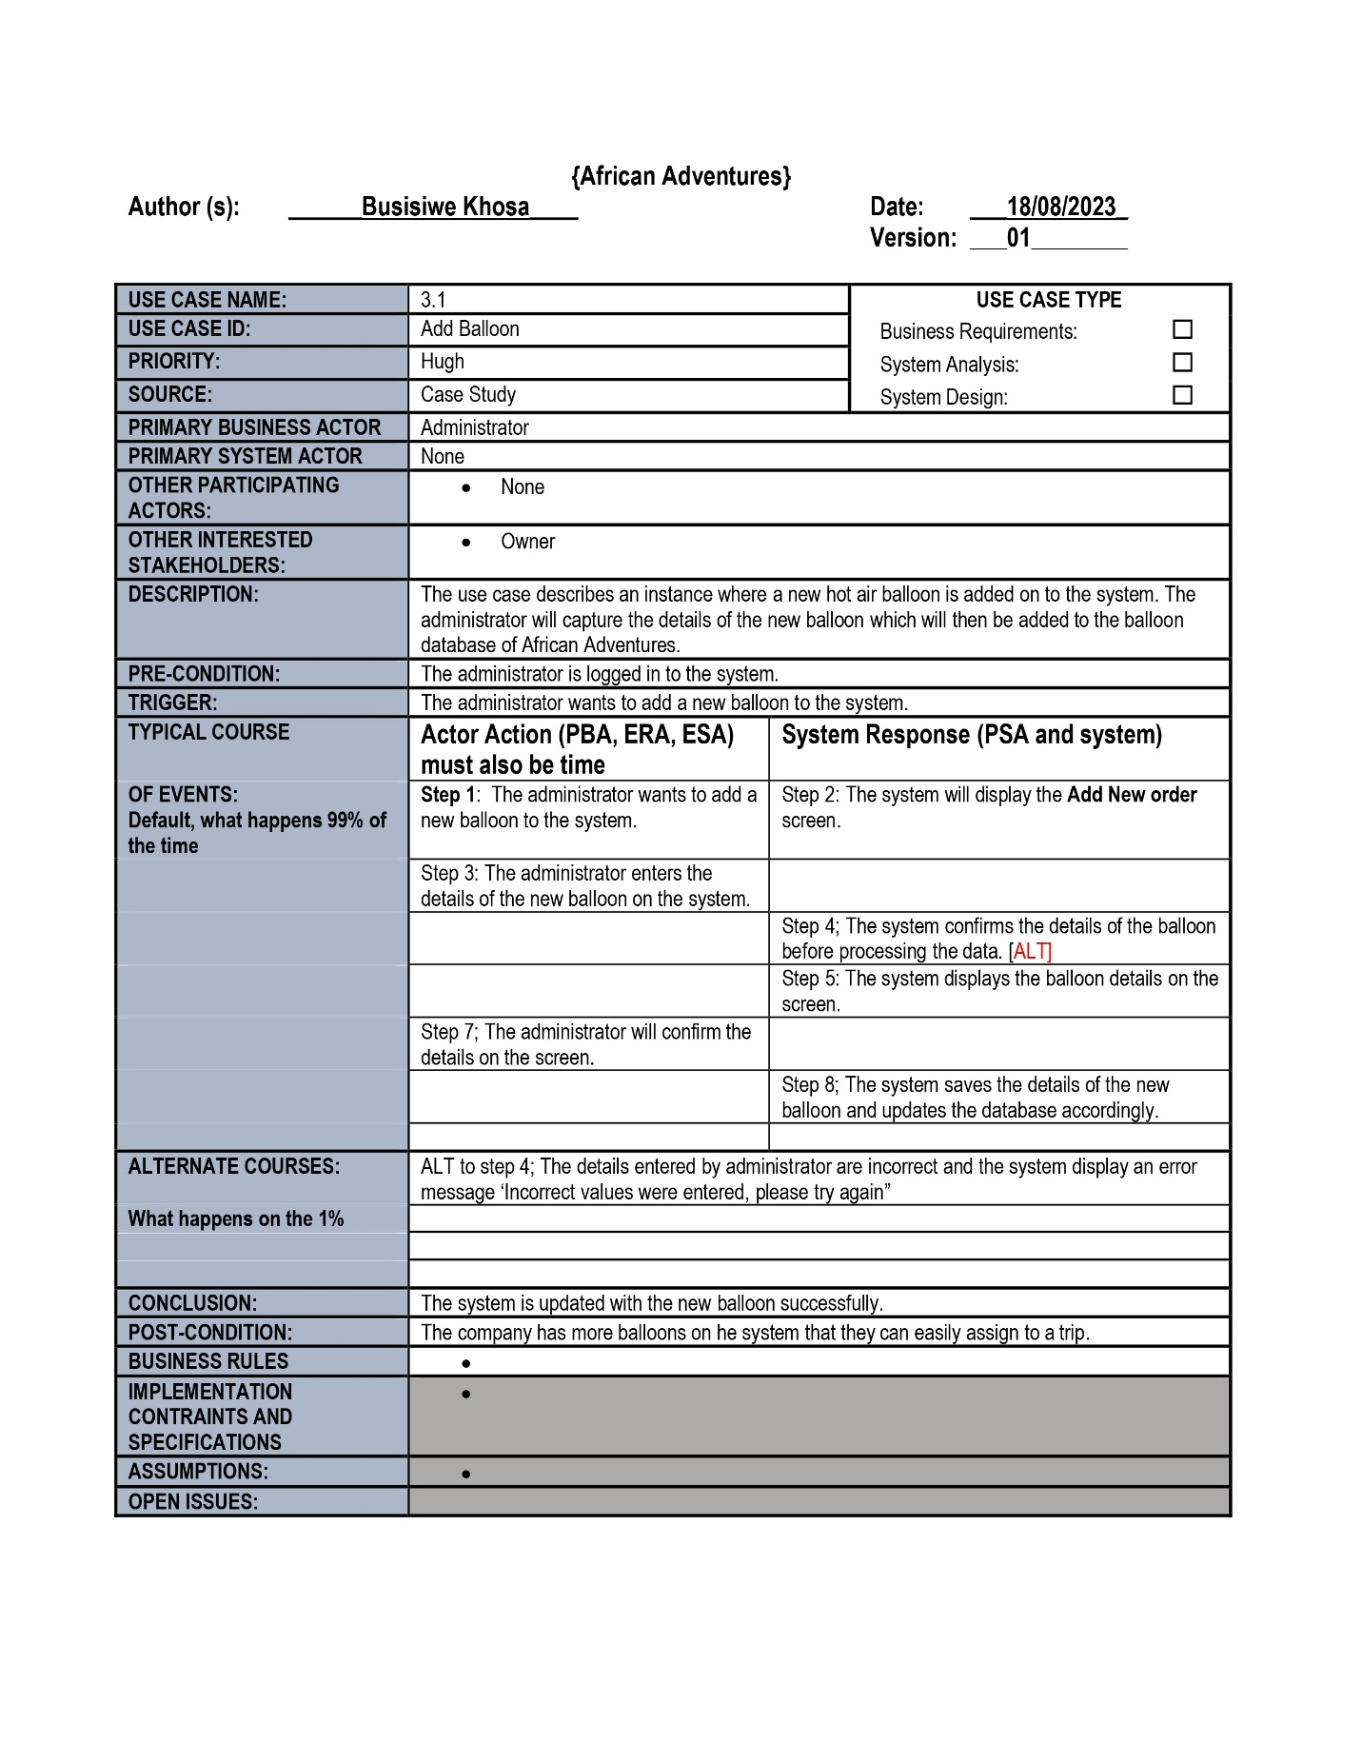

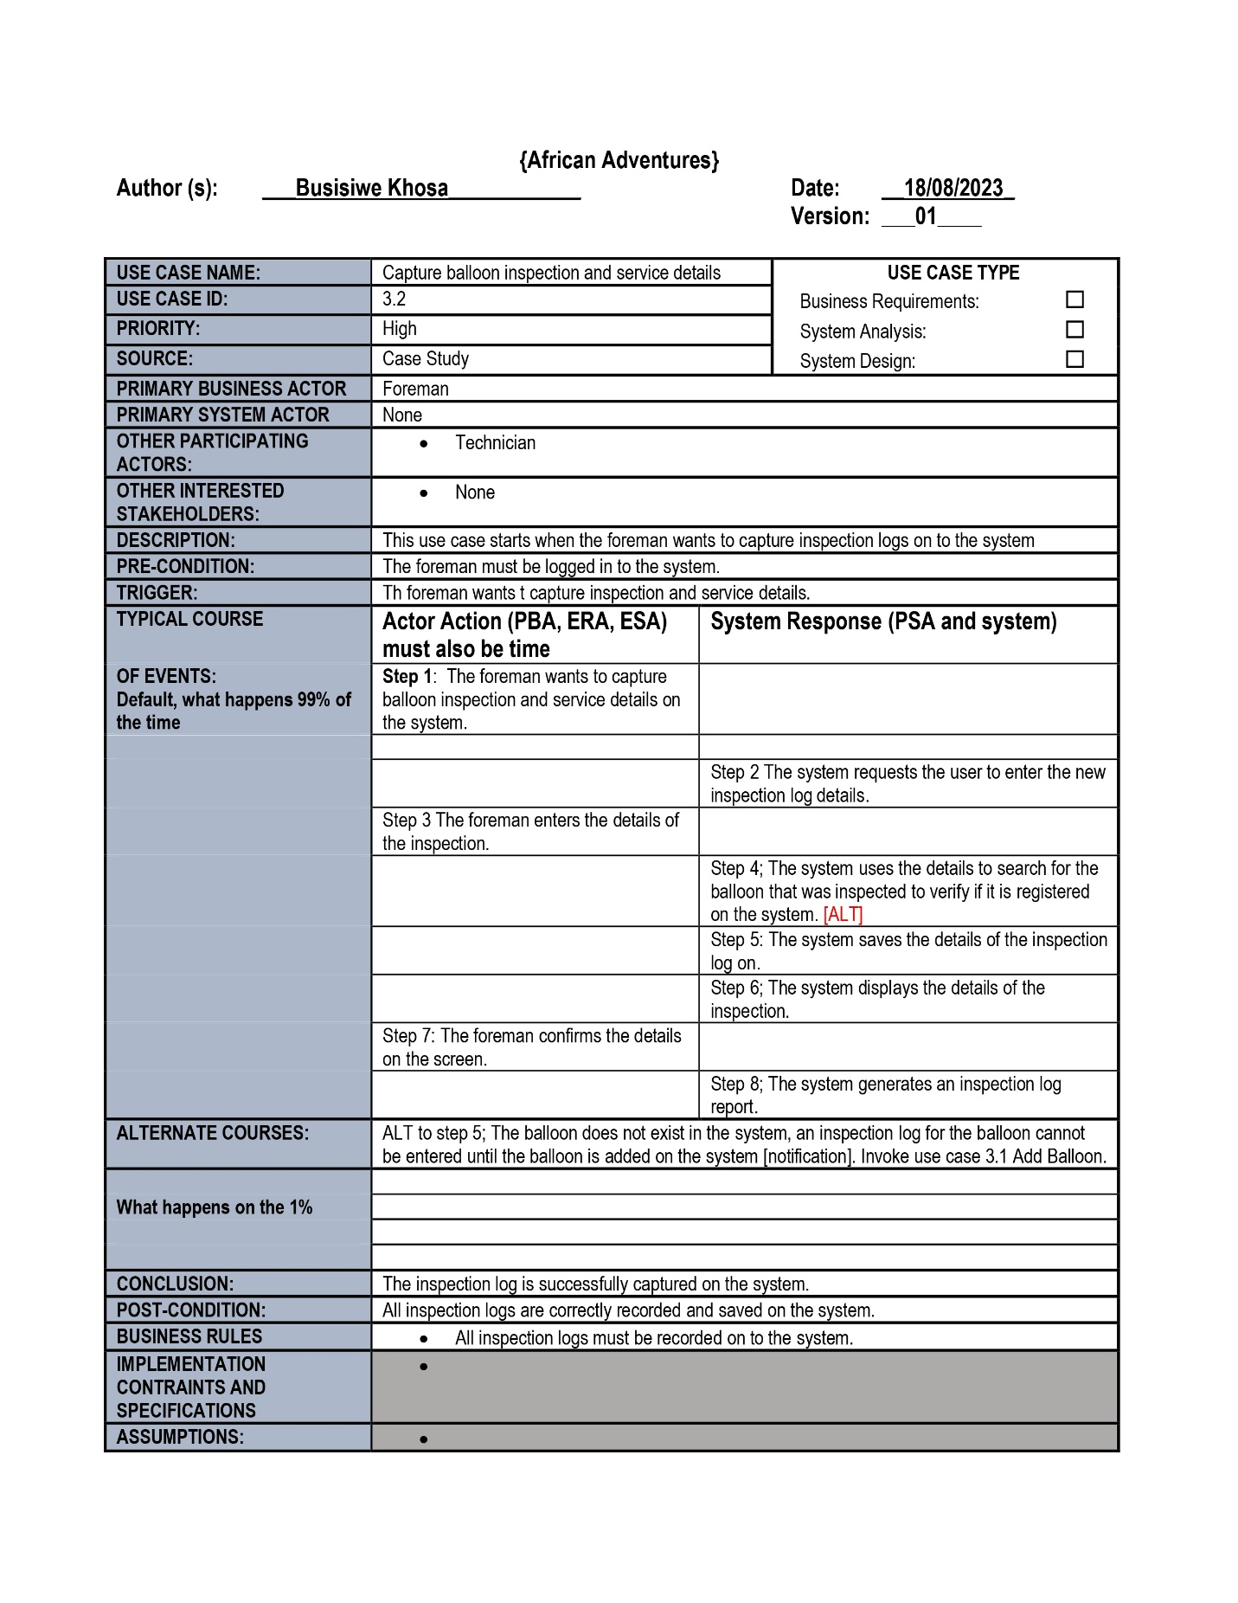

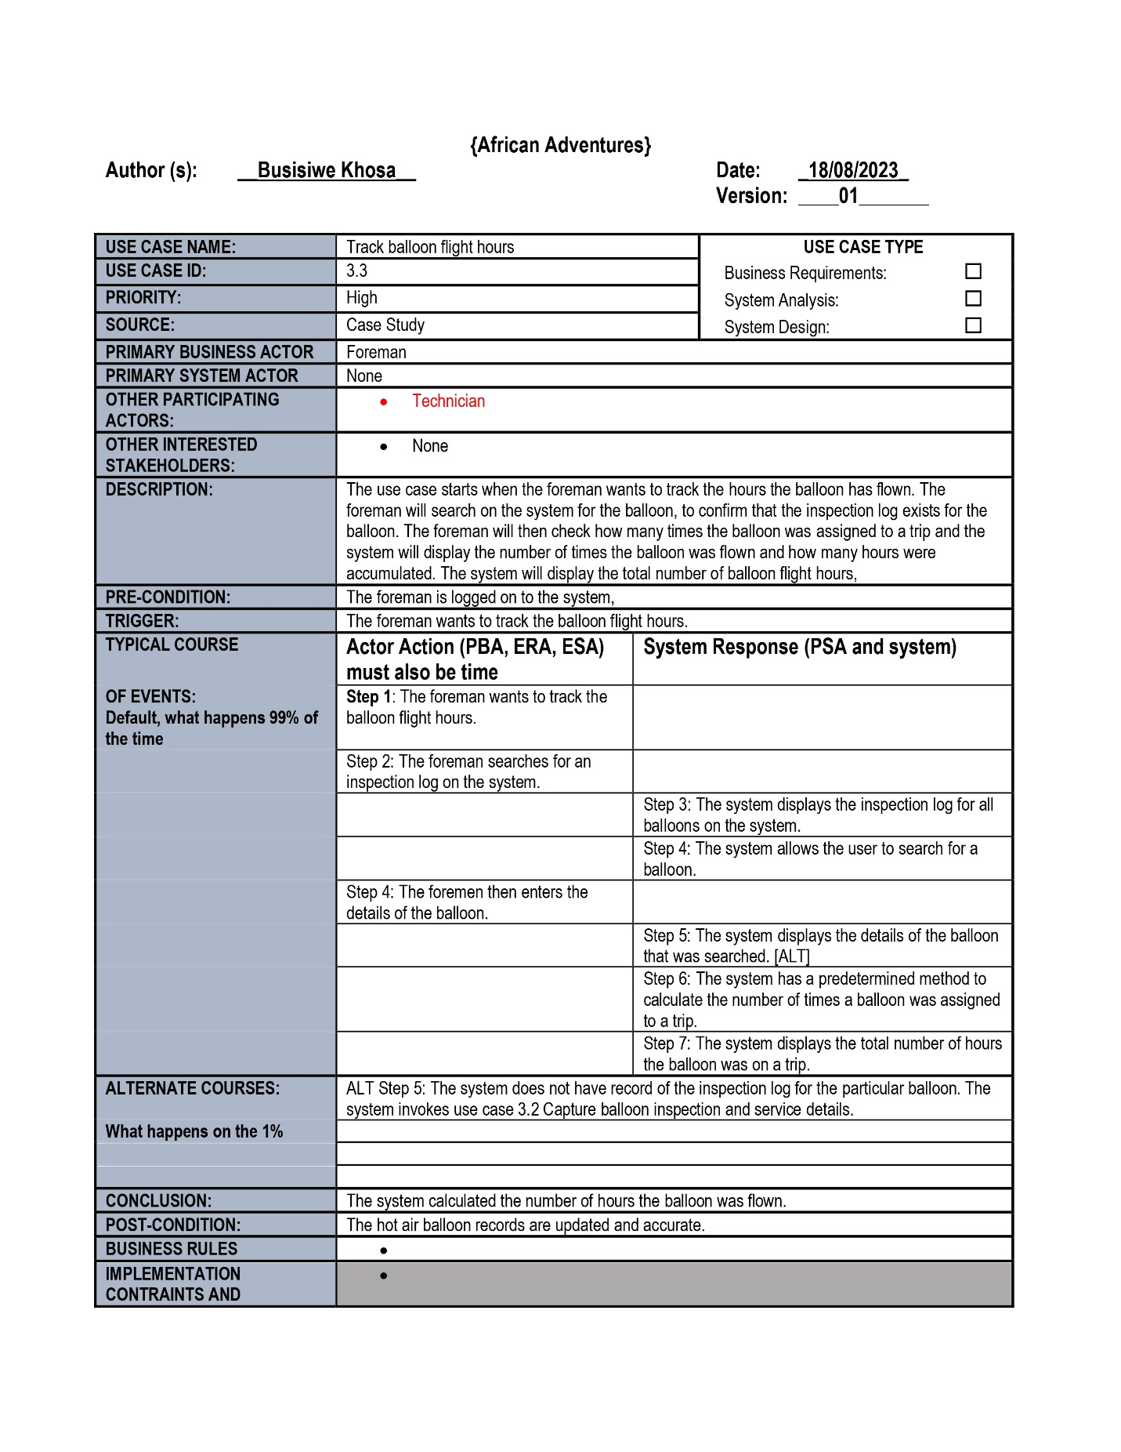

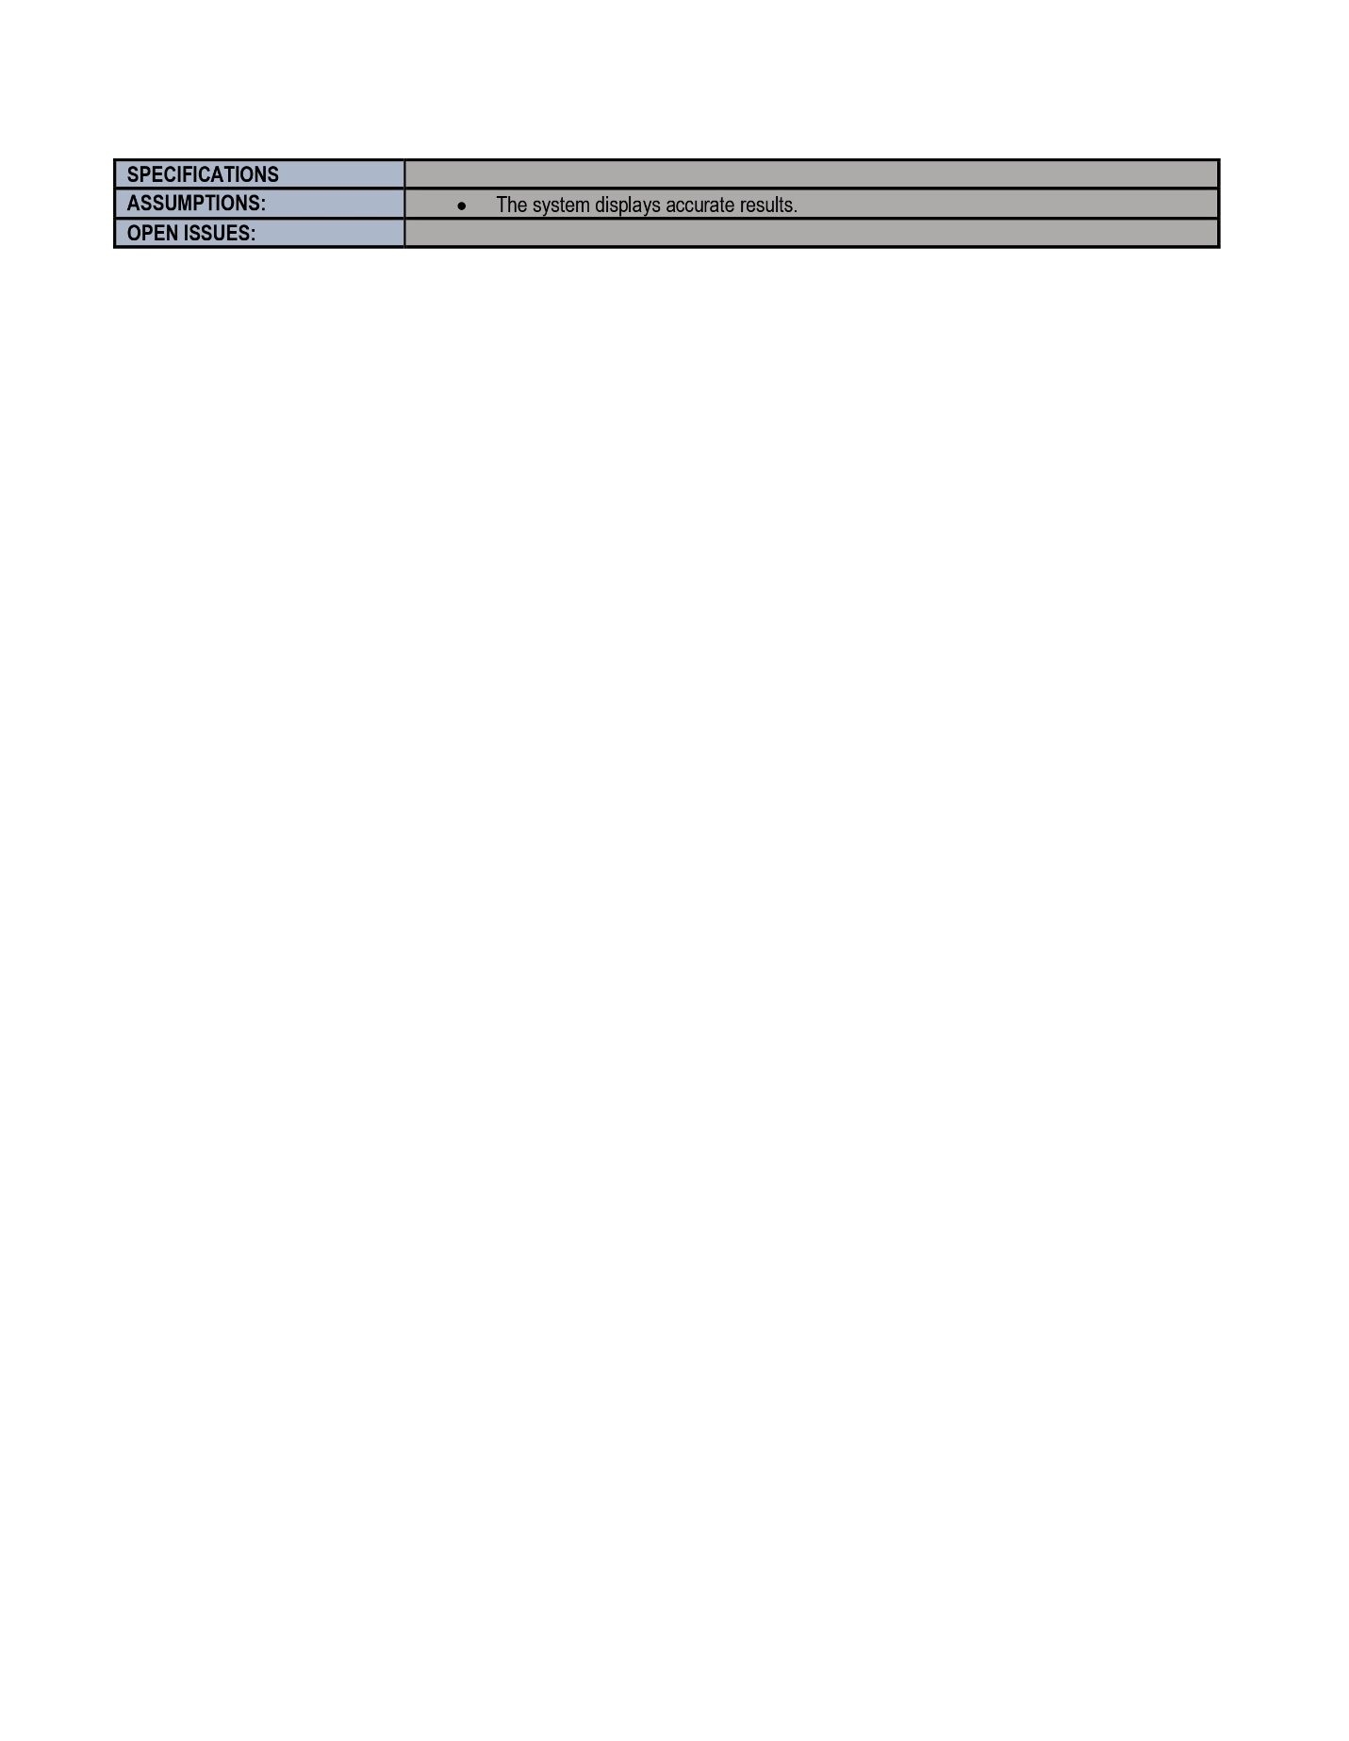

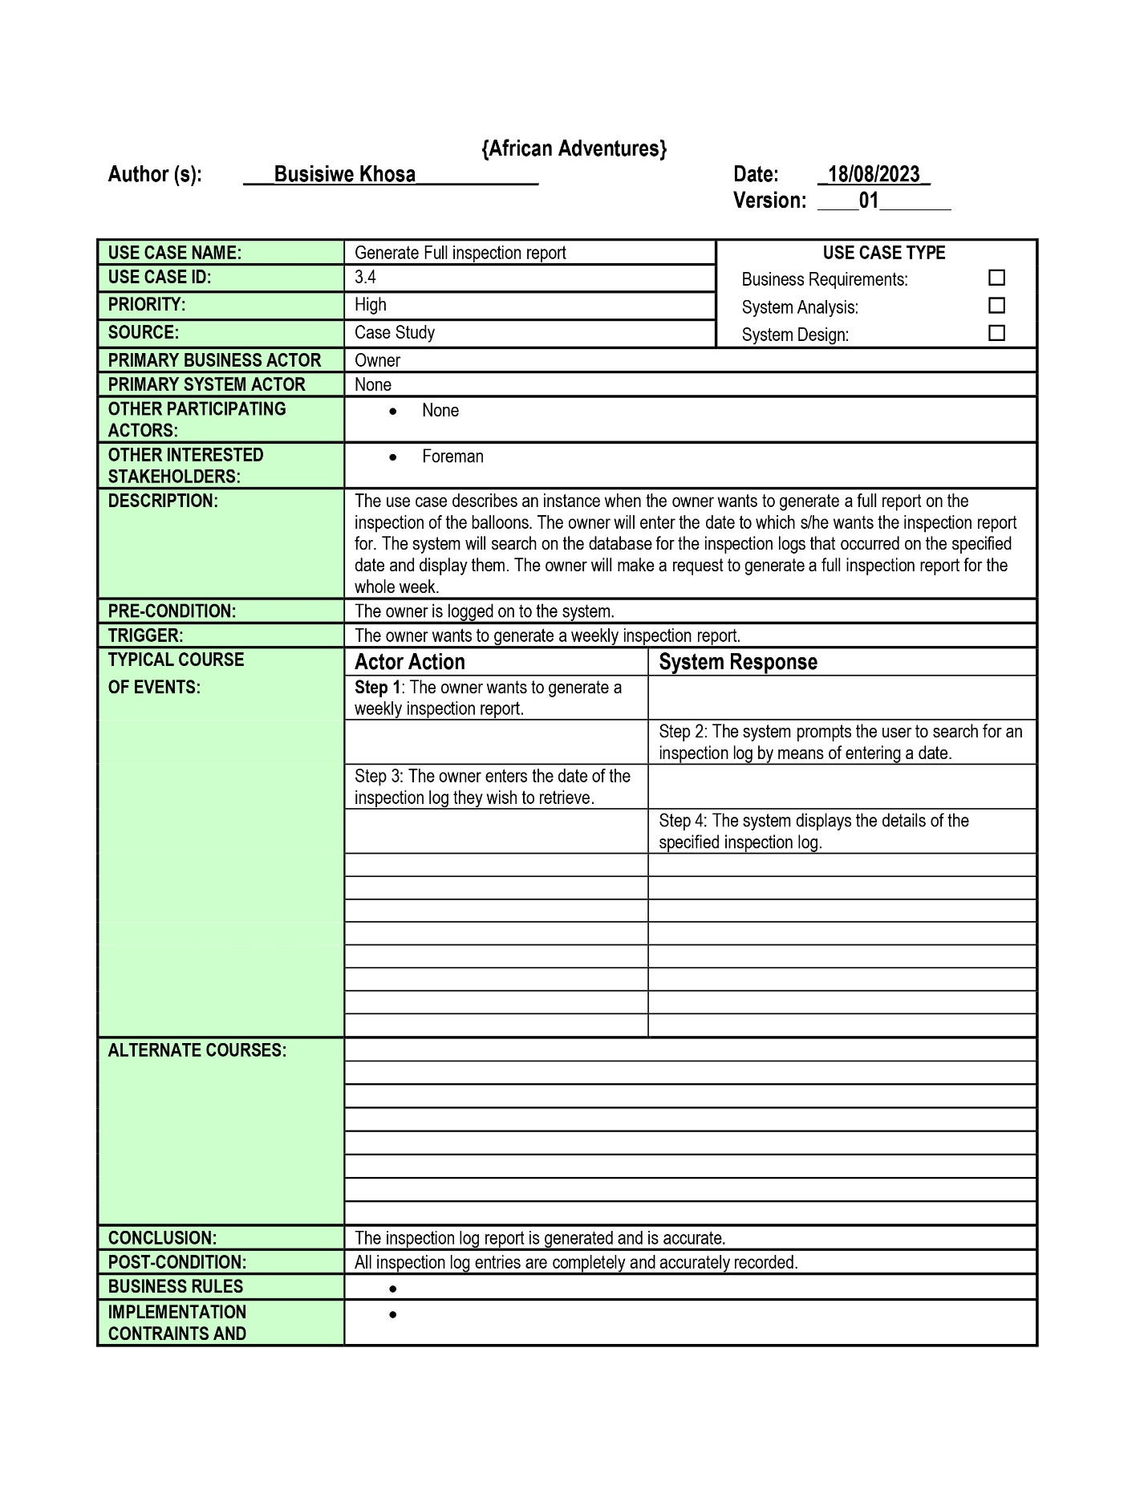

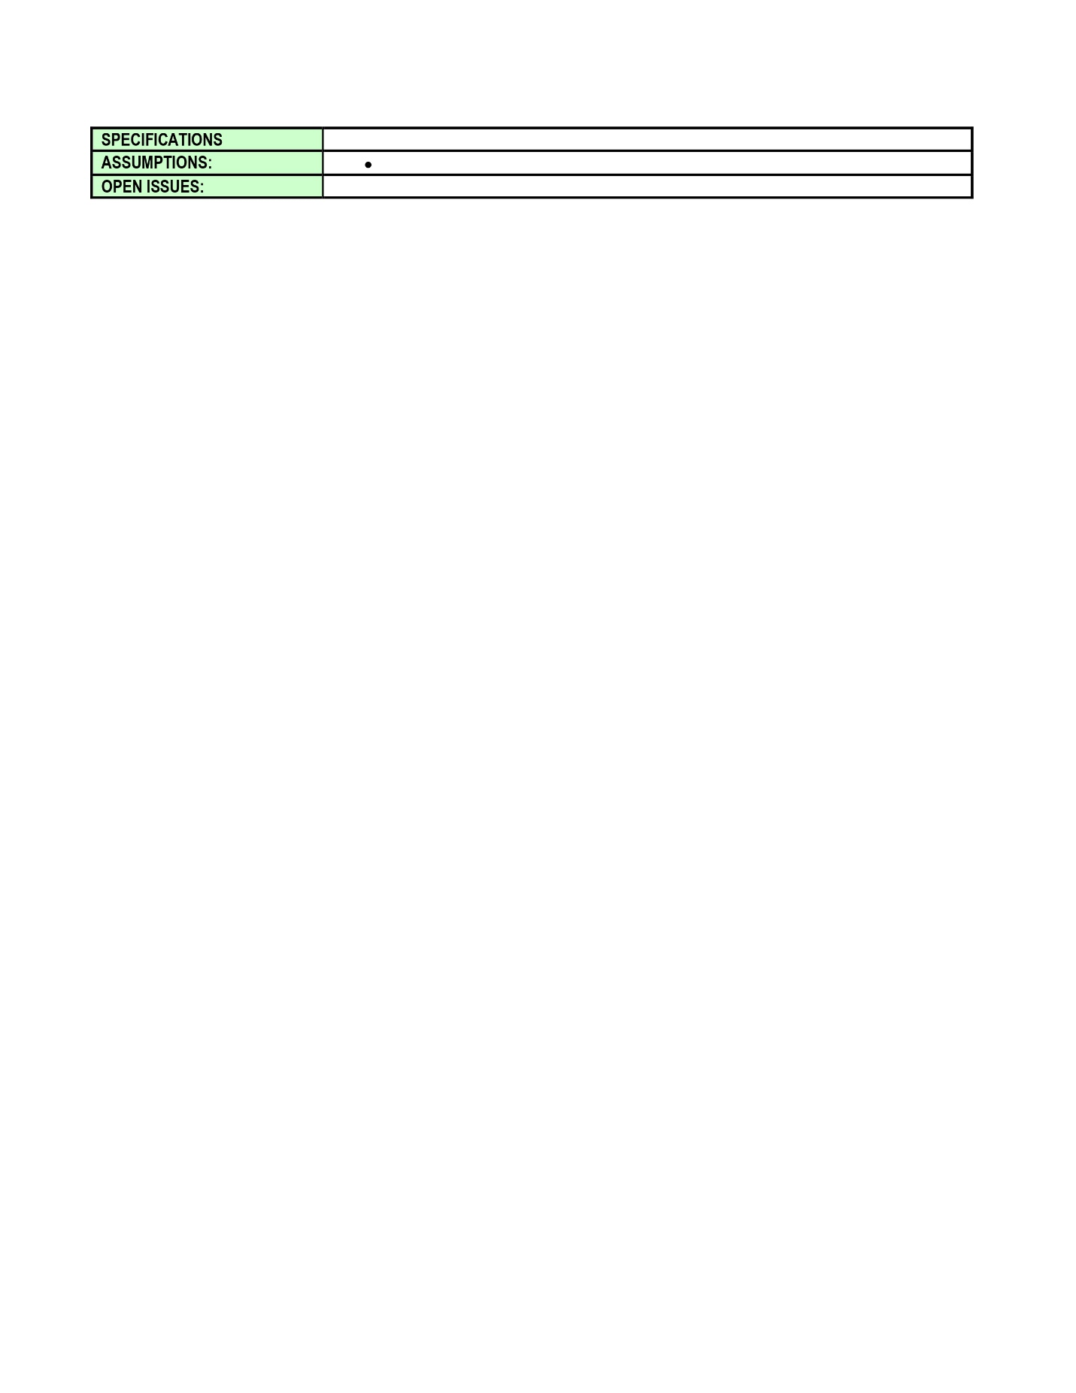

Conclusion

This section provided more details of the events that occurred in the system, where it showed the actors and how the interacted with the system.

3.Process Model of the new proposed system

3.1 Context diagram

Introduction

The focus here is to identify the flow of information between the system and external entities, this diagram serves as the big picture that shows how the system talks with the outside world. At this stage, we’re not delving into intricate details. Instead, we’re only focused information and instructions goes in and out of the system and how they connect to the outside world.



Conclusion

The context diagram for African Adventures gives us a big picture look at how the system interact with the outside world. This helps us to understand how information flow in and out of the system, which is important for understanding how the system works.

3.2 Functional decomposition diagram

Introduction

African Adventures functional decomposition serve as visual representation that breaks the system into its functional components, it provides a structured overview of how different functions within the business work amongst each other to achieve a goal.

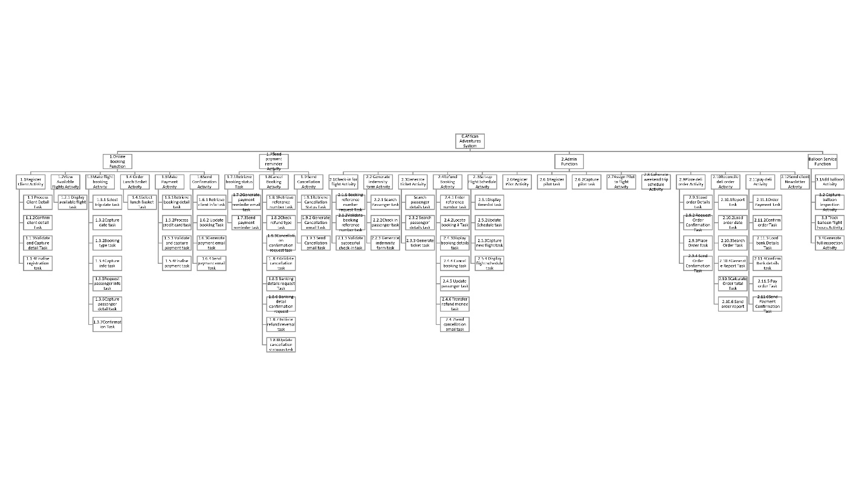

Conclusion

Functional decomposition provides us with valuable insight into inner working of African Adventures. By breaking the system into smaller parts, we gain a better understanding of how each part contribute to the overall operation.

3.3 High level

Introduction

At high level for our functional decomposition for African Adventure, we provide a clear overview of the business and it key functions as well as its operations. This helps stakeholders to know their main operating area and how they interconnect.

1. Online booking function

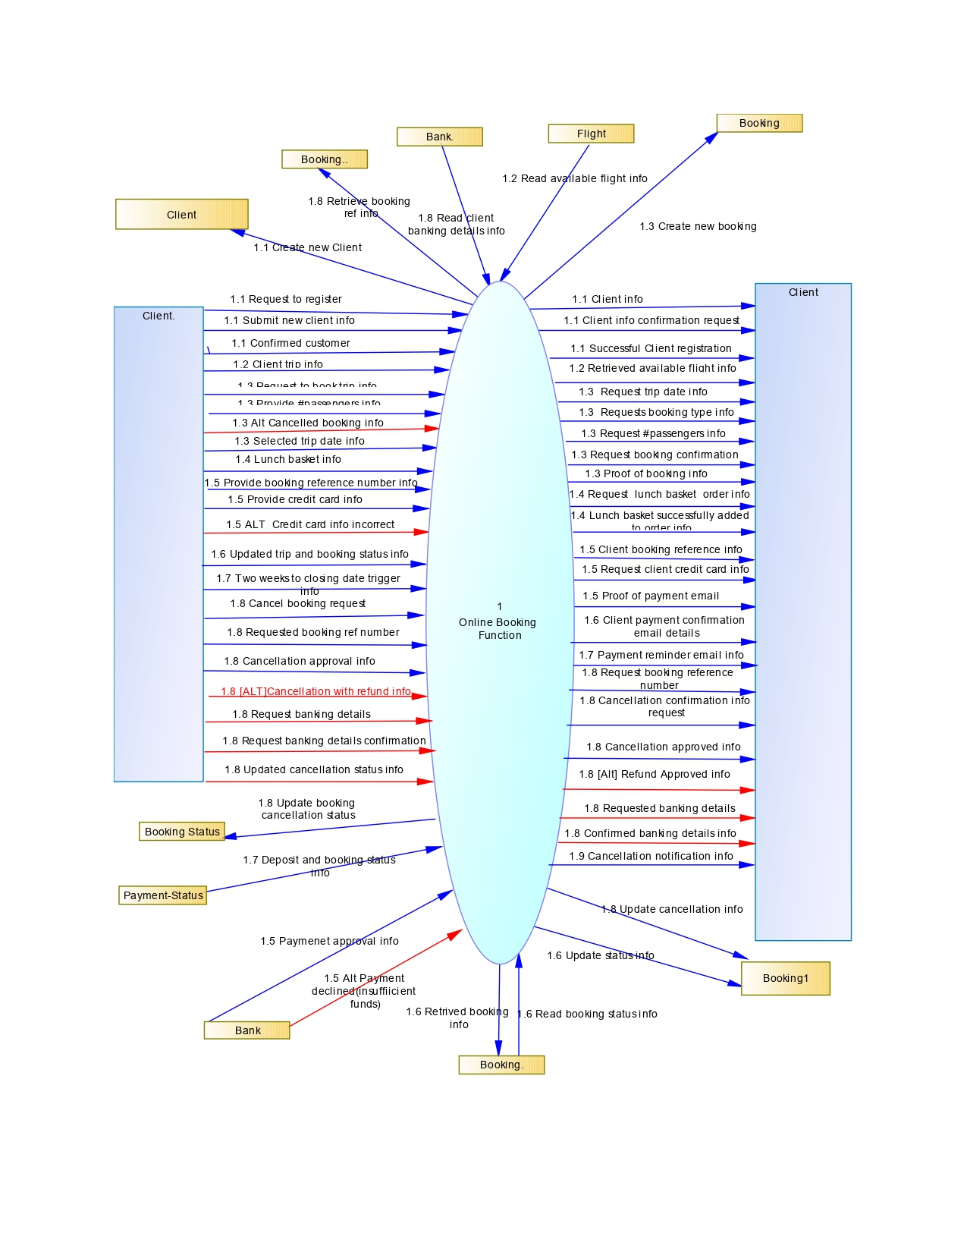

1. Admin function

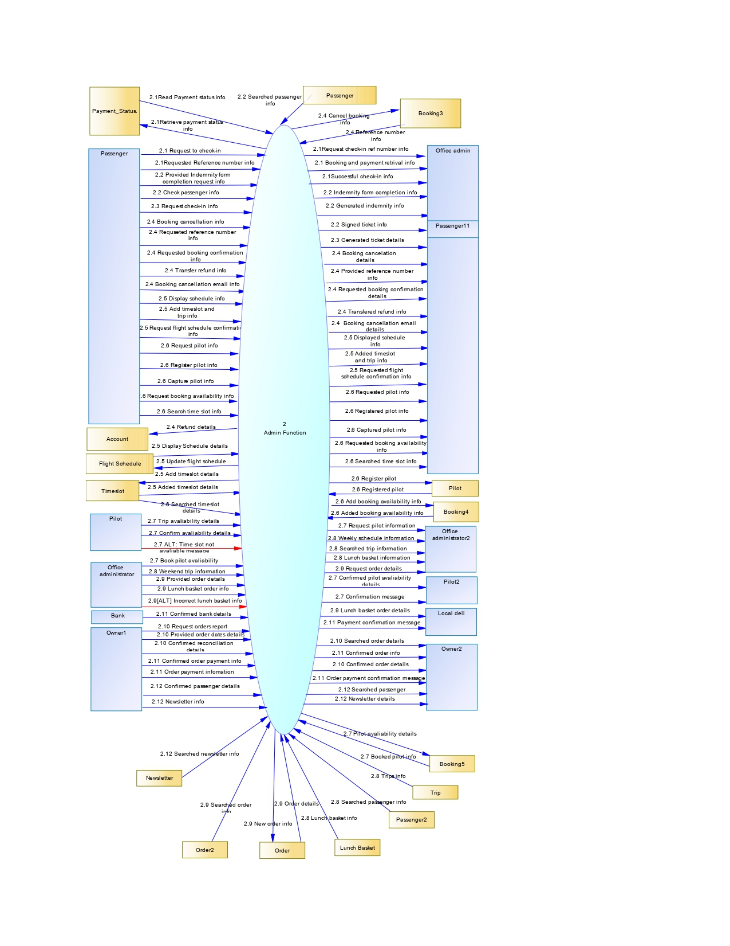

1. Balloon service function

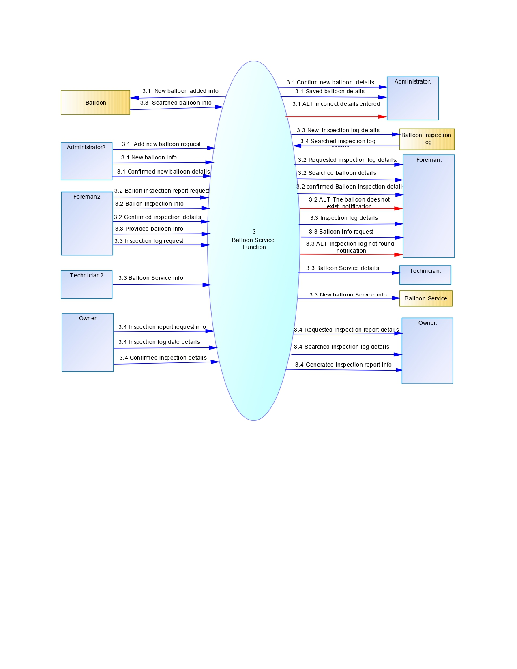

Conclusion

The high-level view of our functional decomposition diagram provides an essential starting point for understanding African Adventures’ overall structure and key functions.

Middle level

Introduction

Moving into middle level, we dive deeper into specific functions within African Adventures. We start breaking down the high-level functions into more detailed components.

* 1. Register client activity.

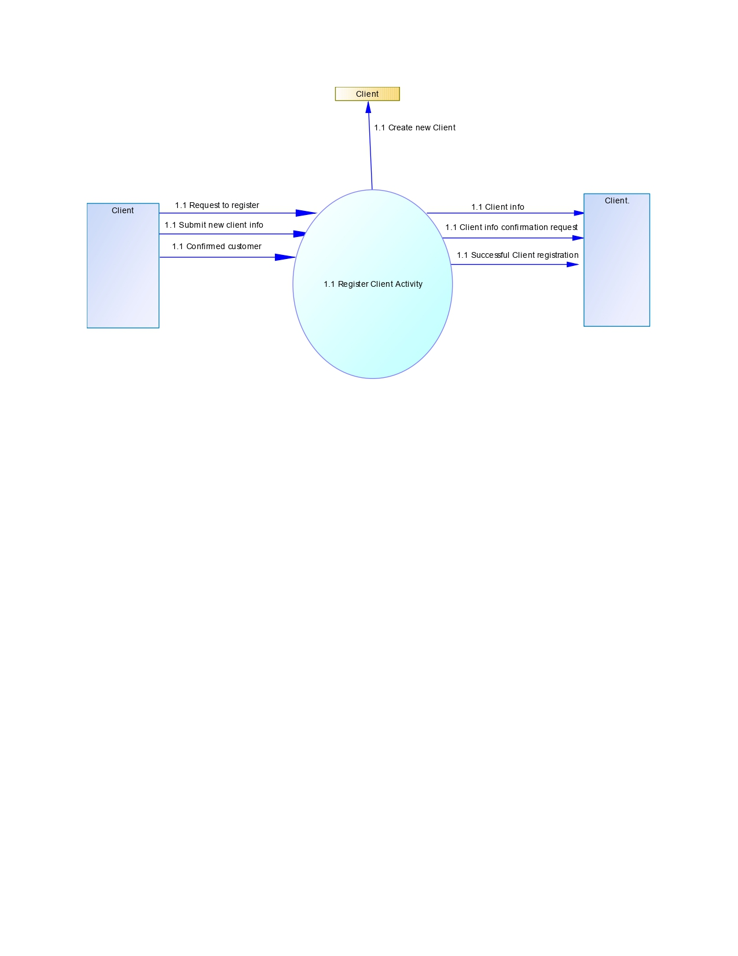

* 1. View available flights & 1.3 Make flight booking activity.

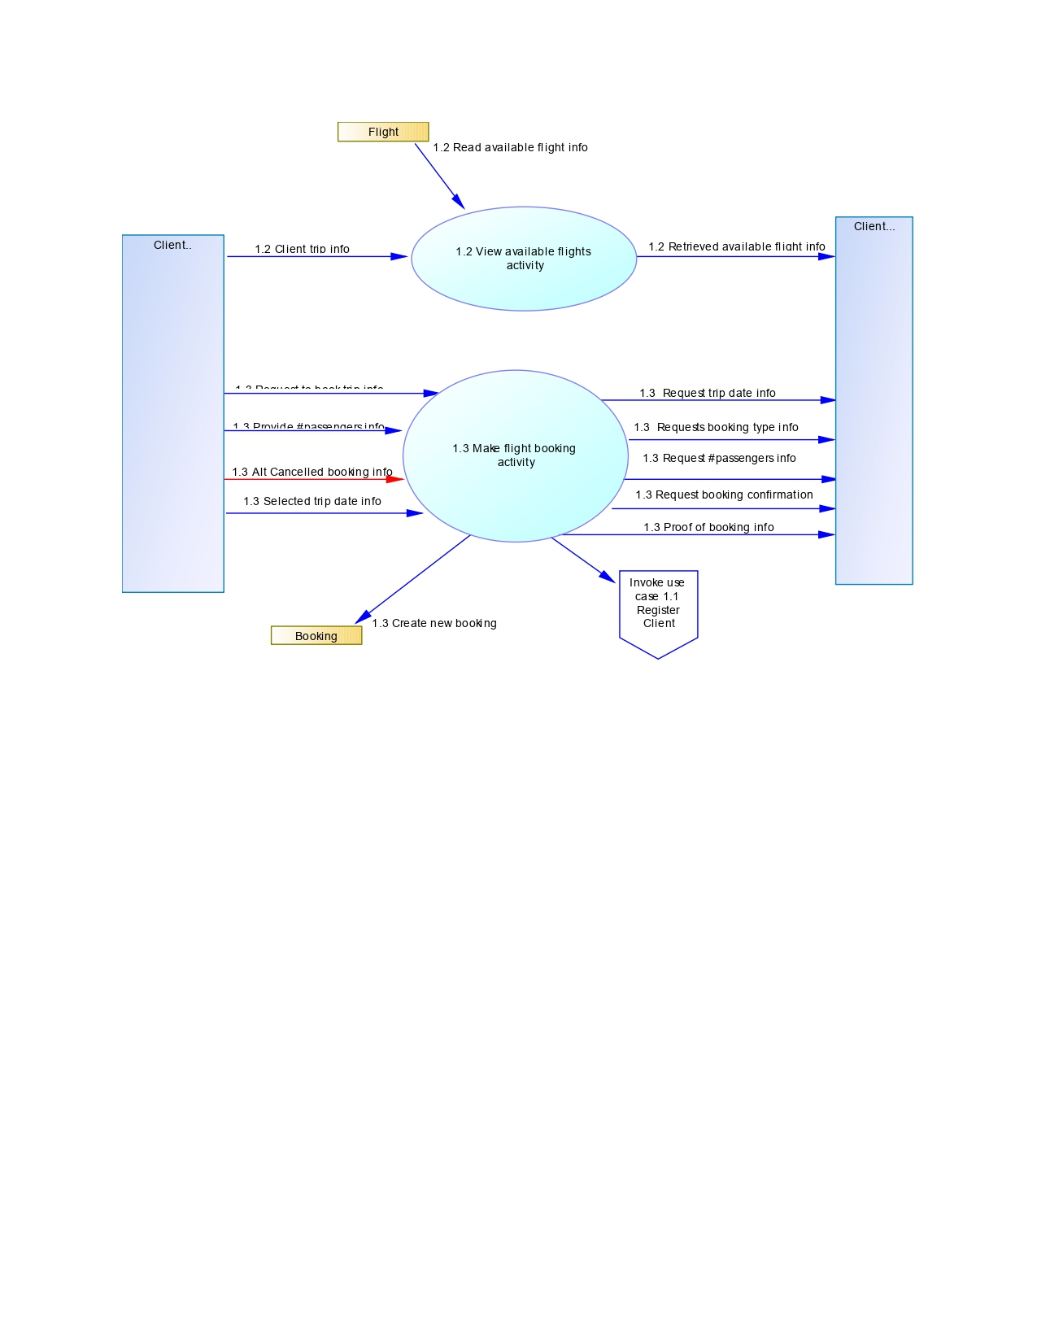

* 1. Order lunch basket & 1.5 Make payment activity.

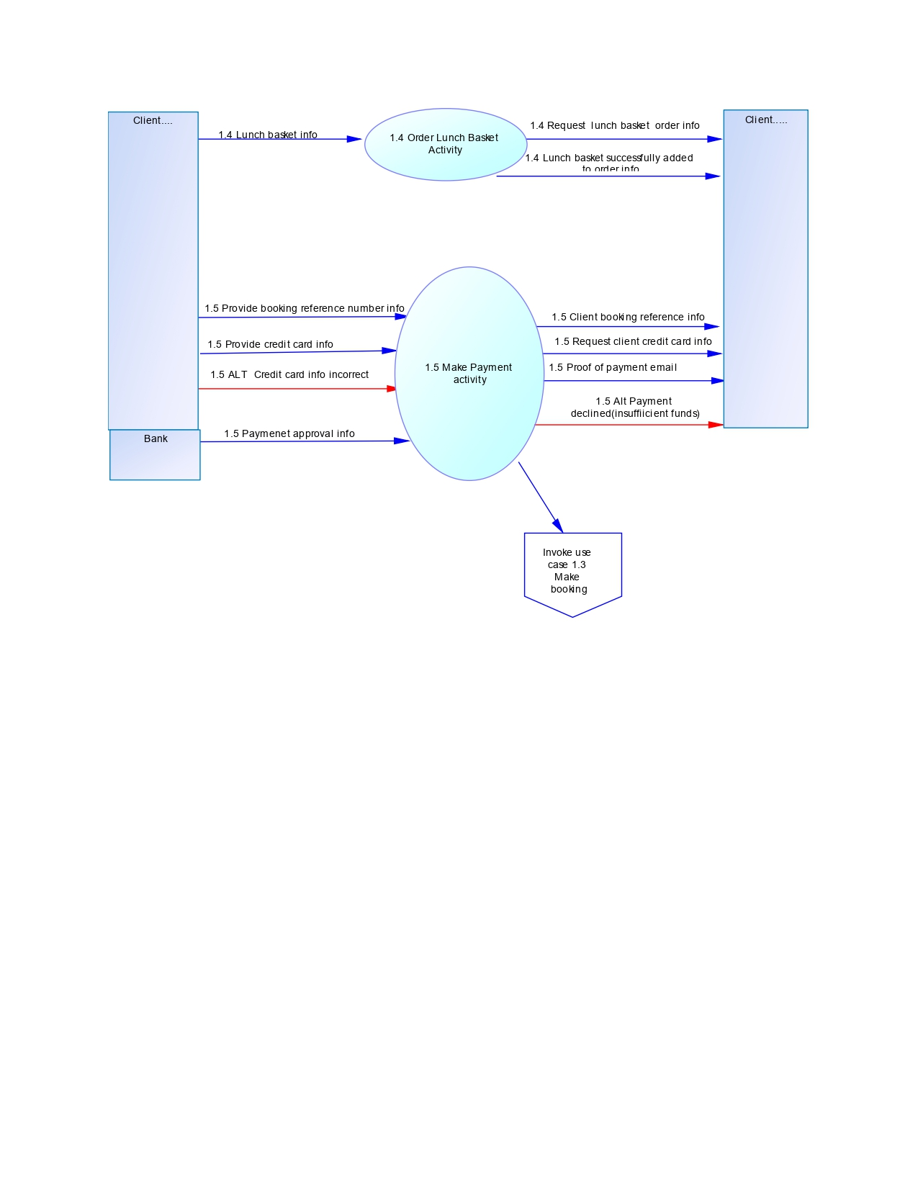

1.6 Send payment confirmation & 1.7 Send payment reminder activity.

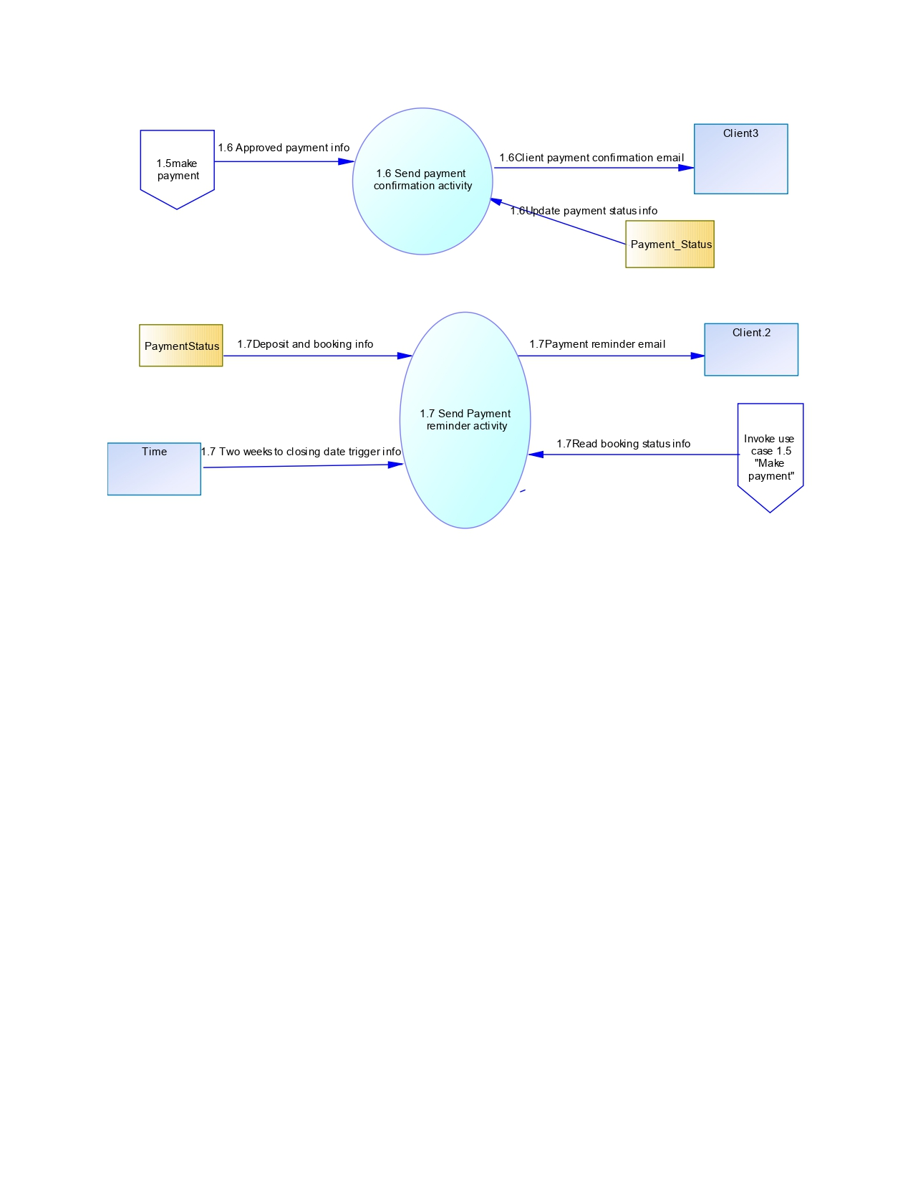

1.8 Cancel booking & 1.9 Send cancellation notification activity.

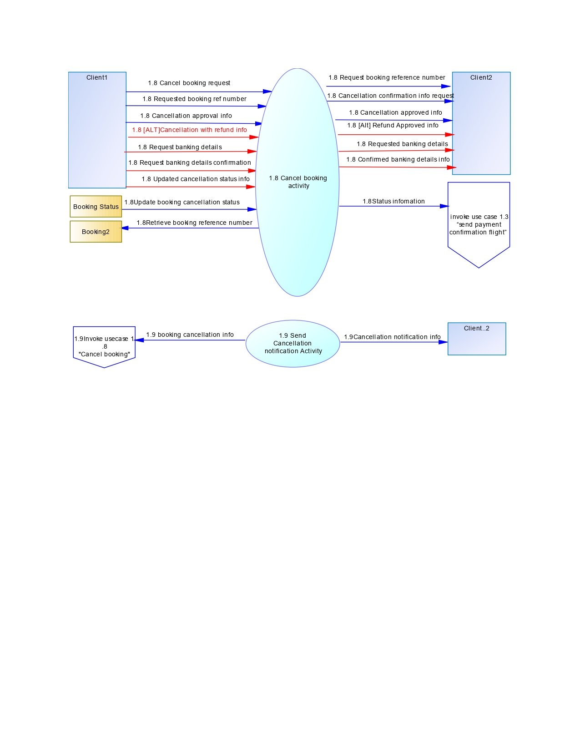

2.1 Check-in for flight activity.

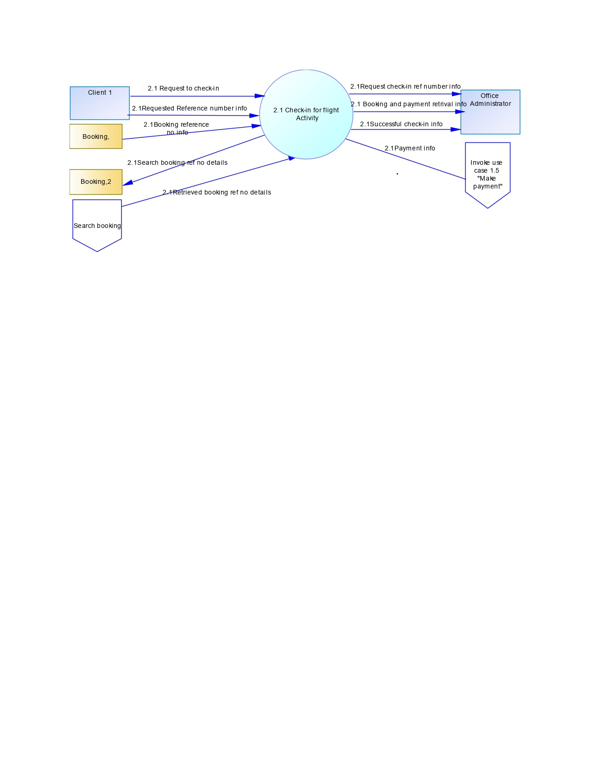

2.2 Generate passenger indemnity form & 2.3 Generate ticket activity.

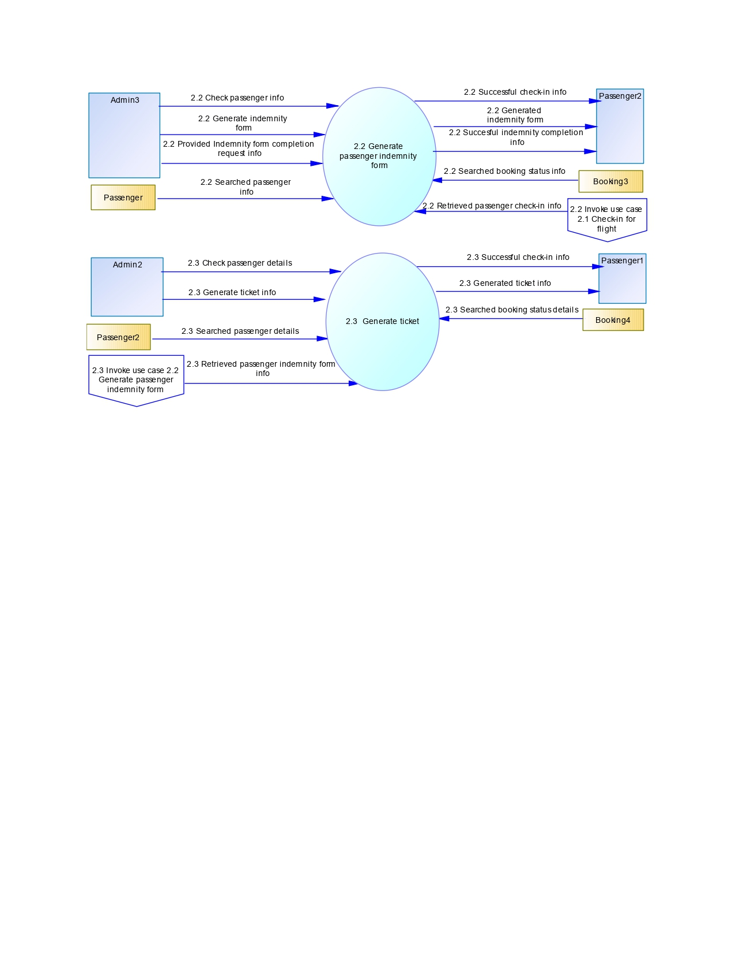

2.4 Refund booking & 2.5 Set-up flight schedule activity.

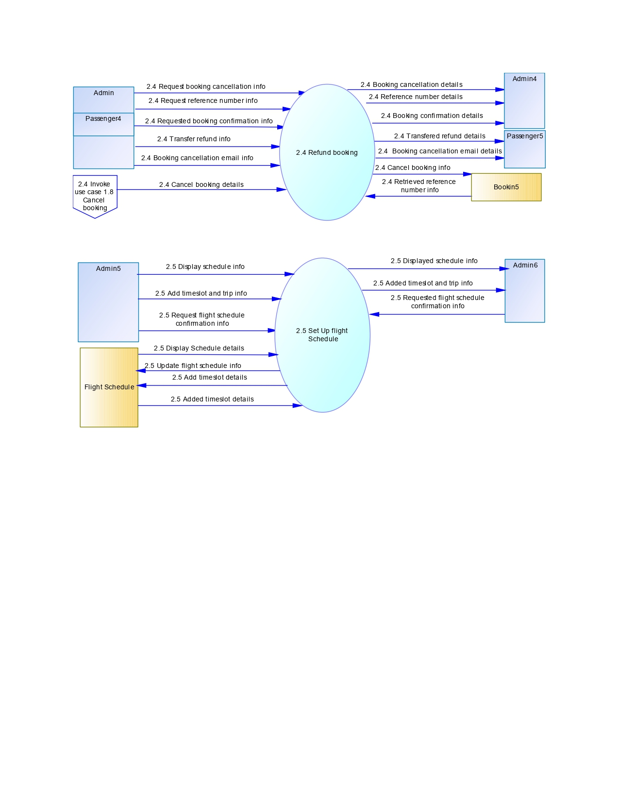

2.6 Register client, 2.7 Assign pilot to flight & 2.8 Generate weekend trip schedule activity.

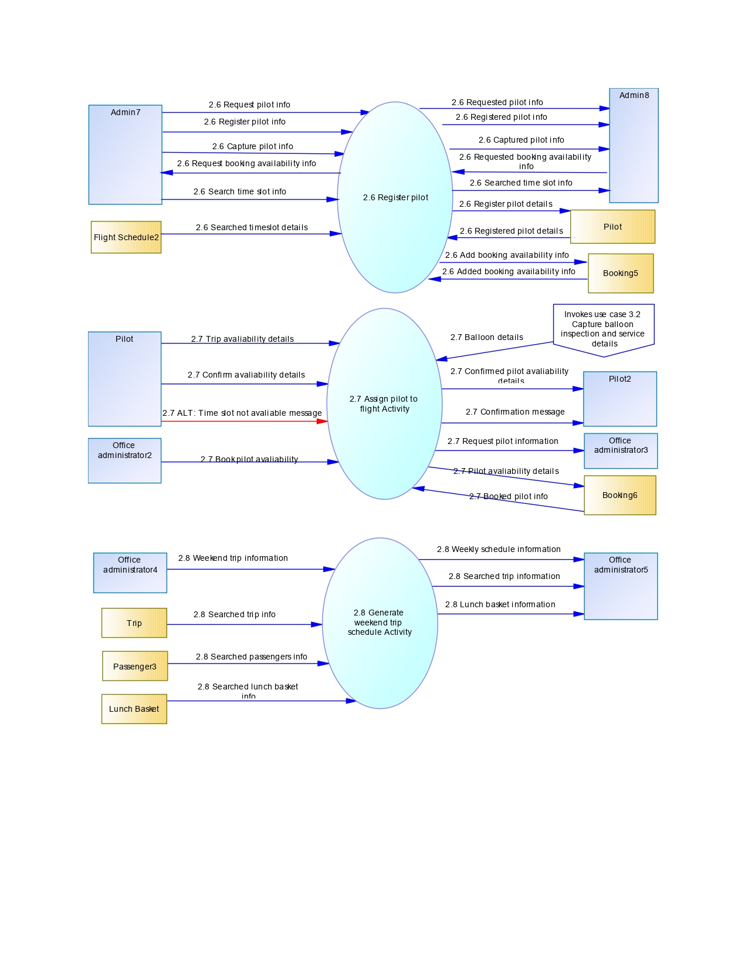

2.9 Pay deli order, 2.10 Reconcile deli payment & 2.11 Pay deli activity.

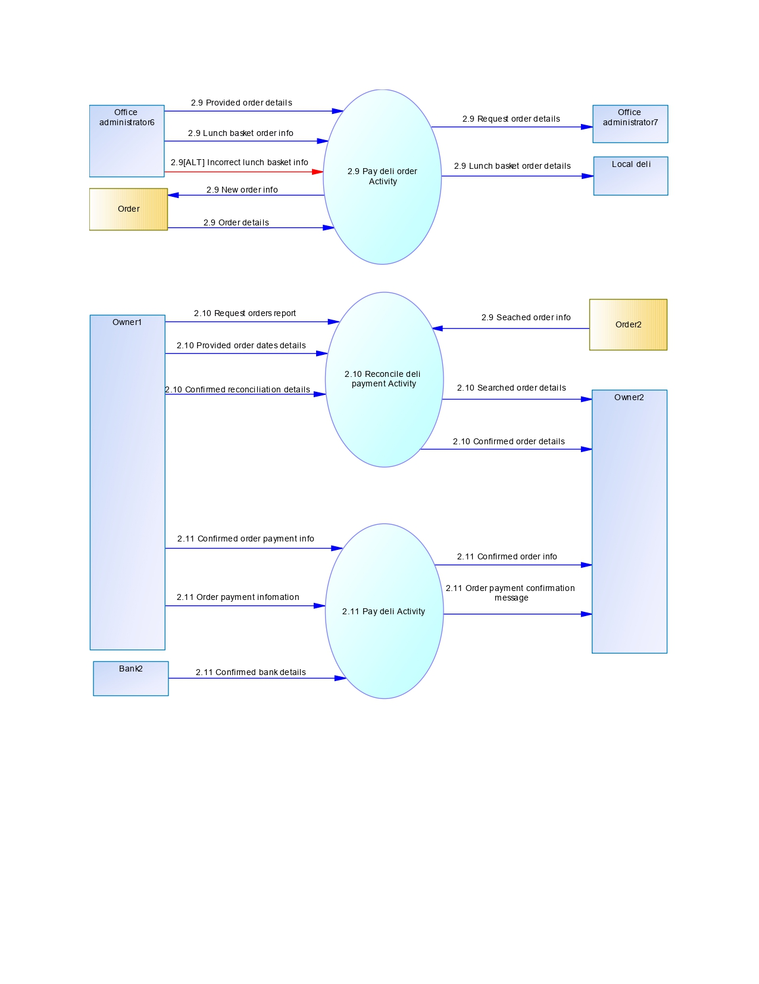

2.12 Send client newsletters, 3.1 Add balloon & 3.2 Capture balloon inspection and service details activity.

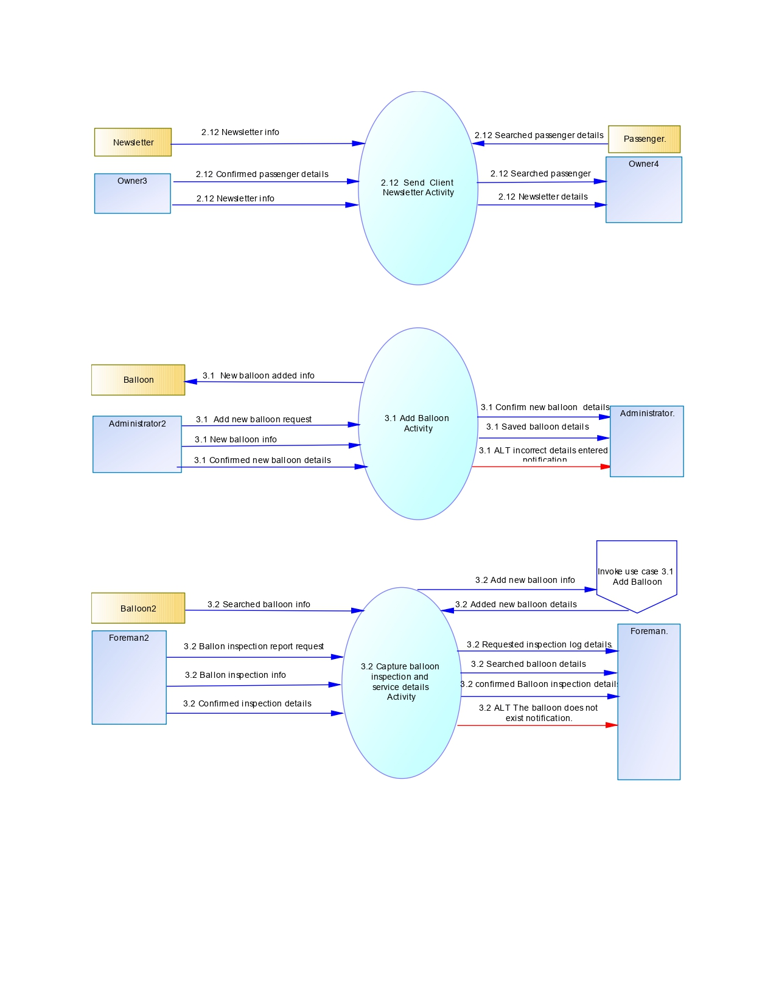

* 1. Track balloon flight hours & 3.4 Generate full inspection report activity.

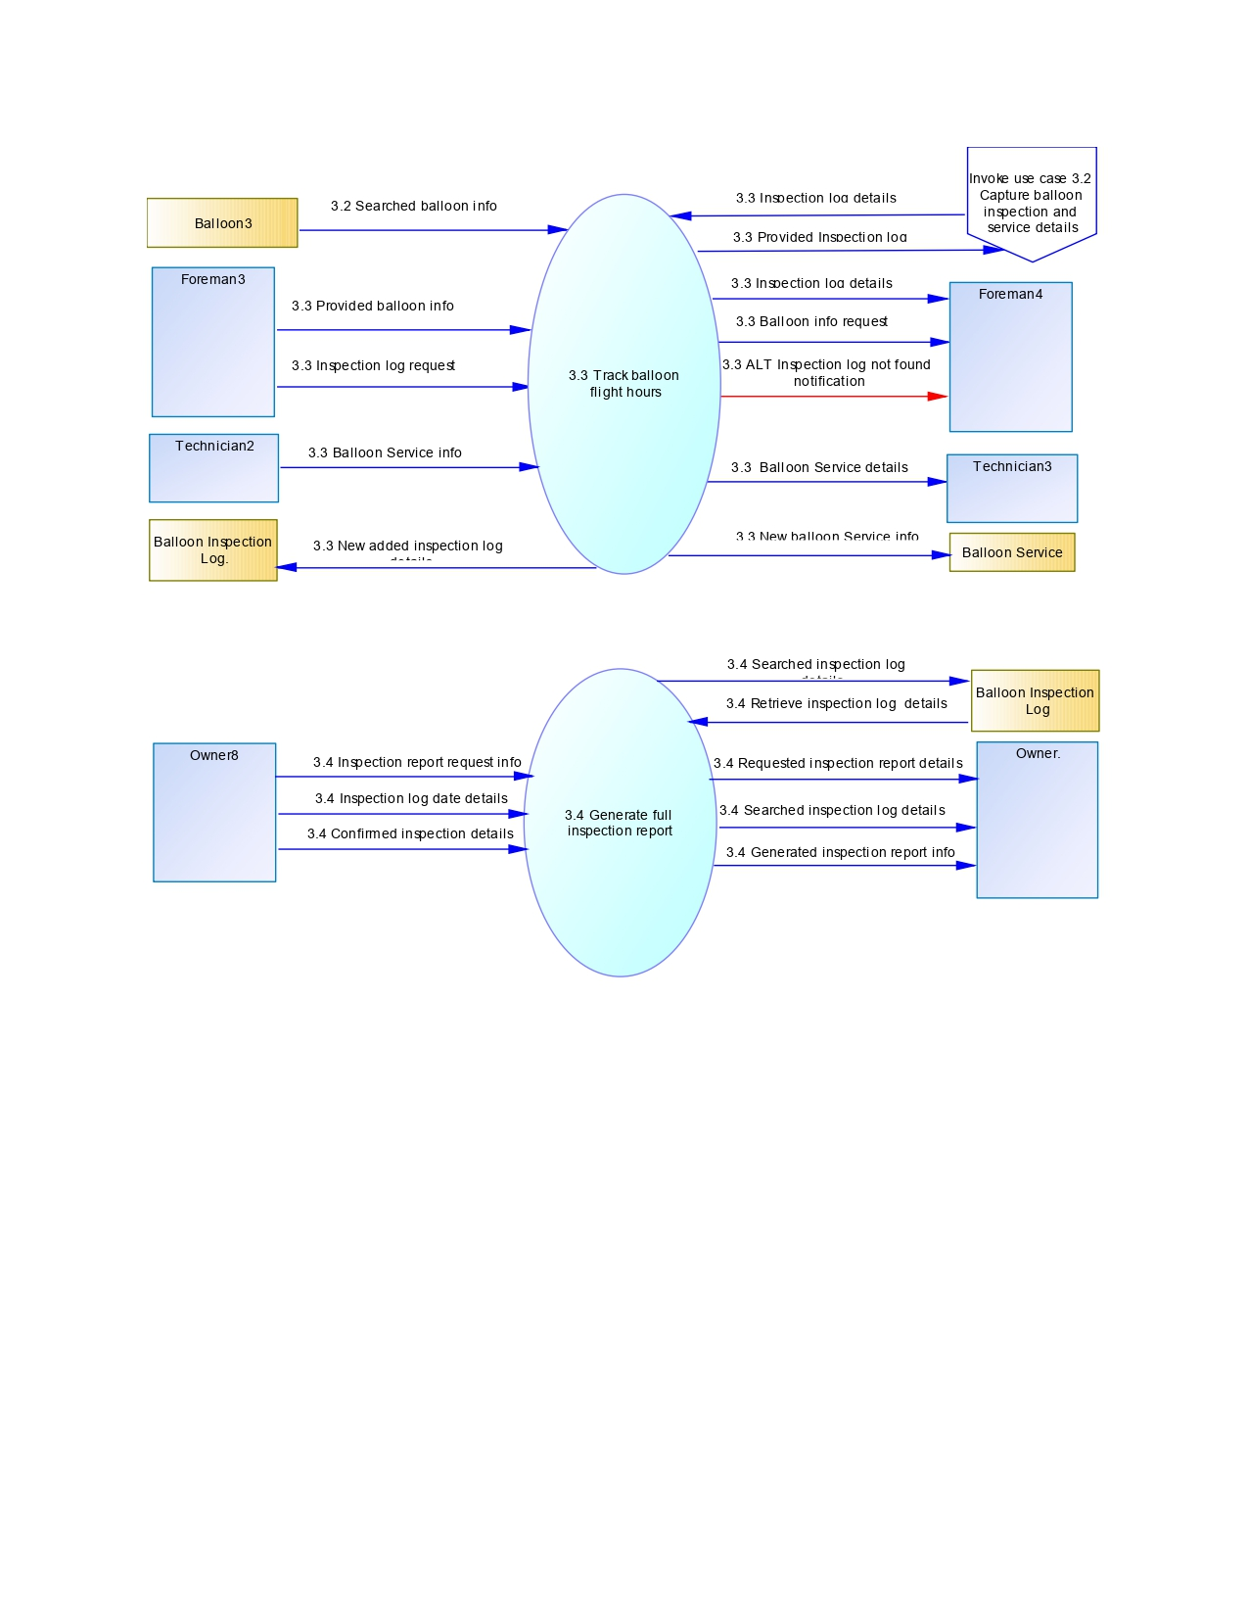

Conclusion

At the middle level, we’ve examined specific functions and their interdependencies. This equips us with insights on how different parts of African Adventures collaborate.

Primitive level

Introduction

At this level we delve even further, dissecting the functions identified at the middle level into their most granular components.

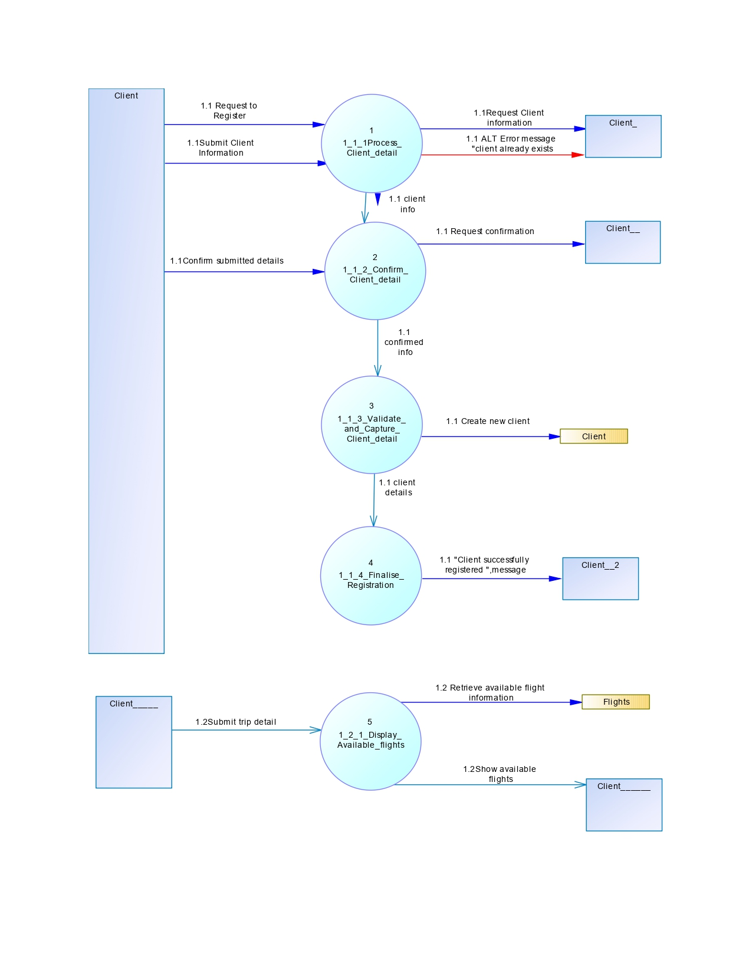

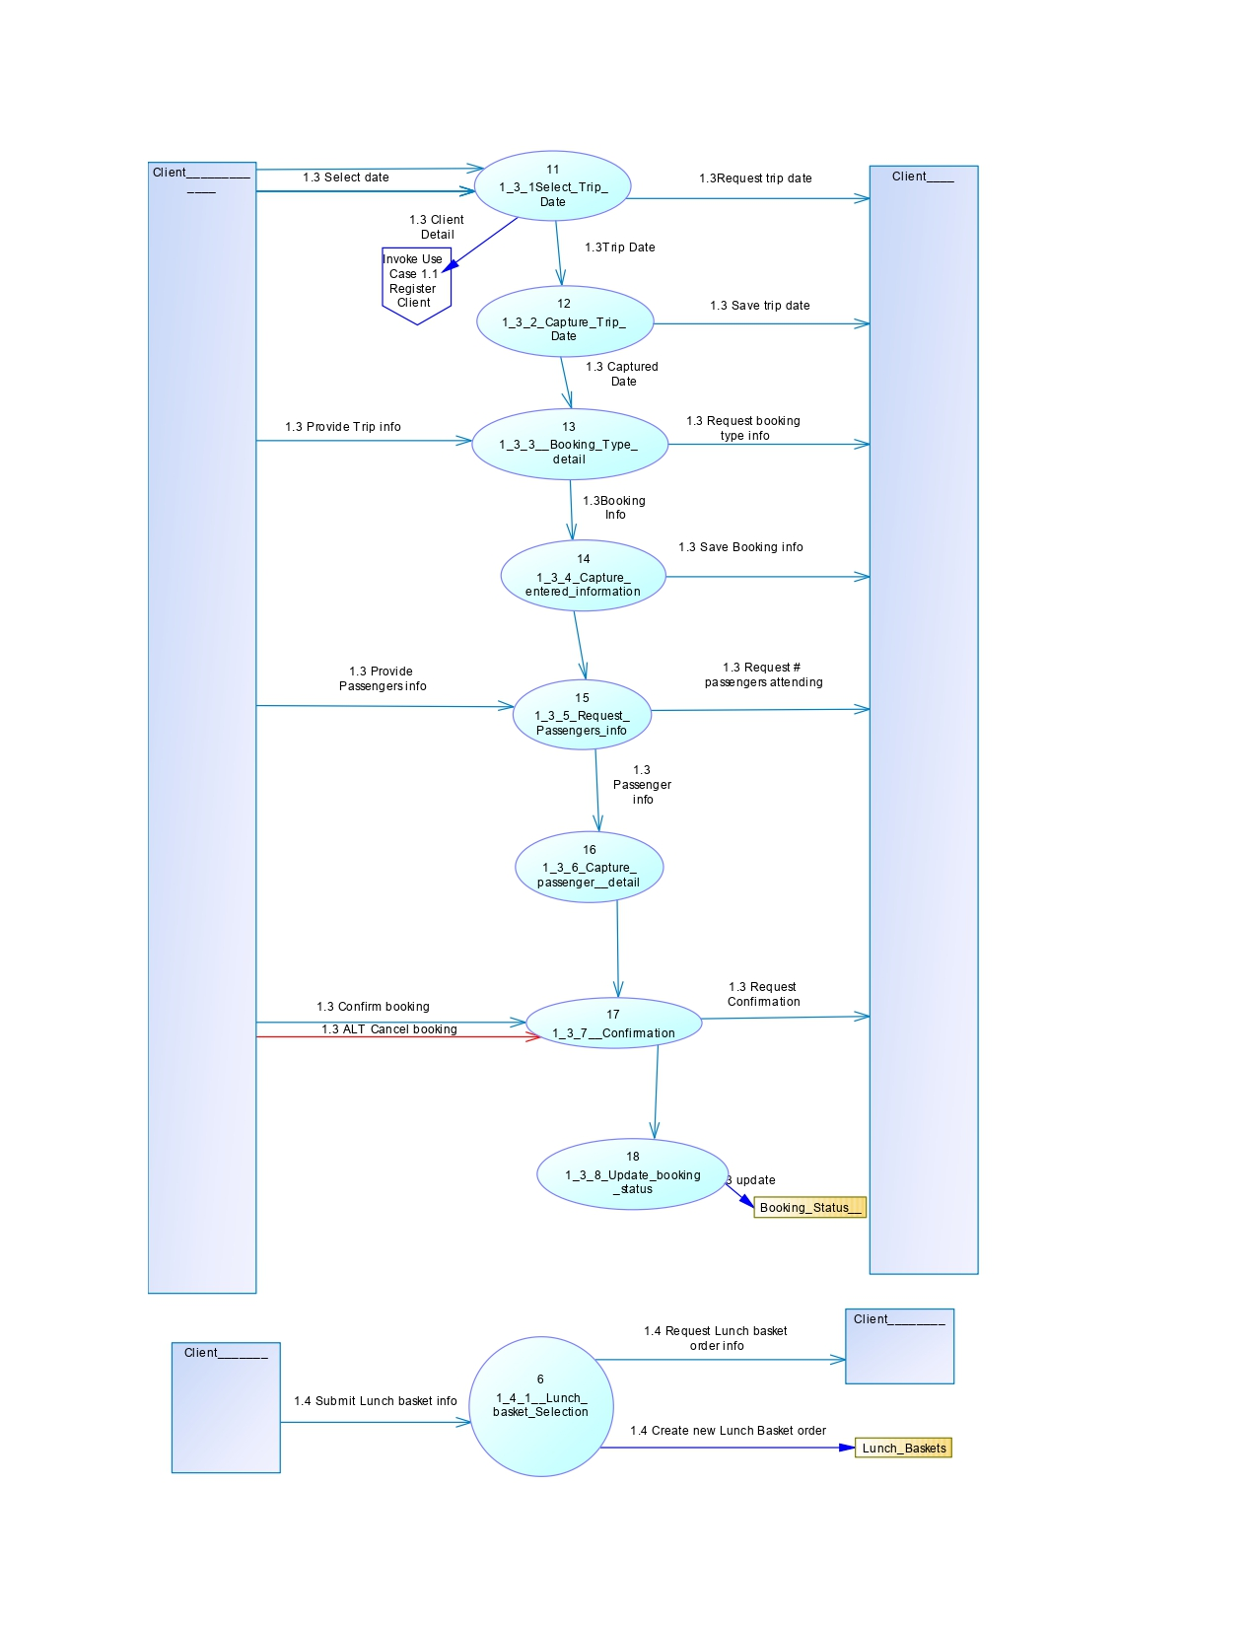

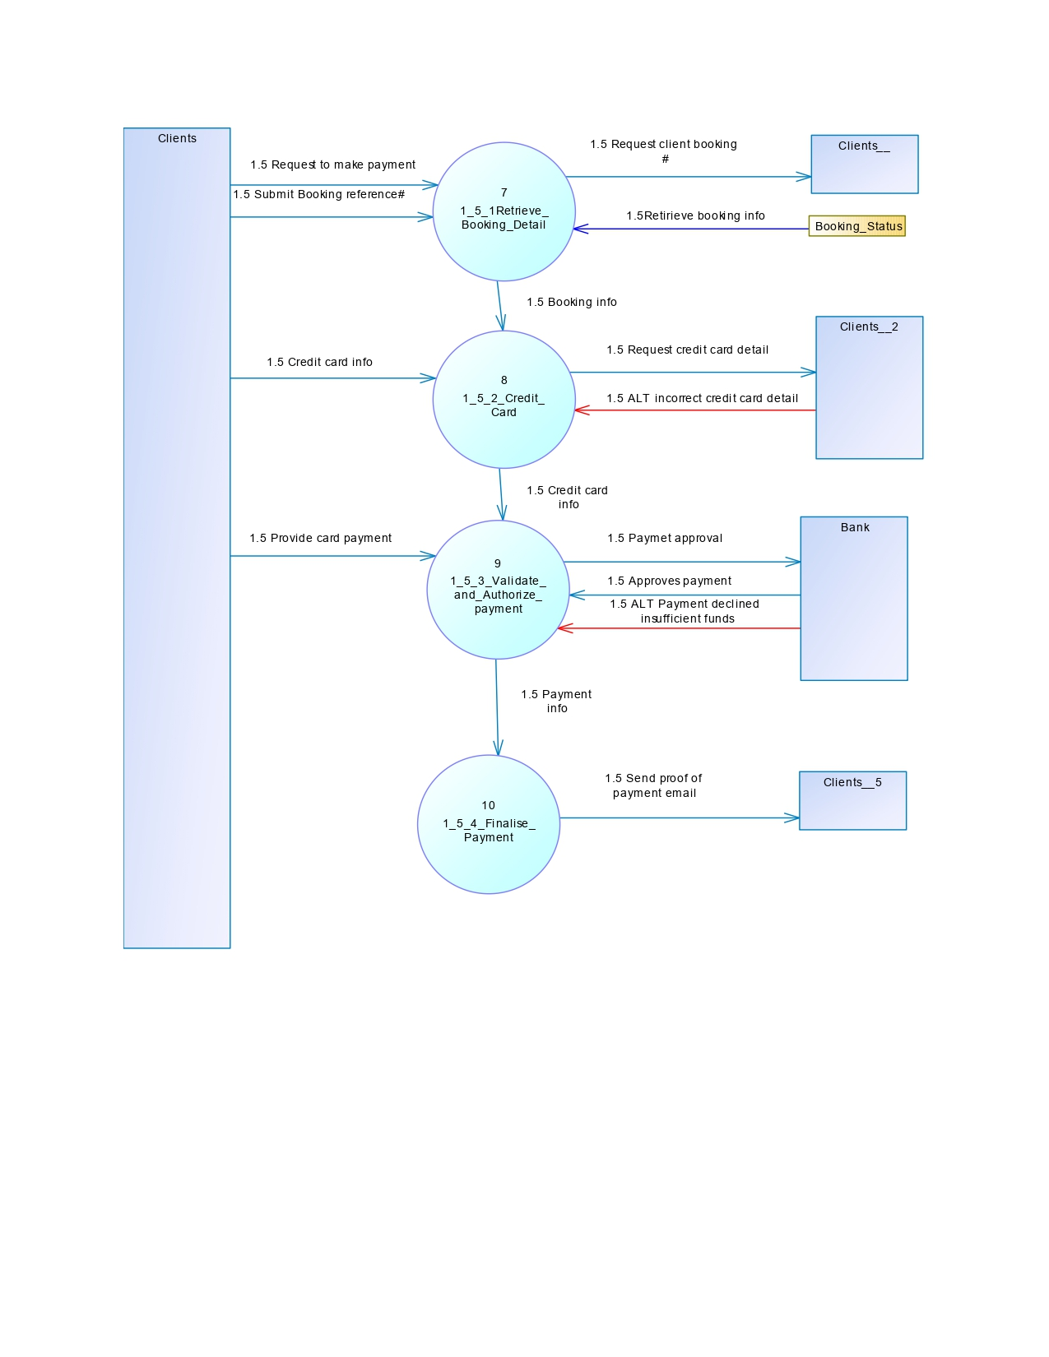

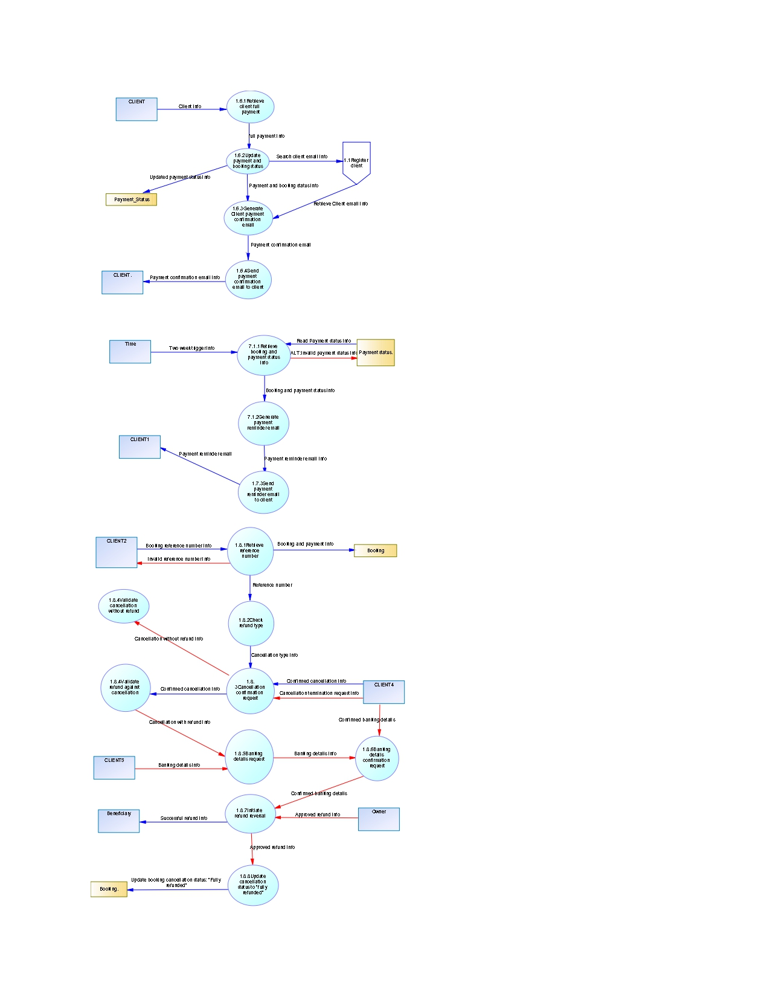

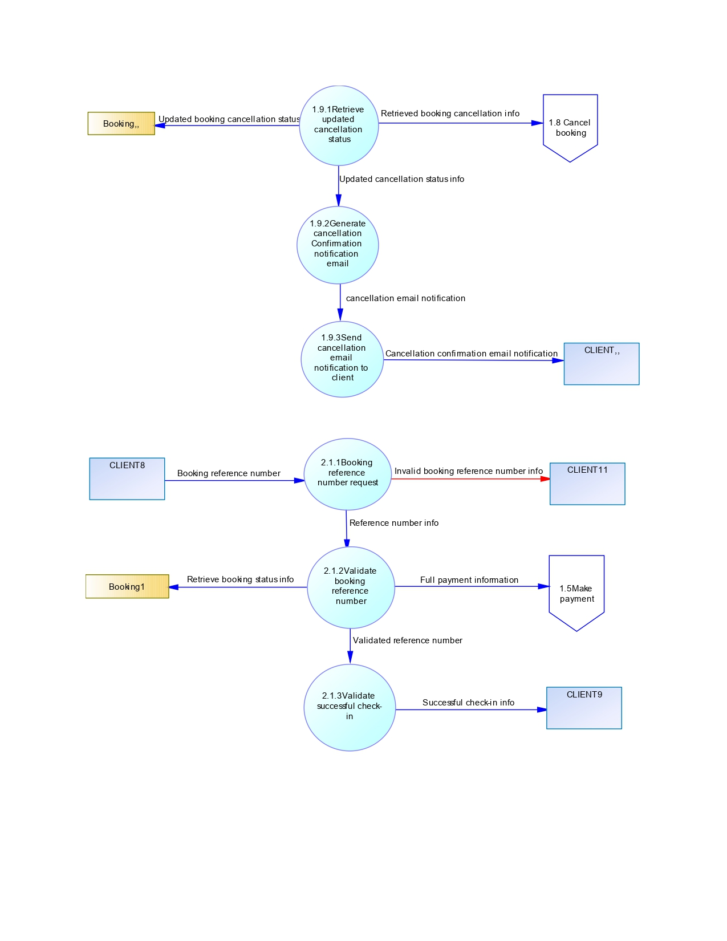

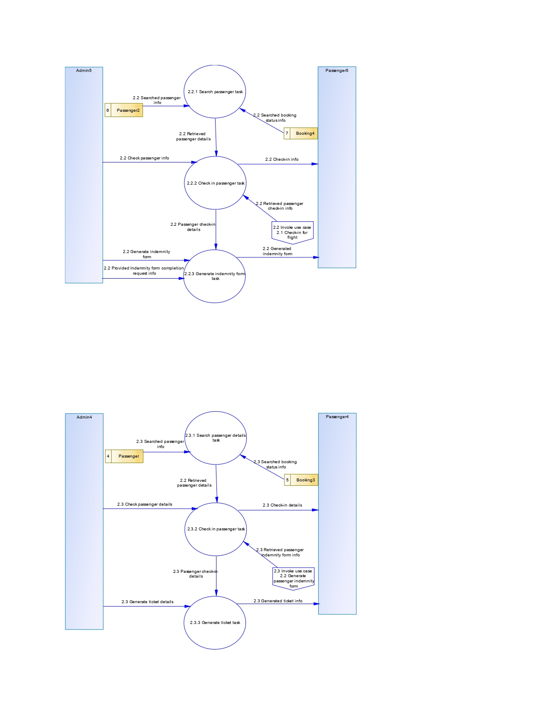

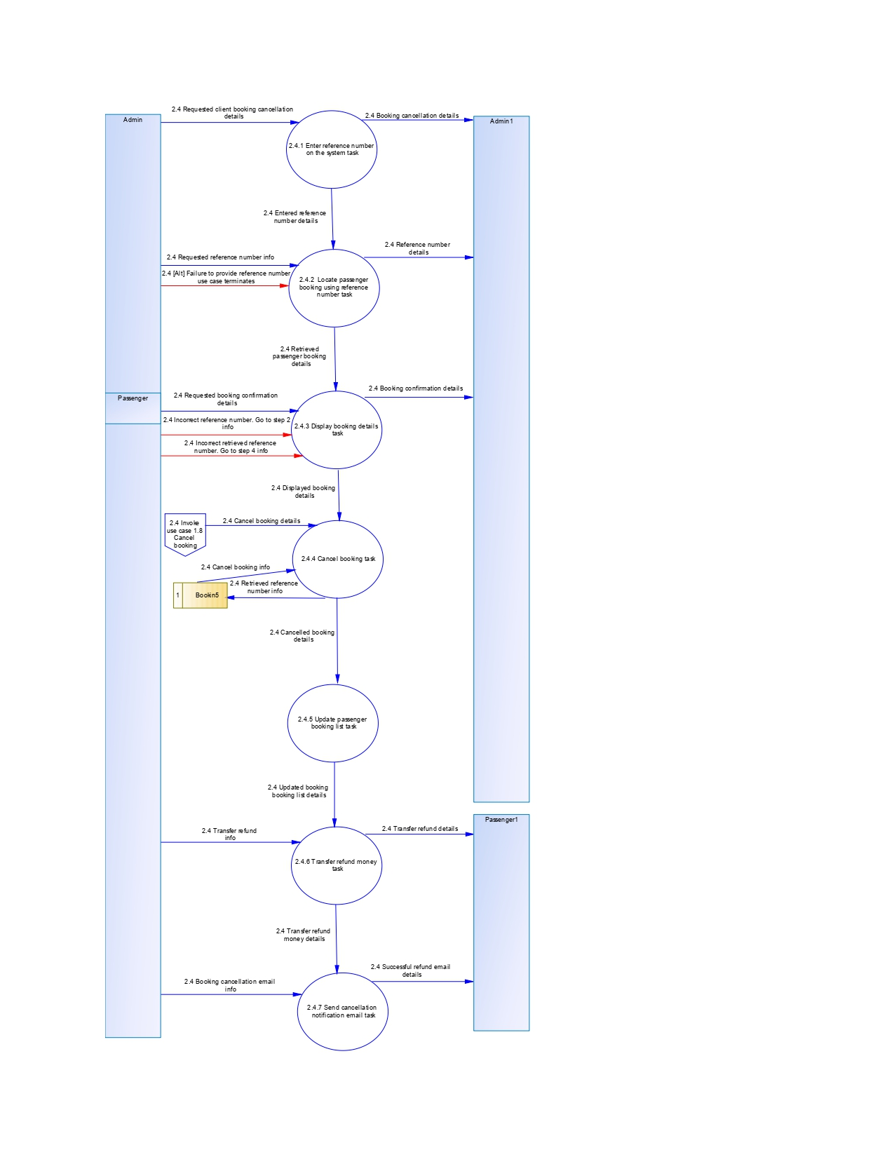

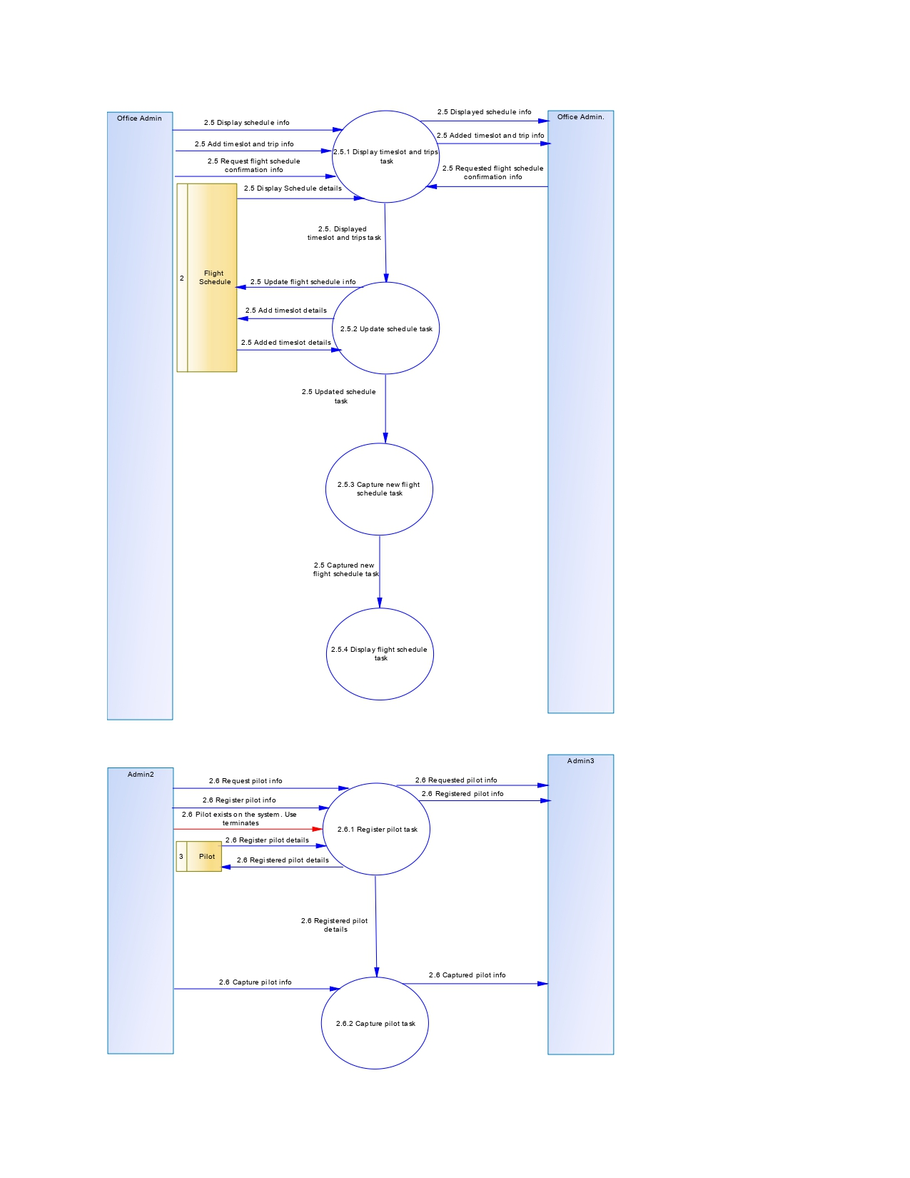

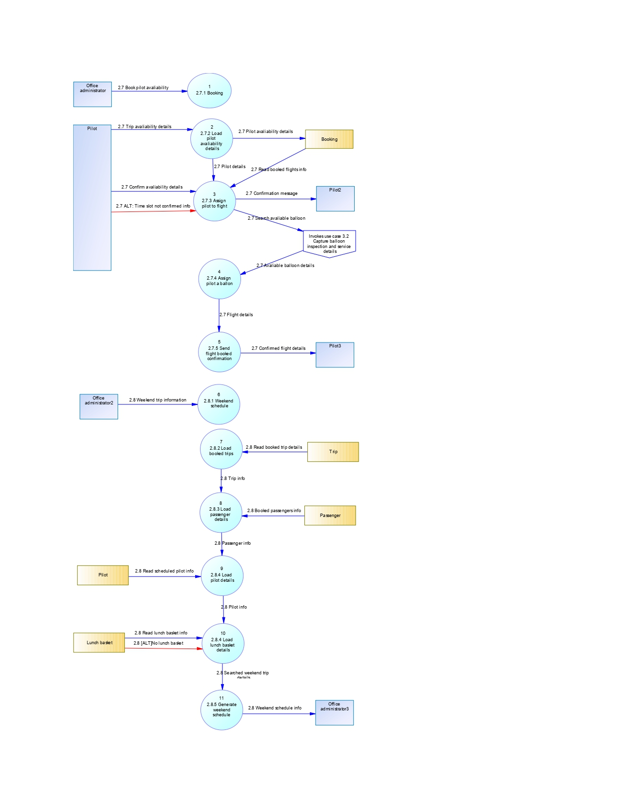

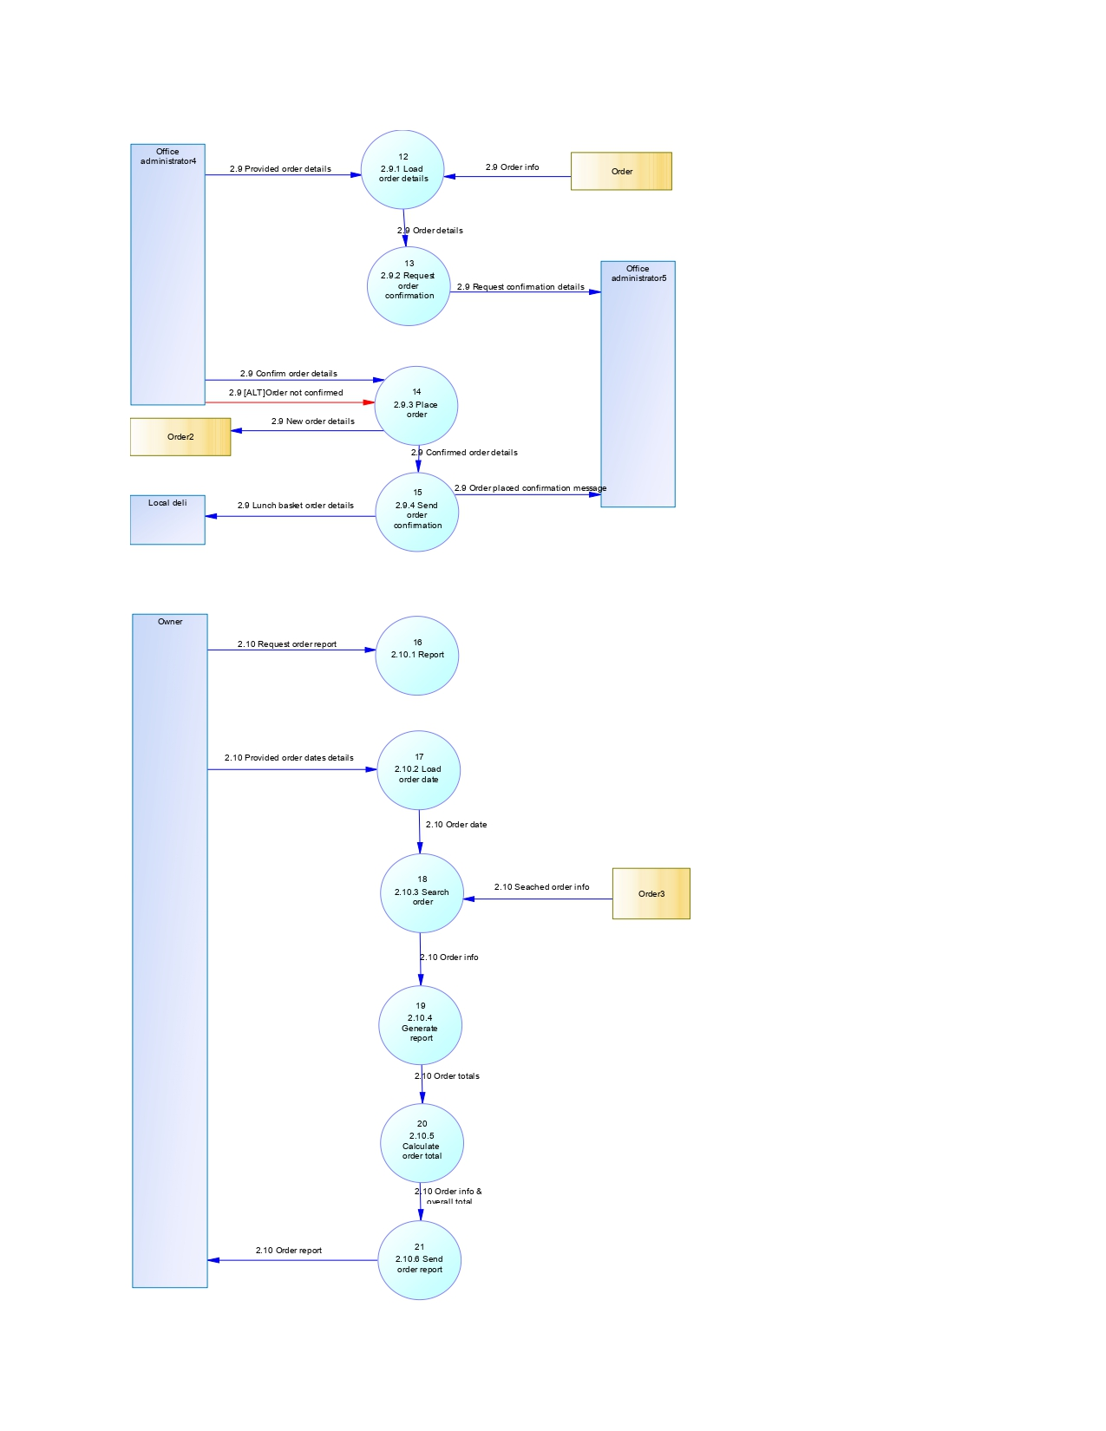

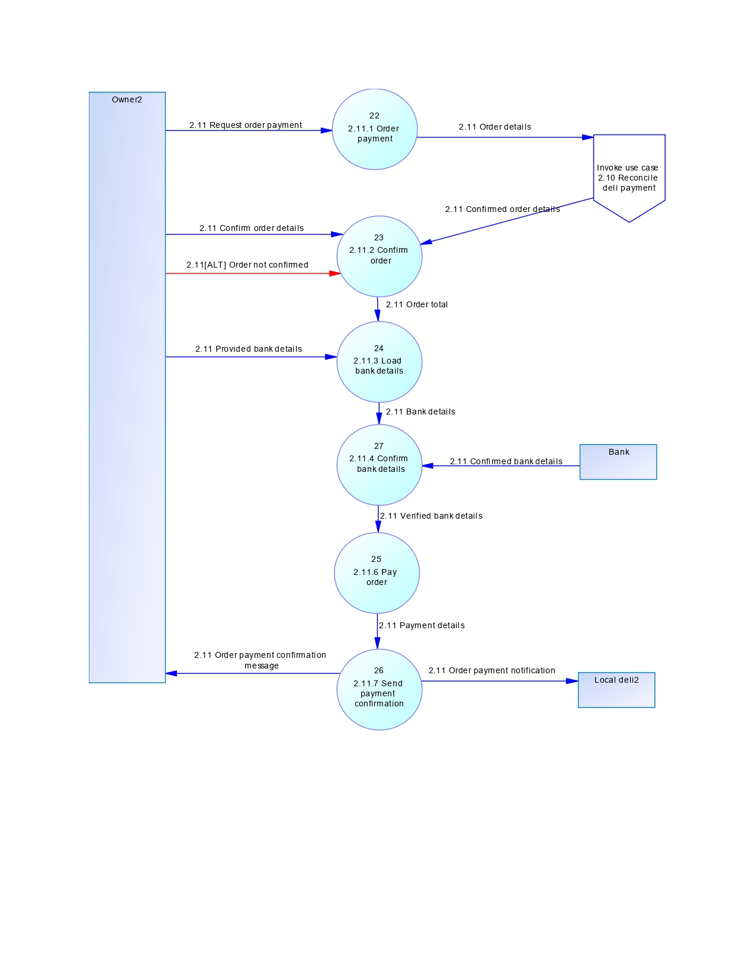

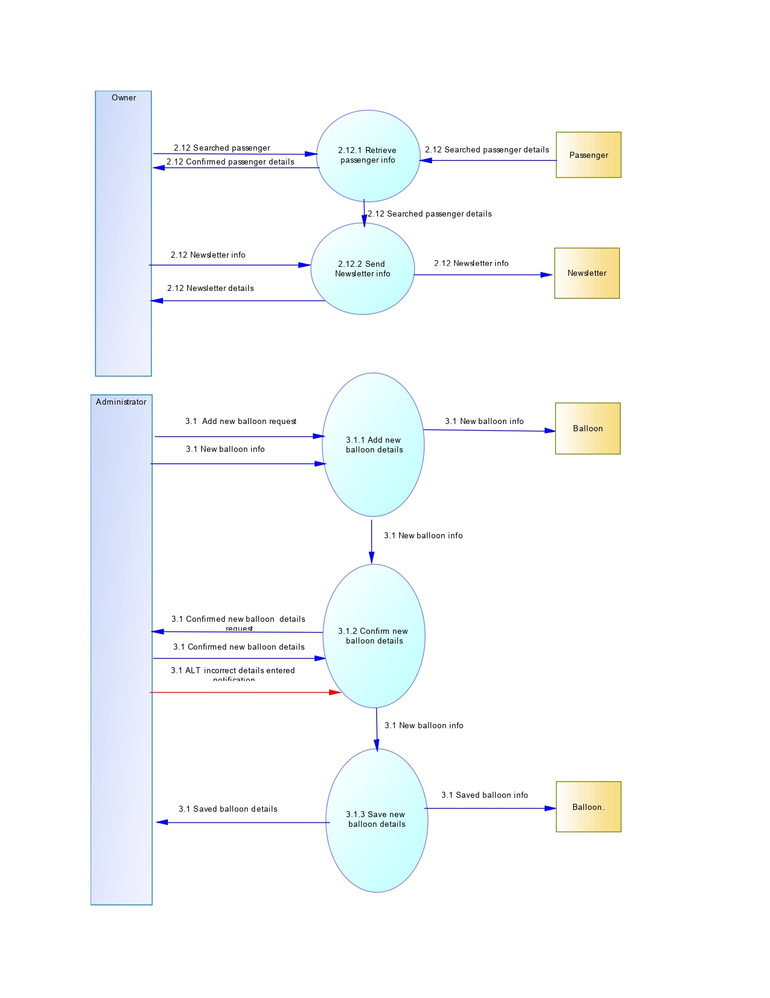

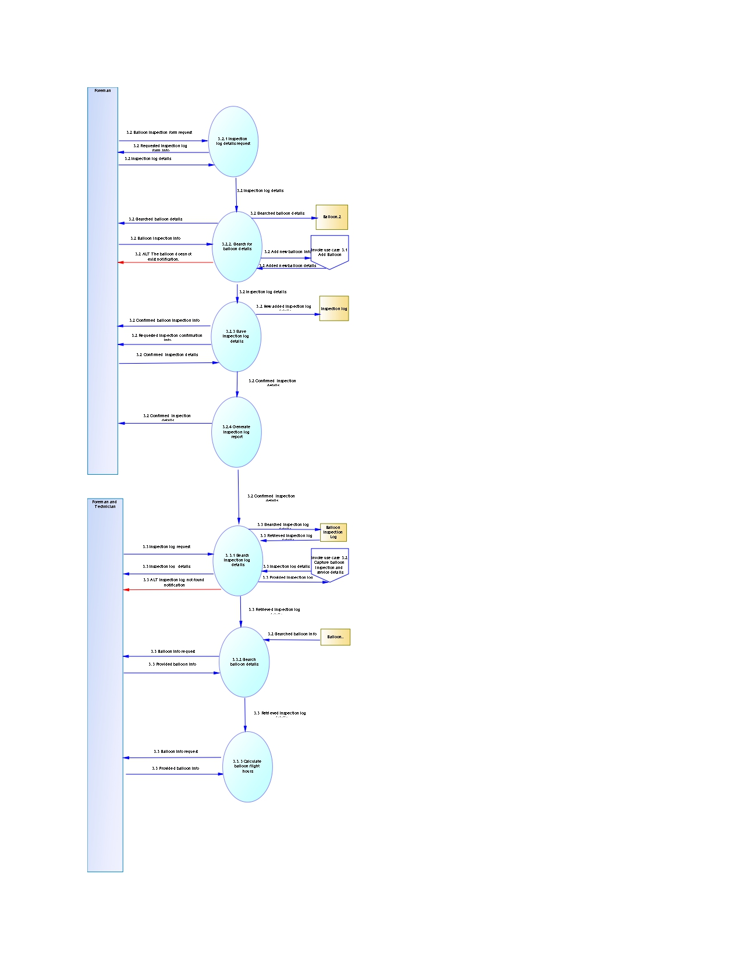

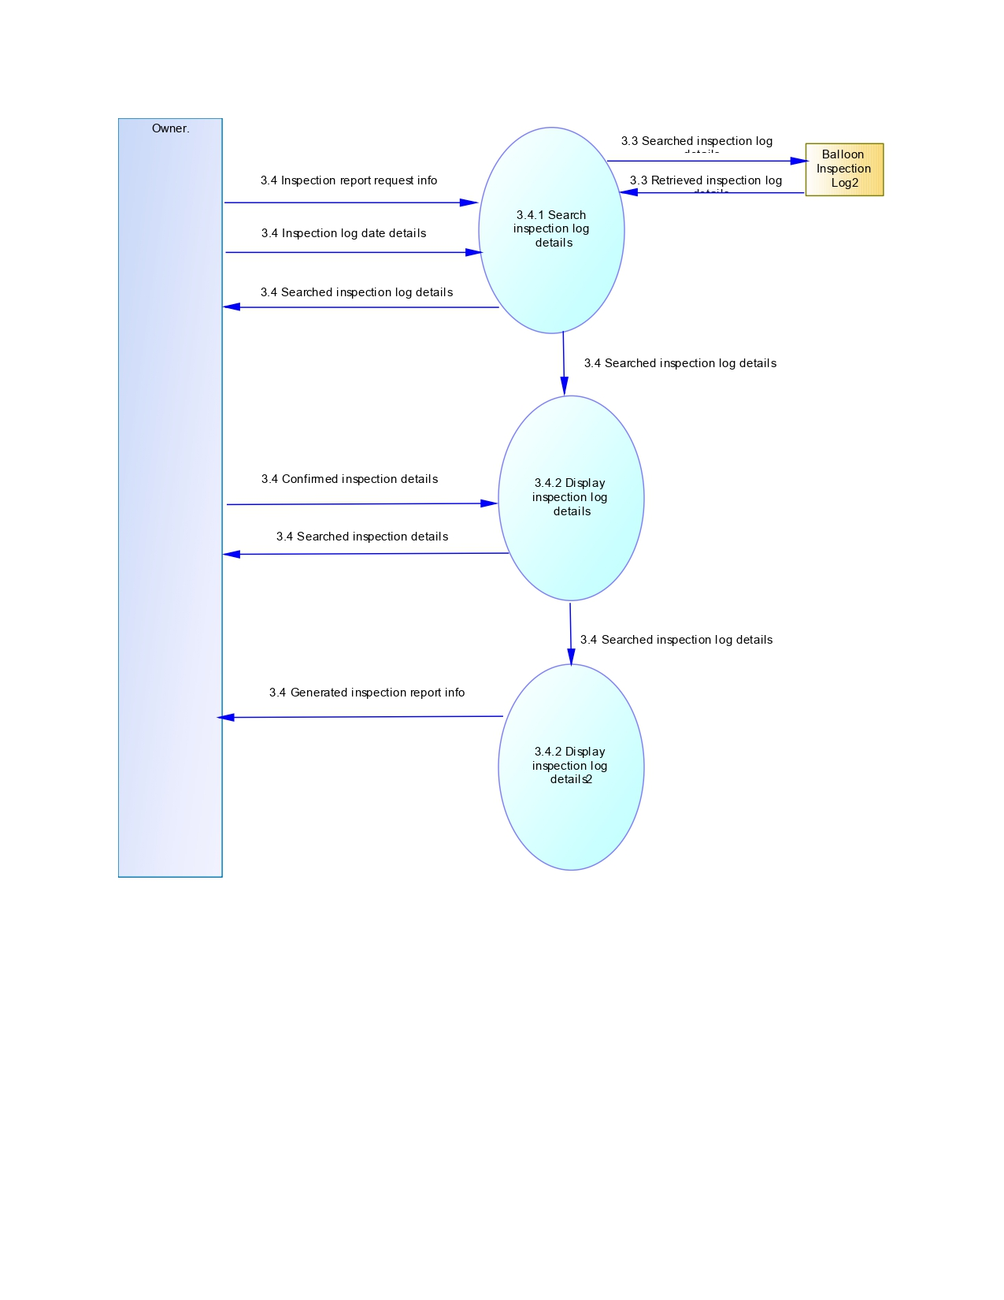

Conclusion

Finally, the primitive level provides the finest level of details, where we’ve dissected functions into their basic components.

4.UML MODELLING

4.1Logical class diagram

Introduction  
This section primarily emphasizes the system’s backend, with the goal of consolidating all the system components to illustrate their relationship and provide clear descriptions of their functions and services. In the context of African Adventures, a total of twenty-four objects have been identified.



Conclusion

By providing such a comprehensive description, African Adventures gain a distinct advantage in the process of designing a meticulously crafted system that functions as intended. This detailed description equips them with the essential insights and understanding required to develop a system that aligns with their objectives.

4.2Activity Diagrams

Introduction  
This section illustrates different activity diagrams derived from different use case narratives for the African Adventure System.

Activity 1.1



Activity1.2



Activity 1.3



Activity 1.4



Activity 1.5



Activity 1.6





Activity 1.7

Activity1.8



Activity 1.9



Activity2.1



Activity 2.2



Activity 2.3



Activity 2.4



Activity 2.5

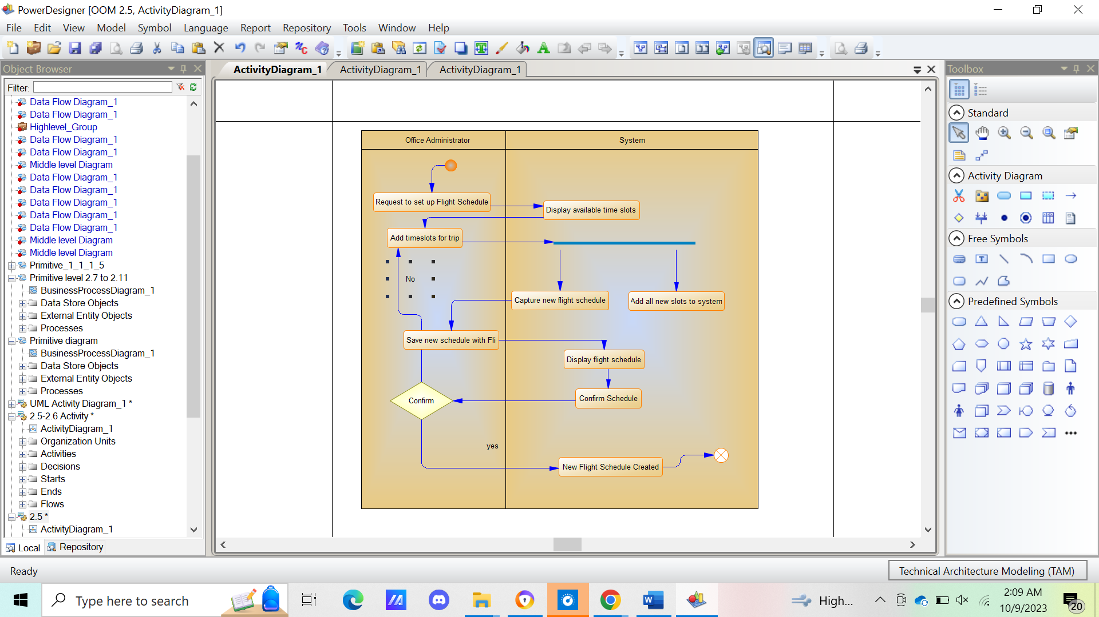

Activity 2.6

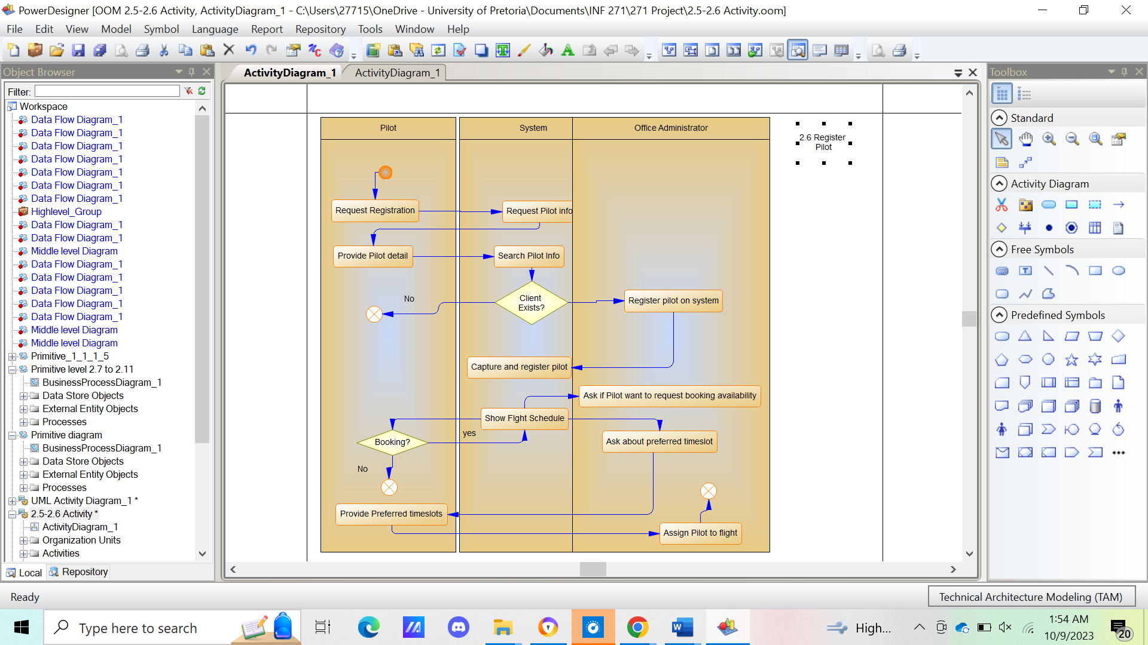

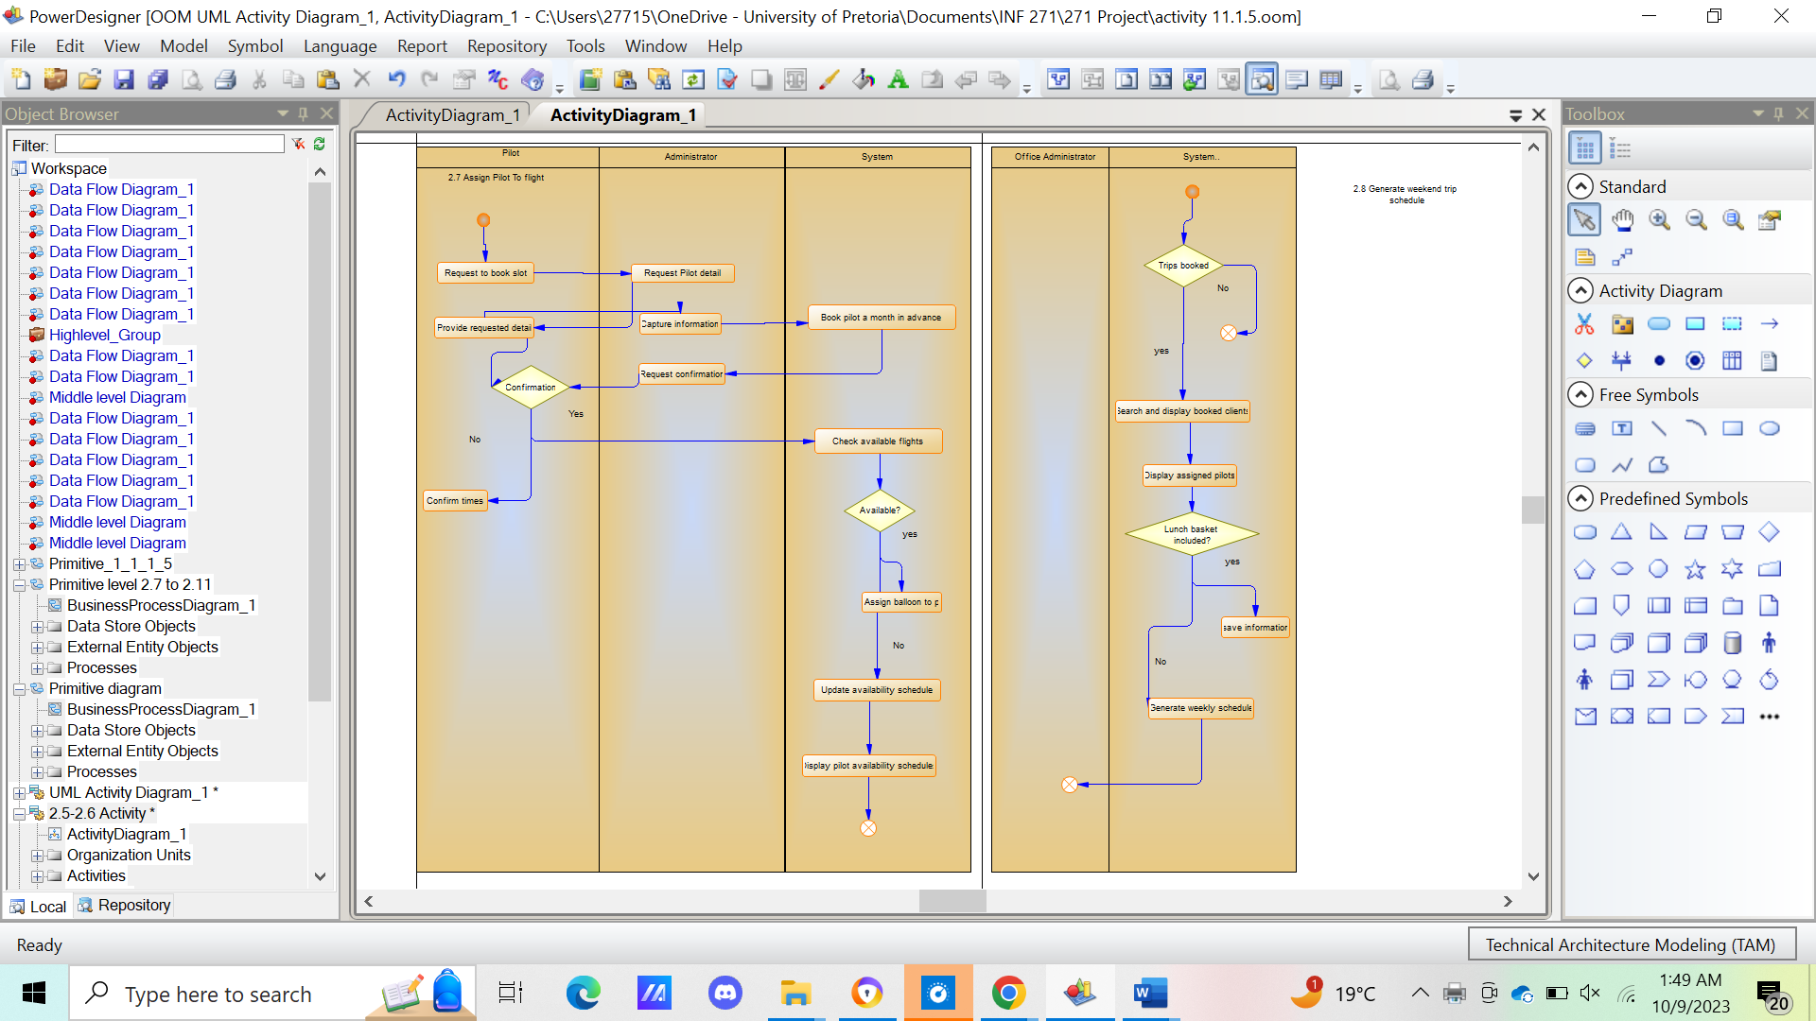

Activity 2.7



Activity 2.8

Activity 2.9



Activity 2.10



Activity 2.11



Activity 2.12





Activity 3.1



Activity 3.2



Activity 3.3

Activity 3.4



Conclusion   
The activity diagrams above will help African Adventure in modeling their software systems and business processes.

5.DATA MODELLING

Introduction

This section of the project will do an analysis of the database structures of the African Adventure’s proposed system. This section will provide a details layout of all the data and related entities to provide an understanding of the data requirements and relationships within the system.



Conclusion

The provided figure of the proposed system’s ERD (Entity Relationship Diagram) shows a clearly detailed visual presentation of the relationships between the entities found in the system.

6.INTERFACES AND OTHER INPUTS

Introduction  
Section 6 investigates the possible interface and input designs for the proposed system.

|  |  |
| --- | --- |
| Font | For font we have decided to use Vijaya  African Adventures  *Welcome to our Site!* |
| Screen Background Colors: | We have decided to play on turquoise and white colors since the business operations of African Adventures occur in the sky.  background-image: linear-gradient(to right, #fafeff, #7ae4ff); |
| Pilot booking Calendar  : the turquoise slots denote booked times.  And the brown tiles are unbooked times |  |
| Button Shapes | We will make use of rounded rectangle shaped buttons, with turquoise outline. |

Conclusion

With this research our system begins to come alive, allowing both the programmer and Business Analyst to visualize the system and start brainstorming on the possible implementation routes.

7.REPORTS AND OTHER OUTPUTS

Introduction  
This section is about Reports and other outputs, the outputs below serve various purposes including enhancing customer communication, supports operational efficiency and ensure compliance with the business's requirements and policies. They are generated automatically, periodically, or as needed, depending on specific triggers.

|  |  |  |  |
| --- | --- | --- | --- |
| **OUTPUT** | **PURPOSE** | **FREQUENCY** | **ENTITIES** |
| 1.Booking Confirmation Emai | To confirm a client's booking and provide them with essential trip details. | Generated automatically upon successful online booking and payment | Clients |
| 2.Payment Confirmation Email | To confirm the receipt of a full payment for a booking | Automatically sent when a client pays the remaining balance online | Clients |
| 3.Cancellation Notification Email | To notify clients of a cancelled booking and, if applicable, refund details. | Automatically sent when a booking is cancelled | Clients |
| 4.Trip Schedule Report | Provides a detailed schedule for the upcoming weekend trips | Generated every Friday for the weekend trips | Field Office Staff, Pilots, Clients |
| 5.Indemnity form | Automatically generates passenger indemnity forms with accurate information. | Generated for each passenger upon check-in | System, Clients, Field Office Staff |
| 6. Newsletter | Distributes newsletters to past clients with updates on specials and events | periodically as part of marketing efforts | Past Clients |
| 7. Trip Inspection Report | Records and generates inspection reports for each hot air balloon after a trip | Generated after each trip and when required for maintenance | Technicians, Foreman |
| 8. Deli Order Report | Generates a report of deli orders placed by African Adventures | Generated every Friday for deli order placement | Deli |
| 9. Deli Invoice Reconciliation Report | Compares the deli's invoice with orders placed by African Adventures for reconciliation | Generated monthly upon receiving the deli's invoice | Office Admin, Deli |
| 10. Refund Approval Records | Records and tracks refund requests and approvals | Generated as needed when clients request refunds | Owner |
| 11. External Application Integration | Facilitates communication with external applications, such as secure payment processing services | Real-time integration during online payment transactions | External Payment Processing Service |

Conclusion

The reports and other outputs have been successfully shown on the table below.

8.VALIDATION

Introduction

This section aims to provide a detailed explanation of the process that occurred on the system response side (Primitive Level processes). It will explain how a process occurs as well as the various entities involved.

|  |  |  |  |  |
| --- | --- | --- | --- | --- |
| **BOOKING SUBSYSTEM** | | | | |
| Requirement | Use Case | Process on data flow diagram | Invoke | Entities |
| 1.1 Register client | 1.1Register client | 1.1.1Process client details | None | None |
| 1.1.2Confirm client details | None | None |
| 1.1.3Validate and capture client details | None | Client |
| 1.1.4Finalise Registration | None | None |
| 1.2View available flights | 1.2View available flights | 1.2.1 Display available flights | None | flights |
| 1.3 View available flights | 1.3View available flights | 1.3.1Select trip date | 1.1Register client | None |
| 1.3.2Capture trip date | None | None |
| 1.3.3Booking type details | None | None |
| 1.3.4Capture entered information | None | None |
| 1.3.5Request passenger info | None | None |
| 1.3.6Capture passenger details | None | None |
| 1.3.7Confirmation | None | None |
| 1.3.8Update booking status | None | Booking status |
| 1.4Order lunch basket | 1.4Order lunch basket | 1.4.1Lunch basket selection | None | Lunch basket |
| 1.5Make Payment | 1.5Make payment | 1.5.1Retrieve booking details | None | Booking status |
| 1.5.2Credit card | None | None |
| 1.5.3Validate and authorize payment | None | None |
| 1.5.4Finalise payment | None | None |
| 1.6Send payment confirmation | 1.6Send payment confirmation | 1..6.1Retrieve full payment | None | None |
| 1.6.2Update payment and booking status | 1.1register client | Payment status |
| 1.6.3Generate client payment confirmation email | None | None |
| 1.6.4send payment confirmation email | None | None |
| 1.7Send payment reminder | 1.7Send payment reminder | 1.7.1 Retrieve booking and payment status info | None | Payment status |
| 7.1.2Generate payment reminder email | None | None |
| 1.7.3Send payment reminder email to client | None | None |
| 1.8Cancel booking | 1.8Cancel booking | 1.8.1Retrieve reference number | None | Booking |
| 1.8.2Check refund type | None | None |
| 1.8.3 Cancellation confirmation request | None | None |
| 1.8.4 Validate refund against cancellation | None | None |
| 1.8.5 Banking details request | None | None |
| 1.8.6 Banking details confirmation request | None | None |
| 1.8.7 Initiate refund reversal | None | None |
| 1.8.8 Update cancellation status to "fully refunded" | None | Booking |
| 1.9Send cancellation notification | 1.9Send cancellation notification | 1.9.1Retrieve updated cancellation status | None | Booking |
| 1.9.2Generate cancellation Confirmation notification email | None | None |
| 1.9.3Send cancellation email notification to client | None | None |

|  |  |  |  |  |
| --- | --- | --- | --- | --- |
| **ONLINE SUBSYSTEM** | | | | |
| Requirement | Use Case | Process on data flow diagram | Invoke | Entities |
| 2.1 Check-in for flight | 2.1 Check-in for flight | 2.1.1Booking reference number request | None | None |
| 2.1.2Validate booking reference number | 1.5Make payment | Booking |
| 2.1.3Validate successful check-in | None | None |
| 2.2 Generate passenger indemnity form | 2.2 Generate passenger indemnity form | 2.2.1 Search passenger task | None | Booking, Passenger |
| 2.2.2 Check in passenger task | 2.1 Check-in for flight | None |
| 2.2.3 Generate indemnity form task | None | None |
| 2.3 Generate ticket | 2.3 Generate ticket | 2.3.1 Search passenger details task | None | Booking, Passenger |
| 2.3.2 Check in passenger task | 2.2 Generate passenger indemnity form | None |
| 2.3.3 Generate ticket task | None | None |
| 2.4 Refund booking | 2.4 Refund booking | 2.4.1 Enter reference number on the system task | None | None |
| 2.4.2 Locate passenger booking using reference number task | None | None |
| 2.4.4 Cancel booking task | 1.8 Cancel booking | Booking |
| 2.4.5 Update passenger booking list task | None | None |
| 2.4.6 Transfer refund money task | None | None |
| 2.4.7 Send cancellation notification email task | None | None |
| 2.5 Setup flight schedule | 2.5 Setup flight schedule | 2.5.1 Display timeslot and trips task | None | None |
| 2.5.2 Update schedule task | None | Flight schedule |
| 2.5.3 Capture new flight schedule task | None | None |
| 2.5.4 Display flight schedule task | None | None |
| 2.6 Register pilot |  | 2.6.1 Register pilot task | None | Pilot |
| 2.6.2 Capture pilot task | None | None |
| 2.7 Assign pilot to schedule | 2.7 Assign pilot to schedule | 2.7.1 Booking | None | None |
| 2.7.2 Load pilot availability details | None | Booking |
| 2.7.3 Assign pilot to flight | 3.2 Capture balloon inspection and service details | None |
| 2.7.4 Assign pilot a balloon | None | None |
| 2.7.5 Send flight booked confirmation | None | None |
| 2.8 Generate weekend trip schedule | 2.8 Generate weekend trip schedule | 2.8.1 Weekend schedule | None | None |
| 2.8.2 Load booked trips | None | Trip |
| 2.8.3 Load passenger details | None | Passenger |
| 2.8.4 Load pilot details | None | Pilot |
| 2.8.4Load lunch basket details | None | Lunch basket |
| 2.8.5 Generate weekend schedule | None |  |
| 2.9 Place deli order | 2.9 Place deli order | 2.9.1 Load order details | None | Order |
| 2.9.2 Request order confirmation | None |  |
| 2.9.3 Place order | None | Order |
| 2.9.4 Send order confirmation | None | None |
| 2.10 Reconcile deli order | 2.10 Reconcile deli order | 2.10.1 Report | None | None |
| 2.10.2 Load order date | None | None |
| 2.10.3 Search order | None | Order |
| 2.10.4 Generate report | None | None |
| 2.10.5 Calculate order total | None | None |
| 2.10.6 Send order report | None | None |
| 2.11 Pay deli | 2.11 Pay deli | 2.11.1 Order payment | 2.10 Reconcile deli payment | None |
| 2.11.2 Confirm order | 2.10 Reconcile deli payment | None |
| 2.11.3 Load bank details | None | None |
| 2.11.4 Confirm bank details | None | None |
| 2.11.7 Send payment confirmation | None | None |
| 2.12Send client newsletter | 2.12Send client newsletter | 2.12.1 Retrieve passenger info | None | Passenger |
| 2.12.2 Send Newsletter info | None | Newsletter |

|  |  |  |  |  |
| --- | --- | --- | --- | --- |
| Ballon Subsystem | | | | |
| Requirement | Use Case | Process on data flow diagram | Invoke | Entities |
| 3,1 Add balloon | 3,1 Add balloon | 3.1.1 Add new balloon details | None | Balloon |
| 3.1.2 Confirm new balloon details | None | None |
| 3.1.3 Save new balloon details | None | Balloon. |
| 3,2 Capture balloon inspection and service details | 3,2 Capture balloon inspection and service details | 3.2.1 Inspection log details request | None | None |
| 3.2.2. Search for balloon details | Invoke use case 3.1 Add Balloon | Balloon |
| 3.2.3 Save inspection log details | None | Inspection log |
| 3.2.4 Generate Inspection log report | None | None |
| 3,3 Track balloon flight hours | 3,3 Track balloon flight hours | 3.3.1 Search inspection log details | 3.2 Capture balloon inspection and service details | Balloon Inspection Log |
| 3.3.2 Search balloon details | None | Balloon |
| 3.3.3 Calculate balloon flight hours | None | None |
| 3,4 Generate full inspection report | 3,4 Generate full inspection report | 3.4.1 Search inspection log details | None | Balloon Inspection Log2 |
| 3.4.2 Display inspection log details | None | None |
| 3.4.2 Display inspection log details2 | None | None |

Conclusion

This has provided a detailed explanation of the processes occurring in the system and eliminates any confusion of how a process was initiated.

|  |  |
| --- | --- |
| Student Info | |
| First Name | Basetsana |
| Last Name | Sekhoto |
| Student No. | 21608611 |
| Date | 06/10/2023 |
|  | |
| Student Info | |
| First Name | Busisiwe |
| Last Name | Khosa |
| Student No. | 20473240 |
| Date | 06/10/2023 |

9.General

|  |  |
| --- | --- |
| Student Info | |
| First Name | Maria |
| Last Name | Sadiki |
| Student No. | 22651609 |
| Date | 06/10/2023 |

|  |  |
| --- | --- |
| Student Info | |
| First Name | Rethabile |
| Last Name | Kgotlane |
| Student No. | 21601144 |
| Date | 06/10/2023 |
|  | |

|  |  |
| --- | --- |
| Student Info | |
| First Name | Phumzile |
| Last Name | Phakathi |
| Student No. | 21575755 |
| Date | 06/10/2023 |